**OPYBS Fall 2025 A League (softball t-ball) Rule Book**

# Table of Contents

## League Structure page 2

**Team Structure / Player Eligibility** page 3

**Scheduling / Rescheduling / Postponement and** page 4

**Cancellation of Games**

Weather-Related Game Postponements Lightning Guidelines

Rainout Guidelines

**The Playing Field** pages 5-6

**Equipment** page 7

**Uniforms** page 8

**The Game** pages 8-9

**The Overthrow** page 9

**The play is over when…** page 10

**Foul Ball** page 10

**The Pitcher** page 10

**The Fielders** pages 10-11

**The Batter** page 11

**Thrown Bat** page 11

**The Base Runner** page 12

**The Umpire** page 12

# Oak Park Youth T-Ball Rule Book Fall 2025

## Team Structure / Player Eligibility:

The number of teams will vary from year to year, based on the number of girls enrolled in the league. Each team will have no less than 11 players and no more than 13 players.

No team shall have more than 10 players returning to the league as kindergarten or 1st grade players. The League President will work to balance each team by age and experience. A “returning player” is defined as one who played in the immediate season prior. New registrants who took a year off are considered new players.

Players are eligible to play tee ball if they are born between 9/1/18 and 8/31/20.  Players born before 9/1/18 should be placed in Fall AA ball and may only play tee ball with the permission of the VP of Softball.

Oak Park Youth Baseball/Softball reserves the right to make exceptions for players with disabilities. Team Rosters are published and distributed each year in August.

## Scheduling / Rescheduling / Postponement and Cancellation of Games:

Game Schedules are published and distributed by the League President shortly after Team Rosters are issued each year.

In cases of game cancellations or postponements NOT related to weather, Head Coaches may reschedule game dates by: 1) checking field availability and finding an agreed-upon date/time; and 2) contacting League President for inclusion in overall schedule; If the Head Coaches fail to agree on an alternate date, the game must be played on the regularly scheduled date. Failure to play on this date will result in a forfeit by the non-attending team(s) and will count as a loss in their winning percentage calculations.

If the Head Coaches decide to play on an alternate date, but fail to contact the League President, the League will have no obligation to provide an Umpire. However, the game will count in the standings as long as it is rescheduled prior to the original game date. Coaches are urged to make every attempt to reschedule well in advance of the date in question.

OPYBS will strive to reschedule games on the first available field at Whittier or Brooks. It is a better game when the field is lined and the Umpire attends. It is possible that make-up/rescheduled games could be played on grass fields or other open fields available to OPYBS.

## Weather-Related Game Cancellations / Postponements:

If games are canceled, the League President, or his designee, will cancel games at least one hour before scheduled games. If games are not canceled by one hour before, expect to play. Further decisions to cancel will rest with the umpire at game time based on weather and field conditions.

*No game shall be played or continue to be played if the on-field temperature (including wind-chill) falls below 45 degrees Fahrenheit*. If the Umpire postpones a game due to weather, the League President will assign another date, time and location for the game to be resumed. The game will be resumed from the point where it was postponed unless the game is considered complete, meaning 4 innings have been played or 3 1/2 if the home team is winning.

## Lightning Guidelines:

Safety is the number one priority. No lightning safety guidelines can guarantee absolute safety. All Coaches, Umpires and Parents must be aware of weather conditions, and use common sense and good judgment. The Umpire has absolute authority to call a game due to lightning. The National Lightning Safety Institute’s overall recommendation is: “**IF YOU CAN SEE IT, FLEE IT; IF YOU CAN HEAR IT, CLEAR IT!”**

The National Severe Storm Laboratory recommends terminating play and seeking shelter when lightning is 6 miles away or flash-to-bang time is 30 seconds or less. To use the flash-to-bang method, count the seconds from the time lightning is sighted to when the clap of thunder is heard. Divide this number by 5 to obtain how many miles away the lightning is occurring.

If lightning is seen, all must wait in a safe area for 30 minutes after the last lightning flash, or for 15 minutes for the sound of thunder before resuming a game. Safe waiting areas include fully enclosed vehicles with windows rolled up. Umpires must seek shelter in a vehicle with a Head Coach or Player’s family if they do not have their own vehicle to wait in.

All must stay away from metal objects like fences, equipment boxes and bleachers. Avoid trees and open fields. **In the event someone is struck by lightning, call 9-1-1 immediately.**

Each time lightning is observed or thunder is heard, the 30 or 15 minute waiting period starts over. If the lightning has not passed after 45 minutes from the first lightning flash, the Umpire will call the game.

The 2015 United States Specialty Sports Association (USSSA) Official Fastpitch Rules & Bylaws apply except where modified below.

## The Playing Field:

The distance from the back of one base to the front of another base is 50 feet. The Pitcher’s Plate will be located 35 feet from the front of Home Plate.

A double safety base will be used at First Base and at Home Plate. The Pitcher’s Circle should have a radius of 8 feet.

An arc with a radius of 10 feet from the tip of Home Plate will be marked. A batted ball must touch or cross this line to be considered “in play.” If the ball touches or crosses the line and retreats within the arc prior to being fielded, or while being fielded, the ball is “in play.” If a ball stops on the arc line, it is a fair ball.

Other Markings on the Field:

* A 1/2 way (25-foot) hash mark perpendicular to the 3rd base line extending onto the field of play will be drawn on the third base line.
* A 35 foot line perpendicular to the 3rd base line, extending onto the field of play. This line should be noticeably longer than the 1/2 way hash mark so it is easily distinguishable.
* A 35 foot line perpendicular to the 1st base line, extending onto the field of play, drawn to a similar length as the 35 foot line on the 3rd base side.

The 35 foot lines are presumed to extend to the middle of the diamond. No defensive player other than the pitcher may begin play in front of this line.

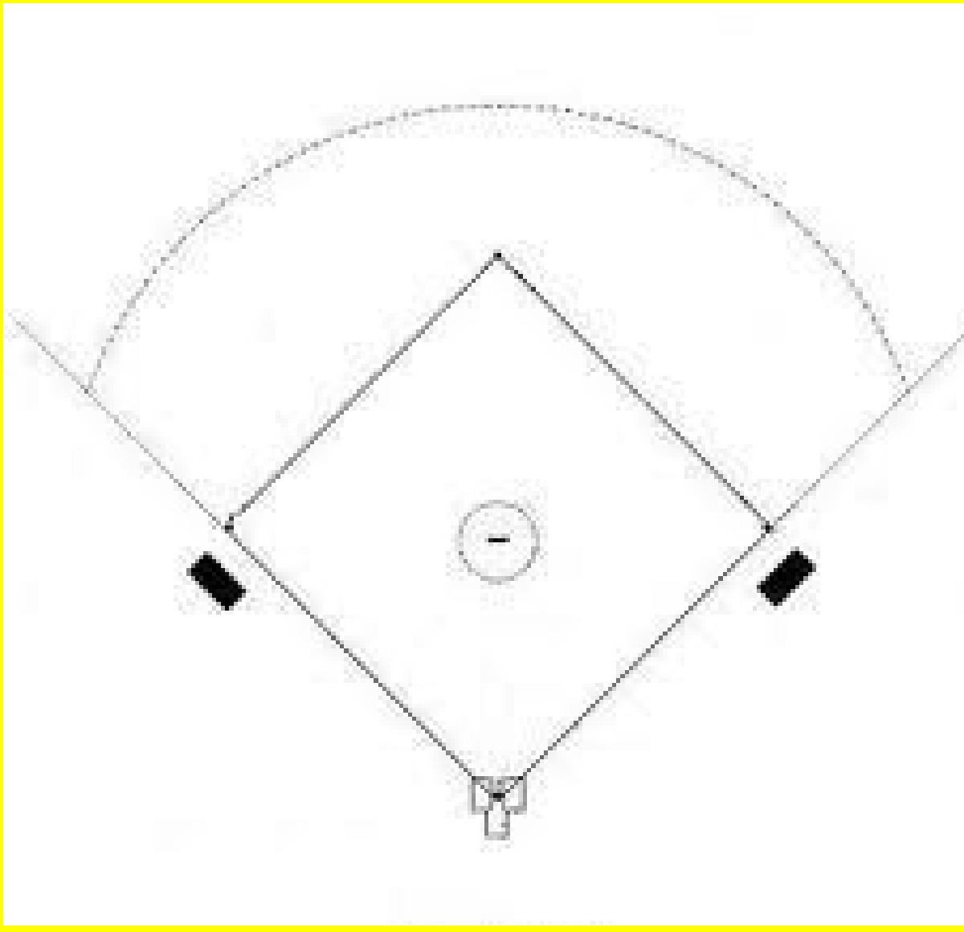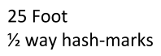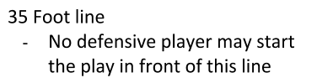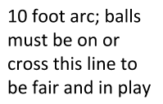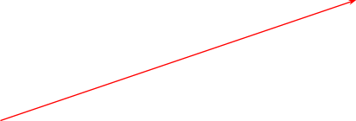

## A properly lined field appears as below (not drawn to scale):

The Pitcher must be on or directly behind the Pitcher’s Plate prior to the ball being struck.

Home Plate consists of a safety base placed with the peak of the pentagon facing the umpire and the opposing flat side facing the pitcher. Against the flat side of the safety base, the tee should be placed. The peak of the tee will face the pitcher while the flat side of the tee will meet with the flat side of the safety base.

The Home Team bats last and always occupies the Third Base dugout.

After the last game of the day/evening, it is the home team’s responsibility to drag the field. Necessary equipment will be available in the boxes.

Whittier: There will be a pathway in the outfield at Whittier allowing passage to the playground from the western sideline area. Batted balls crossing this line will remain in play and will not be declared dead nor will there be a "ground rule" enforced here. The designated crossing area will be intended solely to manage interfering spectator traffic at Whittier.

Please note: Spectators must be kept "out of play" at all times AT BOTH FIELDS to minimize interference. If a batted ball is interfered with by a spectator, the umpire will call the ball dead and the runners will advance to the base they are moving toward. Umpires will stop the game and remind spectators when needed.

Brooks: The turf field at Brooks has clearly marked foul lines. Spectators must sit outside the fences at this field.

## Equipment:

Coaches and players must treat league equipment with care and respect. Players must not throw bats or helmets. An Umpire may eject a player for intentionally throwing equipment.

All defensive players must take a mitt into the field. Leather mitts are strongly encouraged.

All Players in the “on-deck area” must wear helmets.

Batters and Base Runners must always begin an offensive play wearing a helmet.

The league and team will provide necessary bats and balls. Players may bring their own bat. The Umpire will not withhold permission to use a privately owned bat unless there is safety concern.

The Home Team provides the Game Ball and the Game Tee. The Visiting Team provides the On-Deck Tee.

Parents are encouraged to keep players hydrated by bringing water to all games, regardless of temperature. During sunny weather, parents are encouraged to use sunscreen on their players and bring tarps to shade the dugouts as needed.

## Uniforms:

All players are required to wear the current year league-issued shirt, shorts and visor during games. Both players and coaches are prohibited from wearing or displaying a Major League Baseball logo other than the Chicago White Sox. Any uniform alterations or modifications should be in good taste and done in a similar manner by all players on the team. In the event of inclement weather, players are allowed to wear pants under their shorts.

In case of inclement weather, a player can wear a jacket or sweatshirt over her shirt. If possible, the jacket or sweatshirt should be color-coordinated, so an offensive player can be identified on base.

Players may not wear any loose or hanging jewelry during games. Hair should be secured out of a player’s eyes for her own safety and the safety of other players.

All players must wear athletic-type shoes. Wearing sandals and going barefoot is prohibited. The Umpire will determine if any other type of footwear is acceptable based on a concern for safety. Players are not permitted to wear shoes with metal spikes or cleats.

## The Game:

Rule #1: Have fun!

Each team must field a minimum of 8 players for every inning. Failure to field 8 players, for any reason, results in an automatic forfeit.

A team shall forfeit the game if they are not prepared to field a team (of 8 or more players) by 10 minutes past the scheduled game time. When a team has less than 10 players, it is up to the coach of that team which positions are to be left vacant. Players arriving after the game has begun can be immediately placed in the field at one of the vacant positions if that team is in the field; all other players must remain in their current position. On offense, late arriving players should be placed at the end of the batting order (even if the team has not yet had a turn at bat).

If a player arrives late and her team in the field already has 10 players, that defensive inning will not count as an inning on the bench; additionally, that player is exempted from the 3 inning/two position rule mentioned below; however the coach is encouraged to provide that player with as much playing time in as many positions as possible.

Both teams should have an equal amount of time to warm-up on the infield before the game.

Five innings will be played. If a game is tied at the end of 5 innings, it’s a tie, except during playoffs. During playoffs, extra innings will be played until a winner is determined. After seven (7) innings, the team making the most number of “outs” will be declared the winner.

An inning is complete when 5 runs are scored or 3 defensive outs have been made. Before June 1, a new inning may not begin after 8 p.m.

If the Umpire postpones a game due to weather, field conditions, or darkness, the game will be resumed from the point where it was postponed unless the game is considered complete – 4 innings have been played or 3 1/2 if the home team is winning.

No coaches should be on the playing field during a play for any reason. All players must bat in a continuous batting order.

## All players must play a minimum of 2 defensive positions. Because we are an instructional league and want to encourage many girls to learn many positions, the Pitcher and 1st baseman, *cannot play 2 consecutive innings in the same position*, and no player may play 1st or Pitcher more than 2 total innings each per game, or three total innings combined (including extra inning playoff games). For example, one player may play two innings at 1st and one at P, but not two innings at both 1st and P. All players must play at least one infield position prior to the end of the 4th inning. Infield is defined as P, 1st, 2nd, 3rd, SS, or SC.

**Additionally, no player can be on the bench in consecutive defensive innings.**

Each player must play a minimum of 3 defensive innings each game (weather and time permitting). In cases where a team is mathematically eliminated before 5 innings have been played, coaches should complete 5 innings of play to maximize player development.

Failure to play 3 defensive innings and a minimum of 2 defensive positions in a 5-inning game may result in forfeit: the Rules and Competition Committee will review such circumstances upon appeal.

Once the first Batter has swung the bat in each inning, no defensive substitutions may be made except for injury.

Restroom substitutions are permitted but the restroom-breaking player must return to her position immediately upon returning from the restroom. Coaches are encouraged to remind players to “use it” before each game.

The Home Team’s scorekeeper must compare and confirm the score with the Visiting Team’s scorekeeper at the end of each inning.

## The Overthrow:

Because T-Ball is an instructional league, the number of bases awarded to Base Runners due to an overthrow is limited. See “The Base Runner.” To encourage a “play” at first base, an overthrow at first base will not award the runner second base unless the runner is already moving towards second base and

has reached the hash mark/half-way point between first and second base. Other base runners will be awarded the base they are moving towards as long as they have reached or have gone beyond the half-way hash mark between bases, which will be marked off prior to the game by the Umpire.

An “overthrow” is defined as a thrown ball that strikes the front dugout fence or passes beyond the imaginary, extended line of the front dugout fence beyond the first or third bases.

The Umpire may designate an “out of play” area before the beginning of the game. During the game, a ball thrown into these areas will be called “out of play.” For example, at Brooks field, a ball

thrown into the spectators’ area beyond first base or a ball thrown into the bushes on the sidelines would be called “out of play.”

## The play is over when…

* The ball is under the control of a Defensive Player within the Pitcher’s Circle and that defensive player is no longer attempting to make a play on a base runner. Inadvertently running through the circle with the ball to make a play will not stop the play. If the Defensive Player fumbles or the ball rolls away, she needs to gain control of the ball before it being called “dead.”
* The ball has been thrown out of play and Runners have advanced their maximum allowable number of bases.
* A defensive player has stopped the lead Runner and no other runners are advancing. The Umpire should call the play “dead.”
* Three outs or 5 runs have been scored in an inning.

## Foul Ball:

Per USSSA Rule 3 a foul ball is defined as a batted ball which:

* + Settles on foul territory between home and first base, or between home and third base.
  + Bounds past first or third base on or over foul territory.
  + First falls on foul territory beyond first or third base.
  + While on or over foul territory touches the person of an Umpire, a player or any object foreign to the natural ground or contacts the batter in the batter’s box.

Foul territory is that part of the playing field outside the foul lines and perpendicularly upwards. If a ball lands on the 1st or 3rd base chalk line, the ball is fair.

## The Pitcher:

Once the ball is placed on the Tee the Umpire announces, “Ball up,” or similar; the Pitcher should announce the start of a play by shouting “All set?” or similar, to the defensive players before the start of each “pitch.”

The Pitcher must then start the “pitch” with one foot on the Pitcher’s Plate. The other foot should be behind the plate. The Pitcher must be on or directly behind the Pitcher’s Plate prior to the ball being struck.

If the ball is struck prior to “the pitch” the Umpire will call “no pitch” and start the play over.

## The Fielders:

The Short Center Fielder must begin the play behind the baseline.

Outfielders must begin the play with their feet in the outfield grass. In the event the game is being played on an all-grass field, the outfielders should be a minimum of 10 feet (at the judgment of the Umpire) behind the baselines between 1st base and 2nd base, and between 2nd base and 3rd base.

All infielders must **not** position themselves in the baseline.

A fielder may not intentionally roll a ball to put out a runner at any base. If this occurs, the runner is awarded the base. Underhand tosses are permitted, but should primarily be used for close-range throws (less than 10 feet). Overhand throws are highly encouraged!

When receiving a throw at base, a fielder must provide the Base Runner a clear path to the base. If a 3rd out is made on any force out, a Runner heading toward Home does not score.

If a 3rd out is made in a situation that is not a force out and the Runner heading toward Home touches the plate before the out is made, then the Runner scores.

## The Batter:

The Batter must wear a helmet.

The Batter may be positioned in the Batter’s box by the Coach but may not be re-positioned until a subsequent swing. During Play-offs, coaches are not allowed to reposition the batter after the first swing.

The Batter must wait for the Pitcher’s “pitch” before swinging. The Batter cannot strike out.

If the Batter makes contact with a fairly batted ball on her way to First Base, she will be called “out.”

A batter may be forced-out or tagged out by any fielder, except that the pitcher cannot touch first base to force the batter out unless she is receiving a throw from another fielder. As an instructional league we should encourage throws in most circumstances. If the batter “rounds” First Base, any defensive player may tag the Batter-turned-Base-Runner out.

The Batter must turn right after passing First Base to be “out of play.” If the Batter-now-Runner turns toward second, in an attempt to advance to the next base, she will be considered “in play” and eligible to be tagged “out.”

## Thrown Bat:

If the Swinging Batter accidentally throws her bat, the Umpire will immediately issue one “Bench Warning” to the offending team. This will be the only warning to that entire team. Subsequent thrown bats by any member of **that** team will result in the batter being called “out”.

If a Batter from the opposing team throws a bat, the opposing team will receive a warning and the process will repeat itself.

If a Batter is called out for a thrown bat, the play shall be ruled dead. The Runners stay at their base. Any runners that advanced shall be returned to their previous base(s).

## The Base Runner:

No player may be touched by a base Coach at any time while the ball is “in play.” The ball is considered in play from the time it is placed on the tee until the umpire has declared the play “dead”. If a Coach touches a Base Runner when the ball is in play, the Runner will be called “out” due to Coach’s interference.

The Base Runner must begin each play wearing a helmet. The Base Runner cannot “steal” a base. “Lead-offs” are not permitted. The Runner will be called “out” if a “lead-off” is taken.

The Runner must be in contact with the base at the beginning of every play.

In the case of an "overthrow," the Runner receives the base she is moving toward if she has reached the hash mark/half-way point between bases when the ball is declared an overthrow/dead ball. As an instructional league and to encourage a "play" at first base, an overthrow at first base will not award the runner second base unless the runner is already moving towards second base and has reached or gone beyond the half-way point or has mark at the time when the dead ball/overthrow is called. Other base runners will be awarded the base they are moving towards and not receive the extra base.

For Example:

* + If she is retreating to a base, she is awarded the base to which she is retreating.
  + If she is stationary at a base, she remains on the base.
  + If she is moving toward the next base and has reached or gone beyond the half-way point or hash mark, she receives the base she is moving toward (unless there is already a runner at or awarded that base).

If a thrown ball strikes a Runner, the Umpire will call the play “dead” and the Runner is safely awarded the base to which she is advancing or retreating.

If a Base Runner is hit by a batted ball after the ball has passed any defensive infielder besides the Pitcher, or after the ball is touched by any fielder, she may advance without penalty; however, if the Base Runner is struck by a batted ball in front of all defensive infielders (besides Pitcher), she will be called out.

If a Batter is called out due to a thrown bat, the Runners stay at their base.

No base runner may pass another base runner at any time. If one does pass the other, the originally “trailing” runner will be called out. Base runners may legally have contact with one another but they may not pass.

Tagging up is allowed.

Per USSSA Rule 8, Sec. 6, Part G: Two runners may not occupy the same base simultaneously. The runner who first legally occupied the base shall be entitled to it, unless forced to advance. The other runner may be put out by being touched with the ball.

## The Umpire:

The Umpire is the ultimate authority on the field. All decisions by the Umpire are final. Once an umpire makes a call, it cannot be changed. The umpire should not be bullied into changing his/her call because s/he feels outnumbered or intimidated. If a coach disagrees with the call, s/he should demonstrate good sportsmanship and discuss the situation with the league president after the game.

The Umpire’s primary objective is to ensure the safety of all players, coaches and spectators. The Umpire’s secondary objective is to ensure a fair and evenly called game.

One Umpire will be at each Regular Season game. Two Umpires will be at all Playoff Games. The Home Plate Umpire’s decision is final except where the Home Plate Umpire defers to the Second Umpire.

## If the league president (LP) or board member receives a complaint regarding a member, manager, coach, player or parent’s behavior towards an Umpire, the LP will discuss the encounter with the Umpire and the person against whom the complaint was made. Depending on the situation, the LP may issue a warning to the member, manager, coach, player or parent. Additionally, depending on the nature and severity of the behavior or if a second complaint is made about the same person regarding behavior towards an umpire, the OPYBS Board reserves the right to suspend, discharge, or otherwise discipline the member, manager, coach, player or parent as provided in the OPYBS Bylaws.

For more information, please see the Oak Park Youth Baseball and Softball website: [www.opybs.org/](http://www.opybs.org/)