**2025 Season Fundraiser**

Dear Community Partner,

We’re reaching out on behalf of the Steamboat Skating Club (SSC) to ask for your support during our annual **Fundraiser**!

With the help of parents and board members, our dedicated skaters are working together to raise **$12,000** to support the Club—and we can’t do it without you.

Your donation plays a vital role in:

* Keeping skating affordable for all families
* Providing expert coaching and diverse training opportunities
* Supporting scholarships for skaters in need
* Covering essential equipment and facility costs

Skating fees cover only a portion of what’s needed to deliver a high-quality experience. Thanks to the generosity of donors like you, our skaters continue to grow—not just as athletes, but as confident, driven young individuals.

Your support enables us to continue sharing the joy and discipline of figure skating with local youth and our community.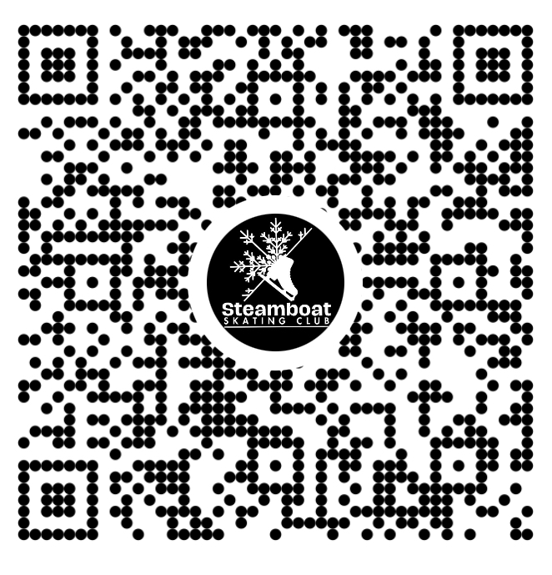

**Thank you for making a difference on and off the ice.**

The Steamboat Skating Club   
[info@steamboatskatingclub.org](mailto:info@steamboatskatingclub.org) • [*www.steamboatskatingclub.org*](http://www.steamboatskatingclub.org)

DONATION RECEIPT Date________________

Donor Name/Organization__________________________________________    
Donation Value $__________________   
(Check payable to: Steamboat Skating Club or Venmo @SteamboatSkatingClub)

*Mission: The Steamboat Skating Club is an inclusive organization that provides ice skaters of all ages, abilities, and ambitions the opportunity to develop personally, athletically, and artistically in a positive, fun, and supportive environment.*

*This is a receipt for monetary donations to the Steamboat Skating Club. No goods or services were received by the donor from the Steamboat Skating Club (TAX ID # 84-1286035). Thank you for your commitment to youth development through partnering with the Steamboat Skating Club*.