**2025-2026 FUNDRAISER**   
Collect donations and win prizes!  
Proceeds will benefit the Steamboat Skating Club, including programming, training, and scholarships.

**Skater Name:**__________________________________

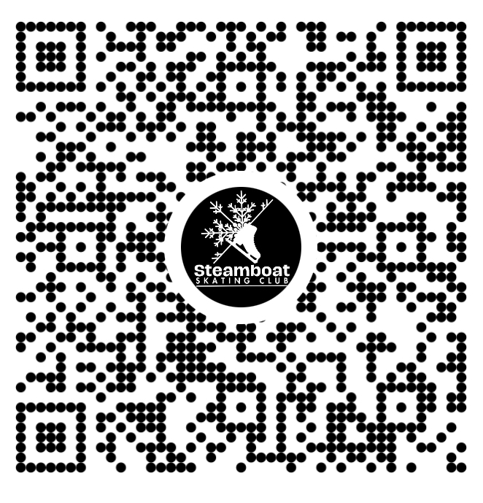

**Parent/Guardian Name & Phone Number:**______________________________________   
  
**Skater Fundraising Goal:**__________________

**All forms & money due by XXXXX  
100% skater participation = Pizza Party!**

| **DONOR NAME** | **PHONE #** | **DONATION AMOUNT** | **HOW THEY PAID Cash/Check # /Venmo** | **DATE MONEY IS COLLECTED** |
| --- | --- | --- | --- | --- |
|  |  |  |  |  |
|  |  |  |  |  |
|  |  |  |  |  |
|  |  |  |  |  |
|  |  |  |  |  |
|  |  |  |  |  |
|  |  |  |  |  |
|  |  |  |  |  |
|  |  |  |  |  |
|  |  |  |  |  |
|  |  |  |  |  |
|  |  |  |  |  |
|  |  |  |  |  |
|  |  |  |  |  |
|  |  |  |  |  |
|  |  |  |  |  |
|  |  |  |  |  |
|  |  |  |  |  |
|  |  |  |  |  |

**Questions? Email finance**[**@steamboatskatingclub.org**](mailto:info@steamboatskatingclub.org)

| **CLUB USE ONLY**  Total Donations: ______________ Total $ Received______________________  Prize Level: ___________________ Prizes Ordered? Y / N |
| --- |