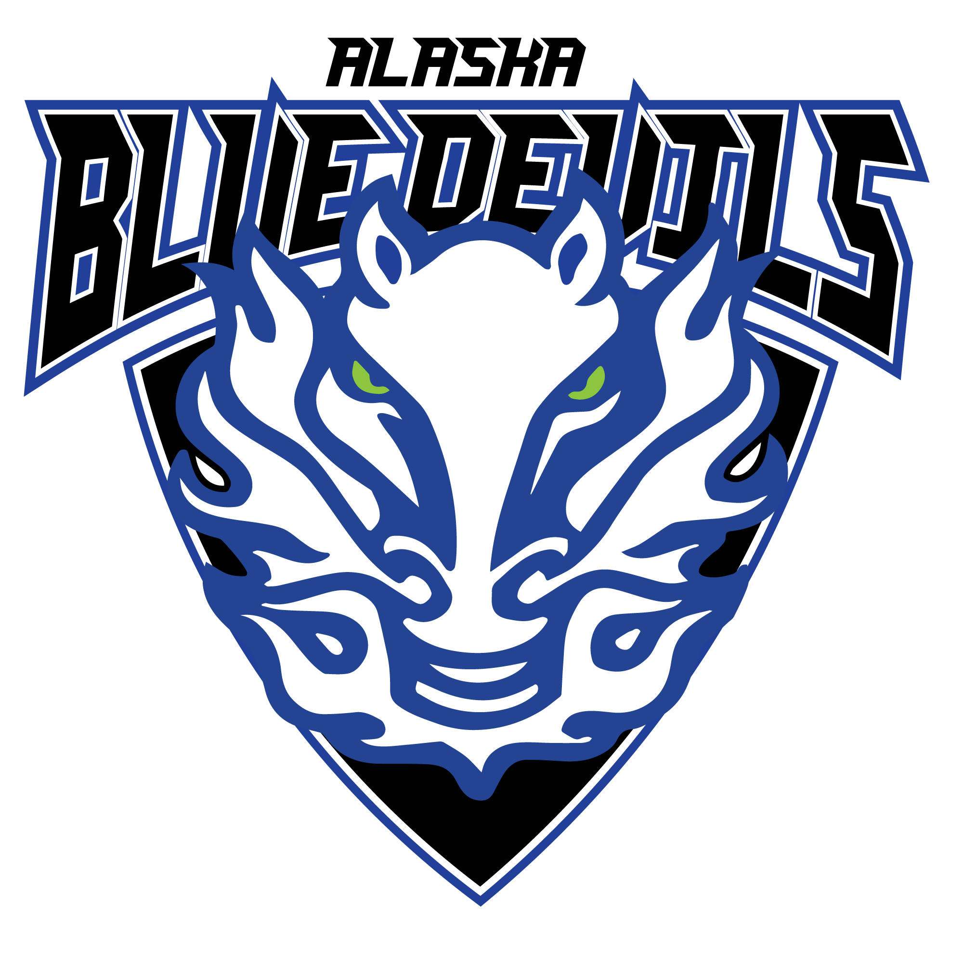

Mustang Hockey Association
P.O. Box 773904 ∙ Eagle River, Alaska 99577 ∙ (907) 691-4660

Dear Hockey Fan:

We hope you will consider being a Team Sponsor of the Mustang Hockey Association for our 2025-26 season. Mustang Hockey Association (MHA) is a volunteer non-profit organization that has provided Competition and Recreational team opportunities for the youth in our Eagle River, Chugiak, Anchorage, and the Valley areas since 1983. MHA relies on registration fees and fundraising to meet the financial obligation of our organization. By supporting MHA, you help us keep the fees affordable for all our members.

The House Recreational Program (Mustangs) emphasizes development and participation. The goal of this program is to teach the basic skills of hockey and develop each player to their maximum potential. The Competition Program (Alaska Blue Devils) is comprised of players and coaches with advanced skills who participate in competition play and travel. Competition teams rely on sponsors and parent support for funding.

If you would like to become a member of our Booster Club, please complete the following information and mail with your contribution to our address listed above. Thank you for your consideration.

Sincerely,
The MHA Board of Directors
-------------------------------------------------------------------------------------------------------------------------------------------------------------------------------------
Team I wish to sponsor: ______________________________________
Team Name and Division

________ Red Line Sponsor ($2,000+) Amount: _______
- Acknowledged on a hanging banner at the MAC.
- Featured on MHA’s main page that will include your business link & in tournament programs.
- Thank you, memorabilia, from MHA.

________ Blue Line Sponsor ($250 to $1,999) Amount: ________
- Recognized on the MHA web site & tournament programs.
- Thank you, memorabilia, from MHA.

________ Team Sponsor (Any amount up to $249) Amount: ________
- Thank you certificate from MHA (House) or Team (Comp)

_______ Player Sponsor, Player Name_________________________ Amount: ________
This is not a charitable donation. Player sponsorships are not tax deductible and do not qualify for the benefits listed.

Sponsor Contact Name: E-mail: __________________________________

Sponsor Company: ___________________________________________ Phone: _____________________

TAX ID # 92-0097188

