USA Referee Hockey Registration

Hello and welcome to USA Hockey Officiating!
Below you will see a link to a YouTube video that will walk you through the USA Hockey registration process. It is straight forward but a couple of notes before you start the process:
- To sign up for a USA Hockey Virtual seminar, you must be 12 years old. If you turn 12 later in the year, you will want to sign up for a seminar hosted in another state. Wisconsin has a cutoff of age 12 for working and will not allow anyone under age 12 to sign up for the “in-state” seminar (this is like prior years).
Here is a link to the USA Hockey registration process -
https://youtu.be/9MZBhNa99OM?si=5lLUTYwmpHNG2vNb

Watching the video will help you visually and the step-by-step process is as follows:

- Navigate to https://www.usahockey.com
- On the top menu bar, select “Become a Member” on the right side in the red box
- If your child is under the age of 18, you will need to complete this process for them
  - Select Register Now (Select I am over age 18)
  - Select Official/Referee
  - Click the check box agreeing to the “Independent Contractor” Rules (meaning that you work for yourself and not USA Hockey or your local hockey association)
  - Select Child Family Member (Under 18)
  - If you are returning, the next page is YES. If you are a new official, the next page is NO
If you have started the process prior BUT DID NOT COMPLETE IT, you are YES.
    - Fill out the necessary information on the next page
  - On the level selection screen – New Referees are Level 1. It is recommended that you continue to progress with your education and move up a level each year.
  - Continue through the screens, answering questions as necessary
  - New for 2025-2026, your WI Affiliate fee can now be included in your USA Hockey registration! There is no need to complete a second step after USA Hockey!
- If you are a brand new referee, there will be a video to watch - complete the registration by paying your USA Hockey referee fee and the WI affiliate fee of $12.
- You will get an email confirmation for the registration (this email will come from receipt) and a reminder to complete your SafeSport training if you are over the age of 17. If over the age of 18, you will also need to complete a background check.

- Scroll down half way in the email and there is a link that you will have to click on to set a password for your SSO (Single Sign On) – this is new this year! (https://lms.usahockeylearningcenter.com)

- The SSO username as at the top of that email. It will be a combination of your name and Official’s Number.
- Once your password is set up, you may need to navigate back to the Learning Center
  - Go to usahockey.com
  - Hover over Officials – Membership Education – Learning Center
- Click the picture halfway down the page – “Click Here to Enter the USA Hockey Learning Center”
- Select Member Login
- Enter in your username from the registration email that you received from USA Hockey and the password you created.
- Once loaded click on the center box marked officials
The next screen should look similar to this (Mine is an adult based profile – children will not have the boxes for Background Check OR SafeSport)
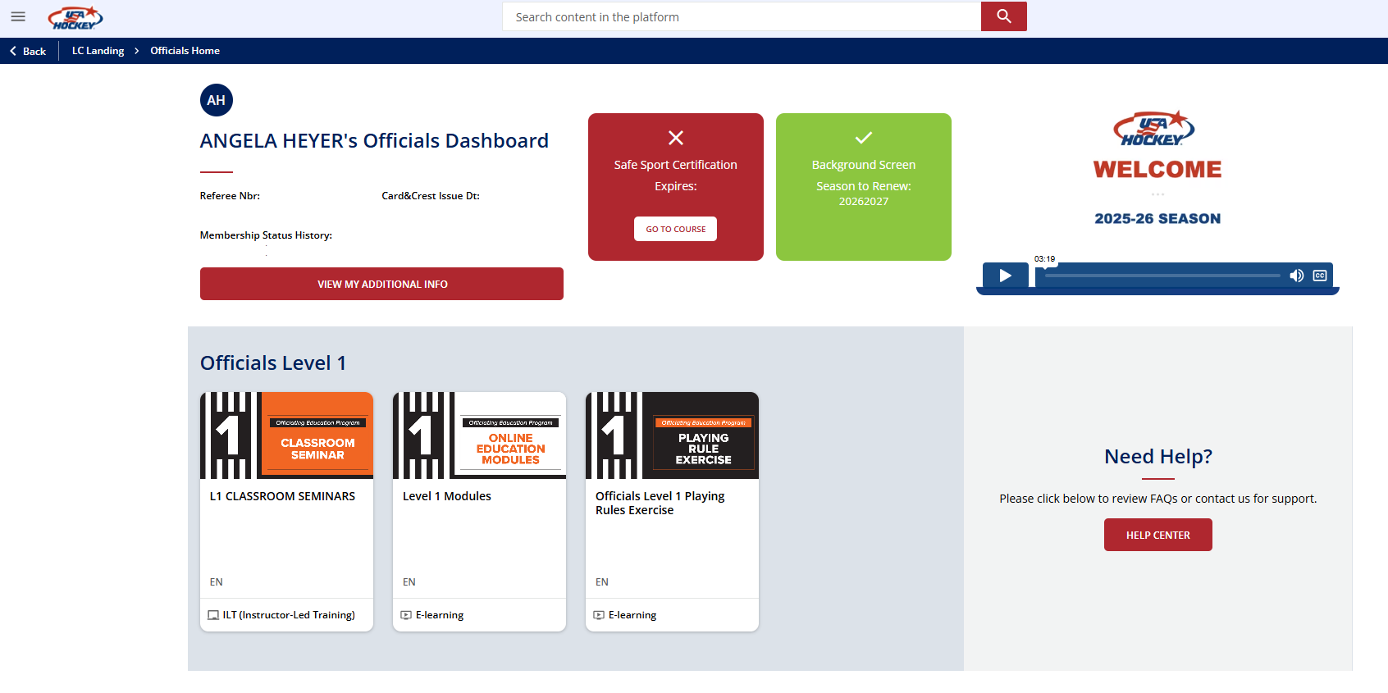
- Click on the Classroom Seminars to pick the Instructor Led Zoom training
- Once all three have been completed, you will receive a crest in the mail from USA Hockey (coming from Colorado)

Refereeing for SHAW:
Once you have completed all the steps outlined above, please reach out to me via email (see below) with the following information so I can add you to Assignr (this is an app on your phone & a website) where you will log in and request games:

Full Name
Birth Year
Email address that you want your notifications to go (it can be the same as an email you already use with another assoc. for Assignr)
Phone number

Once I receive your info, I will set up a profile and you should receive a new user email OR you will notice new access in Assignr

Please email me at the below address with any questions OR contact me via Assignr, if you currently have a profile.

officials@shawhockey.org

