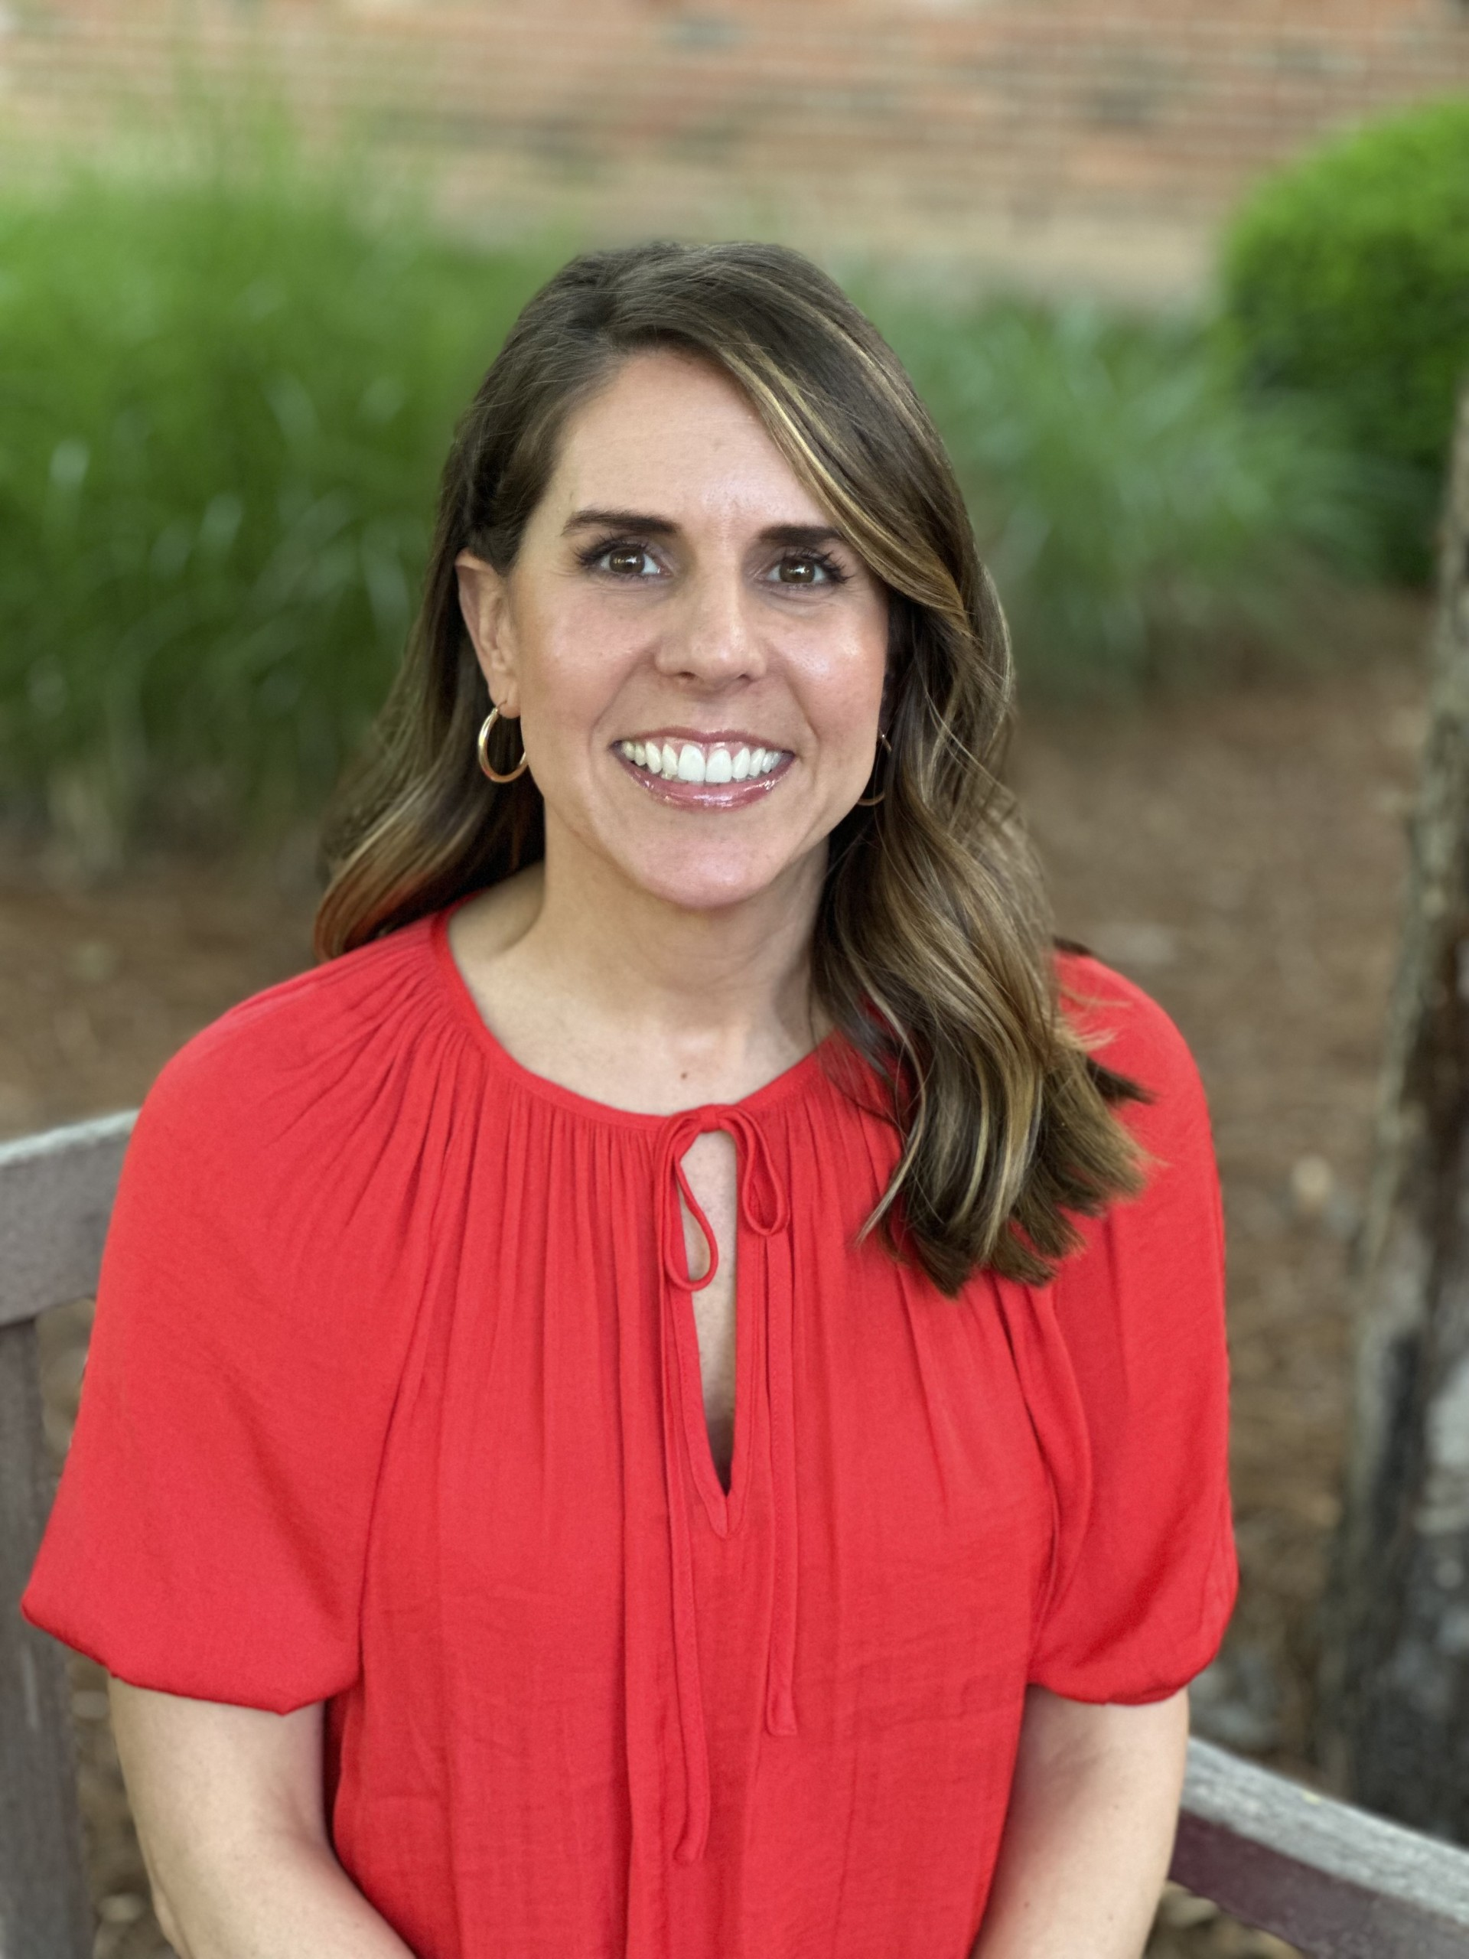

**12 Years Experience**

Coach

+Judge

+Event Partner

**11 Years Experience**

Coach

+ Former Competitor

+Volunteer

**5 Years Experience**

Coach

+Parent

+Volunteer

**Chris Allen**

Chris_Allen@brentwoodacademy.com

Director of Robotics

HS Coach

**Hank Roberson**

Hank_Roberson@brentwoodacademy.com

US Head Coach

**Linnea Wells**

Linnea_Wells@brentwoodacademy.com

HS Coach

Robotics Billing

IRHS Sponsor

**Meet the High School Coaches**2025-2026

2025-2026 Iron Eagles Handbook

**Contact Us:**

**robotics@brentwoodacademy.com**