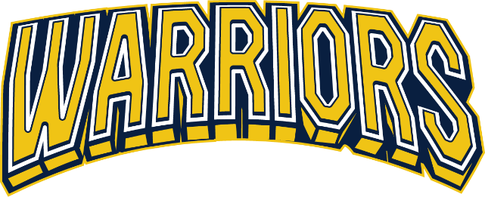

2025 – 2026 Arapahoe Youth Hockey League (AYHL)
Warriors Recreational Fall/Winter Programming Information and Fees
 | 10U  (2015 – 2016) | 12U  (2013-2014) | 14U  (2011 – 2012) | 18U  (2007 – 2010)
League Fees | $1,500 | $1,500 | $1,550 | $1,550
SSPRD Non-Resident (if applicable) | $30 | $30 | $30 | $30
Deposit | $500 + ($30 non-resident if applicable) | $500 + ($30 non-resident if applicable) | $500 + ($30 non-resident if applicable) | $500 + ($30 non-resident if applicable)
Payment Options | Full OR Deposit + payments | Full OR Deposit + payments | Full OR Deposit + payments | Full OR Deposit + payments
Payment Due Dates | $500-October 15th;  $500-November 15th | $500-October 15th;  $500-November 15th | $525-October 15th;  $525-November 15th | $525-October 15th;  $525-November 15th
Additional Season Fees (collected by Team Manager) | Estimated Team Fees: $400 - $600 for additional tournaments and team events | Estimated Team Fees: $400 - $600 for additional tournaments and team events | Estimated Team Fees: $400 - $600 for additional tournaments and team events | Estimated Team Fees: $400 - $600 for additional tournaments and team events
Weekly Practices* | 1 – shared ice; Tues, Wed, Thurs or Fri | 1 – shared ice; Tues, Wed, Thurs or Fri | 1 – shared ice; Tues, Wed, Thurs or Fri | 1 – shared ice; Mon, Tues, Thurs or Fri
Games | 16 games;  1 or 2 per weekend | 16 games;  1 or 2 per weekend | 16 games;  1 or 2per weekend | 16 games;  1 or 2per weekend
Skills & Drills | Bi-weekly - Mondays | Bi-weekly - Mondays | Bi-weekly - Mondays | -
Tournaments Included | Mile High Meltdown | Mile High Meltdown | Mile High Meltdown | Mile High Meltdown
Additional Tournaments | Max 2 In-State | Max 3 In-State | Max 3 In-State | Max 3 In-State
Registration Deadline | September 1 | August 25 | August 25 | August 25
Evaluation Dates** | Sept 15 & 17 | Sept 5 & Sept 6 | Sept 5 & Sept 6 | Sept 2 & Sept 4
Season Length*** | September – February | September – February | September – February | September - February
Equipment required | Full hockey gear | Full hockey gear | Full hockey gear | Full hockey gear
Sports Apparel Included | Reversible jersey, socks, helmet decals | Reversible jersey, socks, helmet decals | Reversible jersey, socks, helmet decals | Reversible jersey, socks, helmet decals

* Day and time slot will be determined once teams are formed
** Evaluation dates subject to change – will follow travel tryout dates
*** Consists of 2 seasons: Fall Season: September – October
Tiered season: November – February (tiering placements 10/27 – 11/2)

