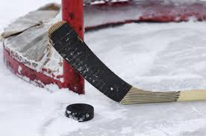

* USA HOCKEY REQUIRES PLAYERS SUSPECTED OF A CONCUSSION TO BE EVALUATED BY A QUALIFIED MEDICAL PROFESSIONAL AND SUBMIT A SIGNED RETURN TO PLAY FORM TO THEIR ORGANIZATION BEFORE RETURNING TO PLAY
* COACHES ALLOWING PLAYERS TO RETURN TO PLAY WITHOUT CLEARANCE WITHOUT A SIGNED FORM COULD BE SUBJECT TO DISCIPLINE AS OUTLINED BY SAFE SPORT
* COMPLETED FORMS SHOULD BE SENT TO **NEDPLAYERSAFETY@GMAIL.COM** WITH THE SUBJECT LINE CONCUSSION REPORTING FORM

|  |  |
| --- | --- |
| **CONCUSSION REPORTING FORM** | **CONCUSSION RECOGNITION TOOL** |
|  |  |

**MORE INFORMATION**

