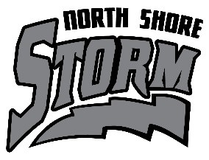**NORTH SHORE STORM**

**FALL HOCKEY REGISTRATION**

**Fall hockey sessions will focus on skill development by improving a player’s skating, puck handling, shooting and overall hockey sense through drills and exercises. These sessions are crucial for building a strong foundation in hockey and advancing to higher levels of play. DATES: Sundays in September– 7, 14, 21 & 28 and two Sundays in October– 5 & 12**

**LOCATION: SAHA, 1015 Oakes Ave, Superior, WI**

**COST: $75 for 6 one-hour sessions (checks payable to Two Harbors Youth Hockey Association) REGISTRATION DUE August 20, 2025 After August 20, 2025: $100**

**PLAYER NAME: __________________________________________________________________________**

**PLAYER LEVEL 2025-26 SEASON: __________________________________________________________ for Mite levels through Bantams**

**PARENT/GUARDIAN NAME: ___________________________________________________________**

**PARENT/GUARDIAN EMAIL: _____________________________________________________________**

**PARENT/GUARDIAN PHONE #: _________________________________________________________**

**Waiver: I will not hold THYHA, SBBLC, any staff or the facility and its employees responsible or liable for accident, injury or loss caused during attendance at North Shore Storm Fall Hockey sessions.**

**____________________________________________________________ Parent/Guardian Signature**

**NOTE: September 7th is tentative – SAHA has an ice floor repair to fix, but the arena should be up and running by**

**September 7th**