Mite Jamboree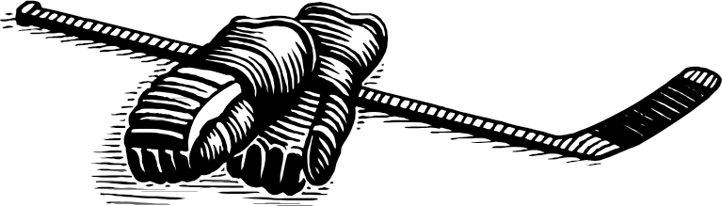
2026 Rules

Section One: General guidelines for the jamboree:
• The overall goal is to celebrate hockey and have fun!
• Each team will play a minimum of 4 games
• All games will be 25 minutes
• Scores will be kept for each game but not posted.
• Buzzer every 2 minutes for shift change
• 5 minute warm up between games
• After a goal the team that scored must skate back to touch their goal and the team that was scored on must start with the puck behind their net

Section Two: Teams
• Only registered players on team/association rosters may play.
• Unregistered players may NOT be used for any reason.
• A team should be composed of six to nine (6 - 9) skaters and one (1) goalie
• Teams must start the game with a minimum five players ie. 4 skaters and a goalie

Section Three: Rules of Play
• USA Hockey Rules will be followed except where amended below.
• All games will be NON-BODYCHECKING.
• Face-offs will occur only at the beginning of each game.
• When play is stopped due to the goalie controlling the puck, a whistle will signal the attacking players to vacate the zone. Once all the attackers have exited the zone, the players may re-enter to resume play immediately. They may not challenge the opposition until they have all exited the zone.

Section Four: Shifts
• Player shifts will be one 2 mintes in length. A buzzer will run to signal the end of each shift.
• Bench doors MUST remain closed until the sound of the buzzer.
• Once the buzzer sounds, players must relinquish control of the puck immediately and vacate the ice. The new players may enter onto the ice surface immediately.
• In the case of a shortened bench due to injury or ejection(s), at the sound of the buzzer all players must make contact with the bench boards; the double-shifted player(s) may then rejoin the action after having touched the bench boards

Section Five: Coaches, Managers
• Up to (3) three coaches, assistants or trainers may be on the benches. All bench personnel must rostered with the players and have proper CEP certification.
• Coaches are required to make every effort to ensure EQUAL ICE TIME for all
Jamboree participants and there is to be no shortening of the bench.
• Any bench personnel having been ejected from a game, for any reason, will be automatically suspended for a minimum 1 game and subject to further review for possible expulsion from the tournament. INAPPROPRIATE BEHAVIOUR, CONDUCT OR LANGUAGE WILL NOT BE TOLERATED!

