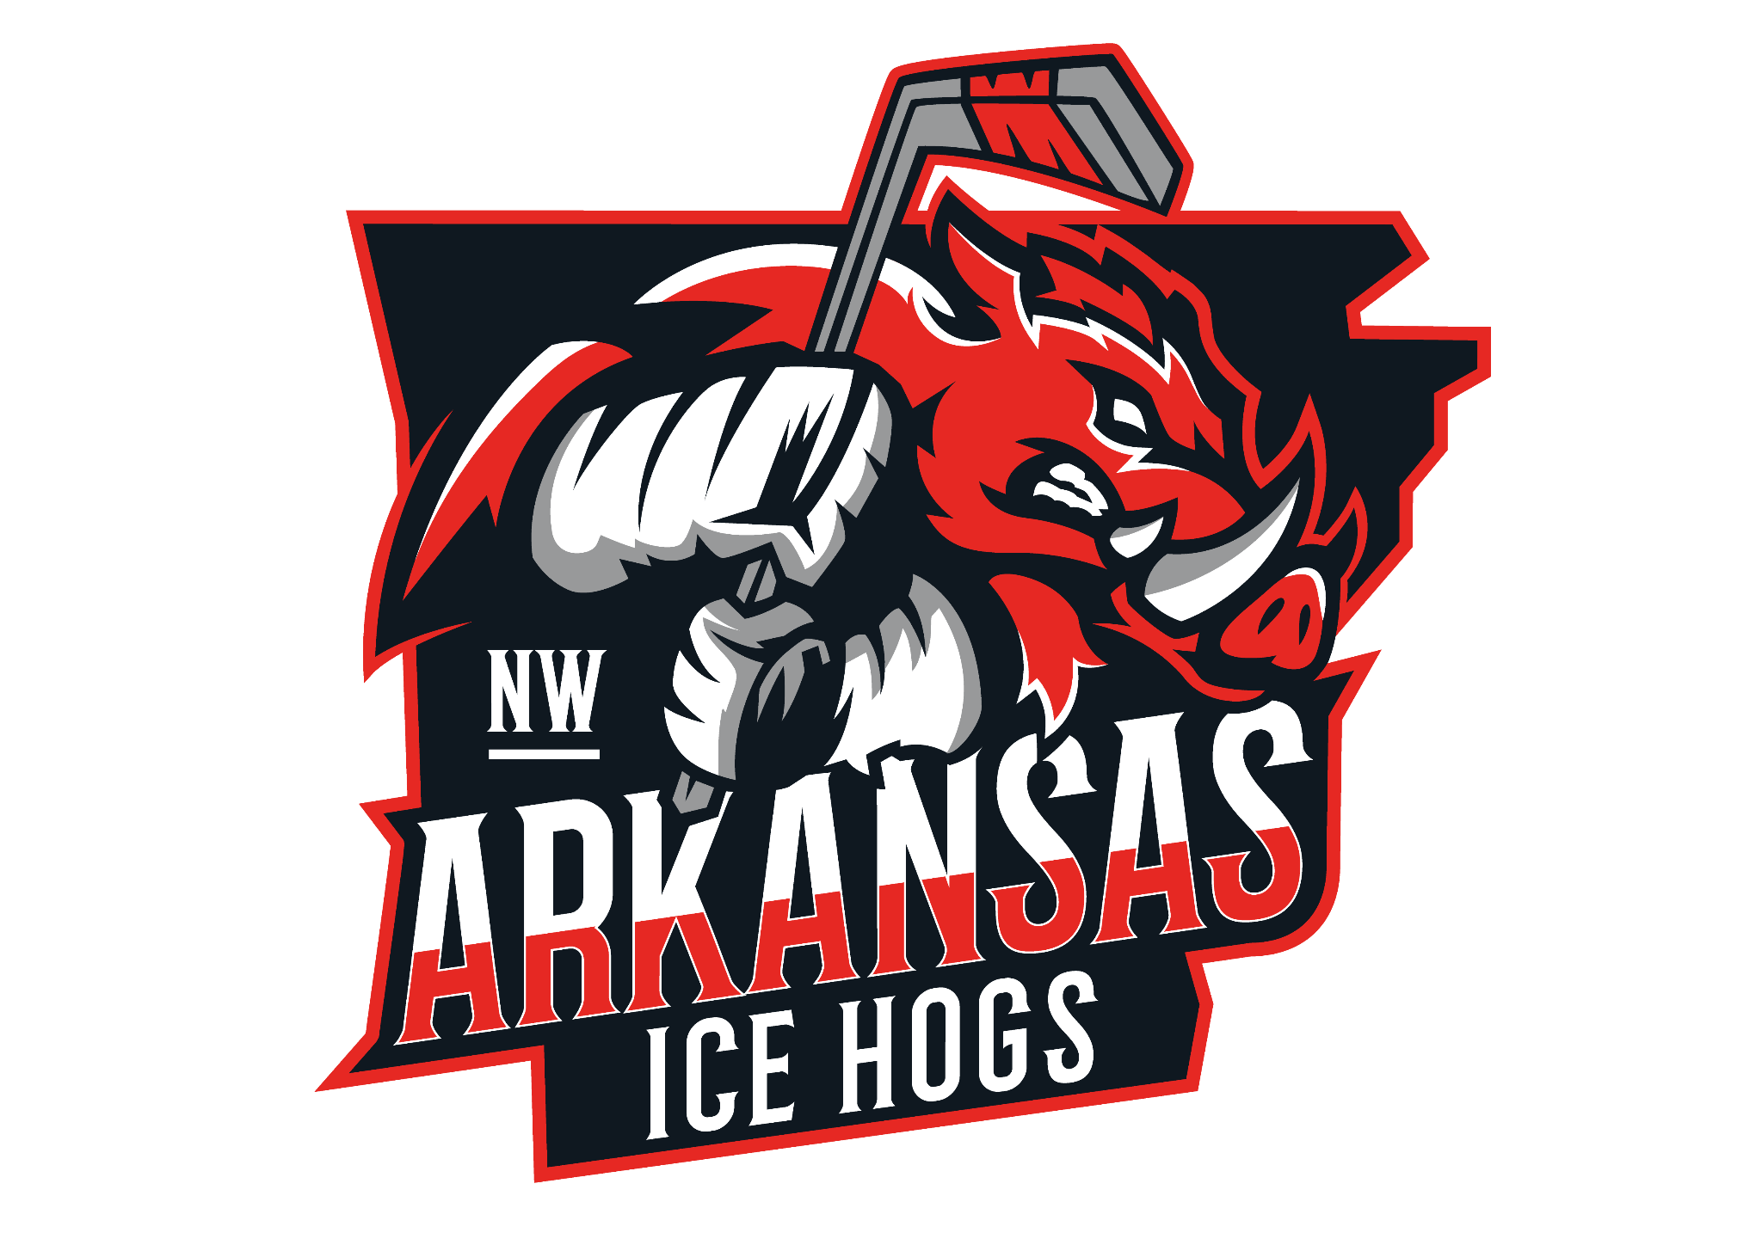**[Your Name]** [Your Title/Role]  
 [Youth Hockey Association Name]  
 [Address]  
 [City, State, ZIP Code]  
 [Email Address]  
 [Phone Number]

**[Date]**

**[Sponsor’s Name]** [Sponsor’s Title]  
 [Company Name]  
 [Company Address]  
 [City, State, ZIP Code]

Dear [Sponsor’s Name],

I hope this message finds you well. My name is [Your Name], and I am [your role, e.g., the Sponsorship Coordinator] for the Northwest Arkansas Hockey Association. We are a non-profit youth sports organization dedicated to promoting teamwork, discipline, and sportsmanship through the great game of hockey.

We are currently seeking sponsorship partners for our upcoming season and would be honored to partner with (sponsor). Your support would help provide essential resources such as ice time, uniforms, equipment, tournament fees, and coaching support—making hockey more accessible for all families, regardless of income.

With over 200 players ranging in age from 4-18 yrs old, our program reaches hundreds of families in the Northwest Arkansas area. As a sponsor, your company would be prominently recognized through various means.

We offer multiple sponsorship levels with varying benefits and visibility. Below, you’ll find a summary of our sponsorship opportunities.

Your support not only promotes youth athletics but helps shape confident, active, and responsible young individuals in our community.

I would love the opportunity to speak with you further about this partnership and how your business can make a meaningful impact. Please feel free to contact me directly at [phone number] or [email].

Thank you for considering this opportunity to support our young athletes. We look forward to possibly partnering with you for an exciting season ahead.

Warm regards,  
 **[Your Name]** [Your Title]  
 [Youth Hockey Association Name]  
 [Phone] | [Email]

[Website or Social Media Handle, if applicable]

**BRONZE** Sponsorship Package $500

The Bronze Sponsorship Package earns the sponsor promotion on our website and two social media posts per year, and recognition at community events and local tournaments.

**SILVER** Sponsorship Package $1000

The Silver Sponsorship Package earns the sponsor promotion on our website and four social media posts per year, and recognition at community events and local tournaments.

**GOLD** Sponsorship Package $2000

The Gold Sponsorship Package earns promotion on our website and 6 social media posts, recognition at community events and local tournaments, and your logo on the teams practice jerseys.

**PLATINUM** Sponsorship Package $5000

The Platinum Sponsorship Package earns the sponsor promotion on our website and 6-12 social media posts, recognition at community events and tournaments, and prominent placement of your company's logo on the team's practice jerseys.