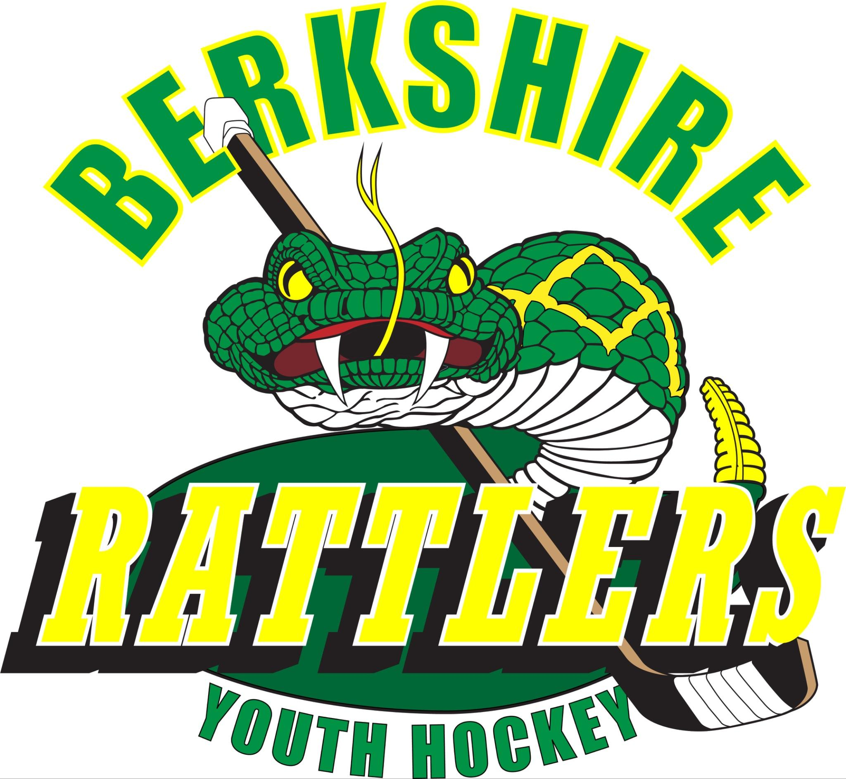

**Please support our event:**

The Jimmy Welch Memorial Tournament is the Rattlers organization’s major fundraiser. This year marks our 28th year of hosting this event, which will be held February 7-8, 2026. We are always so grateful to receive sponsors for the event.

**Platinum Sponsor** - $200+ - You will receive a full-page ad in our event program, your logo on all our event communications and print materials, and your logo on our website.

**Gold Sponsor** ‐ $150 - $199 – You will receive a full-page ad in our event program and your name will be included in our list of sponsors.

**Silver Sponsor** ‐ $100 - $149 – You will receive a half-page ad in our event program and your name will be included in our list of sponsors.

**Bronze Sponsor** ‐ $50 - $99 – Your name will be included in our list of sponsors in our event program.

Platinum, Gold, and Silver Sponsors:

Will you be submitting ad artwork for placement in our program? **Yes or No** (circle one)

If yes, please send your ad file to: JWT Committee at [jimmywelchtournament@gmail.com](mailto:jimmywelchtournament@gmail.com).

**Please send no later than January 18, 2026, so your generous contribution can be recognized in our program materials.**

Please make checks payable to: Berkshire Youth Hockey and mail to: 351 Salisbury Rd, Canaan, CT 06018

Name of Sponsor: ____________________________________ Sponsorship Amount: ___________________

Address: ______________________________________________________________________________________

City: __________________________________ State: ______________ Zip Code: _________________________

----------------------------------------------------------------------------------------------------------------------------------------------------------------

*Berkshire Youth Hockey is a tax-exempt organization under Section 501(c)(3) of the Internal Revenue Code (Federal Tax ID: 22-2474857). All gifts are tax deductible to the full extent of the law.*

The Berkshire Rattlers Youth Hockey thanks you for your support! [www.rattlersyouthhockey.com](http://www.rattlersyouthhockey.com)

**Please keep a copy of this form for your records.**