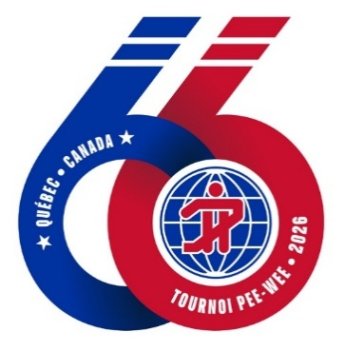


2013 Quebec Program Information Packet

Quebec International Pee-Wee Tournament February 12 -22, 2026

 | TABLE OF CONTENTS | PAGE
Quebec International Pee-Wee Tournament |  | 1
Introduction |  | 3
Registration Fees |  | 3
Practice Schedules |  | 4
Travel
BUS |  | 5
CAR |  | 6
AIR |  | 6
PASSPORTS |  | 6
Hotel
L’HOTEL QUEBEC in STE FOY |  | 7
ROOM RATES |  | 7
CHECK-IN/CHECK-OUT |  | 7
HOSPITALITY ROOM |  | 7
Billeting
BILLET ASSIGNMENTS |  | 8
FIRST NIGHT |  | 8
TIME WITH BILLETS |  | 8
GIFTS |  | 9
PLAYER TRANSPORTATION |  | 9
CASH |  | 9
CLOTHING |  | 9
ELECTRONICS |  | 9
Activities
TOURNAMENT GAMES |  | 10
EXHIBITION GAMES |  | 10
VALCARTIER SNOW PARK |  | 10
Player Dress Code |  | 10
Before We Leave
TRAVEL DOCUMENTS |  | 11
CURRENCY EXCHANGE |  | 11
COMMUNICATION |  | 11
INSURANCE |  | 11
Places of Interest
RESTAURANTS |  | 12
SIGHTSEEING |  | 12
Packing checklist
PLAYERS & PARENTS |  | 13
Forms
Parent Consent for Player To Travel with Team |  | 13
Junior Bruins Medical Waiver Form |  | 13
School Letter |  | 15
Consent for Travel with a Minor Child Form |  | 16

Introduction
Congratulations to your player for being selected to represent the Greater Boston Junior Bruins at the 66th Quebec International Pee-Wee Tournament, February 12-24th, 2026! This is a once-in-a-lifetime experience that your child will remember forever.

This document is intended to offer some general information about the tournament to help you plan for the trip, and we are happy to answer any questions you may have. However, we would like to state up front that the key to a successful Quebec experience is flexibility. Plans are subject to change based on many factors that are outside our control, and it makes things much easier and more fun when everyone is willing to go with the flow.

Fundraising Fees
Your team Fundraising fee of $4,000 a player includes the following:

- Bus transportation for players
- Player apparel
- Travel bags
- Billet parties
- Quebec Ramparts Game
- Souvenirs (team pins, player cards)
- Quebec Tournament games

- All exhibition games
- Special Quebec jersey and socks
- Team Jacket-Hat-Apparel
- Snowpark admission for players
- All meals for players while in Quebec
- All other Quebec expenses for players

Please note: Additional practices, exhibition games, and/or team activities along with other tournament information may be added

2012 Greater Boston Junior Bruins Peewee Major Team

Mondays |  | 8:00 – 8:50 pm | Reilly Memorial Rink
Tuesdays |  | 8:00 – 8:50 pm | Reilly Memorial Rink
Thursdays |  | 8:00 – 8:50 pm | Reilly Memorial Rink
Saturdays |  | TBD | TBD
Sundays |  | TBD | TBD
 |  | ADDITIONAL FULL ICE P | RACTICES WILL BE ADDED
 |  | THROUGHOT THE SEASON | AT BOTH REILLY RINK AND RL

Other Probable Tournaments
Boston Breakout, September 6th,2025
Jr. Bruins Veterans Day Tournament Weekend November 9-10 &11
Springfield Pics Fall Classic – Thanksgiving Weekend November, 28th ,2025
MLK CCM Tournment – MLK Weekend January 12TH, 2026

BUS Bus travel is mandatory for all players. We are scheduled to leave on Thursday, February 12th and will return Sunday, February 24th. Extra seats are available for $250 (round-trip only – Limited Space) on a first-come first-served basis. Parents, siblings, etc. will be able to ride on the bus (space is Limited-no standing room) to and from all games while in Quebec since the players will be transported by their billet families most of the time while we are there.

Each player is permitted to bring an “official” player travel bag (backpack), one player equipment bag, and one additional bag. Players will stow their travel bags in the overhead compartments on the bus. Sticks (2) should be taped together and put in the team stick bag, and they will be stowed under the bus.

Any parent who purchased an extra seat on bus is permitted to bring a travel bag they can stow in the overhead, and one additional bag to stow under the bus.

The bus typically has a DVD player. The Junior Bruins provide family-friendly movies that are appropriate for all ages. The bus will have Wi-Fi and outlets for charging your devices.

Snacks and drinks will be provided for players on the bus. Parents can bring food and drinks with you on the bus (no alcoholic beverages are permitted). The bus will stop once as we enter Vermont so players can stretch their legs and will also stop for lunch and refueling in Newport, VT. Players will eat at McDonalds.

After we cross the border and clear customs, we will head straight to our hotel in Ste Foy,
Quebec City.

When we arrive in Quebec around 4:00 pm, players must remain on the bus while the parents on the bus and Mrs. Cashman check in at the front desk. Parents will need to put a credit card on file for incidental charges.

After players and coaches unload the bus. They will go to the Videotron Center to register with the Tournament. Players will stop on the way back to hotel for their first team dinner in Quebec and return to the hotel to get ready to meet their billet families.

While in Quebec, please be on time for all bus departures; as long as we have all the players we are supposed to have, the bus will leave as scheduled. If you do not plan to take the bus, please let us know so we don’t worry about you. All schedule changes will be posted in the hospitality room the night before,

CAR Notify your car insurance company prior to departure that you will be travelling out of the country. Please note that the tournament is held during the Quebec Winter Carnaval and there will be a parade in downtown Quebec on Saturday, February 14 starting at 7:00 pm. Don’t forget to bring plenty of windshield washer fluid that is appropriate for very low temperatures.

AIR People who prefer to arrive by air can fly into Jean Lesage International Airport (YQB), which is a smaller airport with relatively limited service. Another option is to fly into Pierre Elliott Trudeau International Airport in Montreal (YUL) and drive the three hours from Montreal to Quebec City.

PASSPORTS Please note that signed passports are mandatory for all adults. Children 16 or younger travelling to Quebec by bus or car may enter with an original birth certificate. Passports should have six months’ remaining validity, so if your passport expires after August 13,2025, you should renew it before leaving for Quebec.

Hotel
We will stay at the L’Hôtel Québec in Ste Foy. It is mandatory for all families to stay at this hotel per tournament rules. We have arranged a group rate and blocked rooms for all our families. All reservations must be made through the Junior Bruins team as part of the group. In order to receive the reduced room rate, we need a credit card to hold rooms for ten nights from February 12th through Saturday, February 21st. Additional rooms can be reserved with the same or different arrival and departure dates, but they must be booked well in advance and also with the team, because the hotel does book up. Our contract with the hotel stipulates that room reservations can be cancelled up to 2 weeks prior to arrival.

ROOM RATES While we have not yet finalized the 2025 rates with the hotel, we are including the 2024 standard room pricing for planning purposes.

Room Nights * | Rate per Stay CAD ** | Rate per Night CAD ** | Approx. Rate per Stay USD***
10 | $1,500.00 | $150.00 | $1104.00

CHECK-IN/CHECK-OUT Check-in time is 3:00 pm. While every effort is made to accommodate early arrivals, rooms may not be immediately available before that time. Check-out time is 12:00 noon. Please ask at the front desk for a late departure time (note that late check-out fees may apply).

HOSPITALITY ROOM The Junior Bruins Team will set up a hospitality room in the hotel. In the hospitality room you will be able to get tea, coffee and juice in the mornings along with bagels, toast, english muffins and cereal. The room will become the center of activity for the team for the ten days we spend in Quebec with lunch being served a few days. We ask that all parents help in keeping the room clean at all times. Please remember that young siblings should be supervised while in the hospitality room at all times. All children are expected to be out of the Hospitality room and in their own rooms by 10:00PM.
Billeting
While in Quebec, the players will not stay at the hotel with their families. Without exception, it is mandatory for all players to billet with a host family that have been selected and screened by the Quebec International Pee-Wee Tournament. These families will treat your child as if they were their own, feeding them, doing their laundry, and occasionally transporting them to and from team activities. It is always a dramatic scene when we board the bus to return home, with most billets in tears. We are lucky to have a number of families who billet with us year after year. Billeting is a wonderful opportunity for our players to learn about another language and culture while forming long-lasting friendships. Many families stay in touch with their billets and even invite them to their home for visits.

We are sensitive to the fact that billeting is difficult for many parents and players, and we know that parents can sometimes feel frustrated that they do not have time to enjoy Quebec alone with their children. However, the expectation is that the billets will be the players’ primary caregivers while in Quebec. Players will eat breakfast with their billet families and will return to the billets’ homes at the conclusion of team activities every night. They will eat lunch and dinner with team. We will not allow any exceptions for any reasons at all. Parents and players must treat the billet families with consideration, courtesy, and respect, and anything less than this will not be tolerated.

In order for things to run smoothly, parents must trust the staff and the process that we have refined over the last twenty plus years. Team manager and coaches are responsible for knowing the whereabouts, schedules, and transportation needs of every player, and parents must allow the staff to fulfill this responsibility without interference. Billet families will notify the team manager and/or billet captain before they leave any team activity with their players.

BILLET ASSIGNMENTS Players will billet in pairs, and they are permitted to select their billet team partners. When we get our list of billets around December 18th, we will give you the contact information for your family so you can communicate with them prior to your arrival. If your child is on a special diet, requires medication, allergies or has any other needs, please let us know in advance so we can plan accordingly

FIRST NIGHT On the night we arrive in Quebec, we will all meet with the billet families in the 2nd floor foyer around 7:30 pm. Players should bring their belongings to this meeting because they will go home with the billet families directly. Depending on our arrival time you may feel a little rushed, but please be flexible. These families have been waiting for months for your child to arrive and they will be excited to show them their homes!

TIME WITH BILLETS Either Friday or Saturday night (depending on tournament schedule) we will host a reception (meet-and-greet) in the ballroom of the hotel,note (1). You will also have other opportunities to interact with your billets and there may be another group dinner planned. In addition, most billets join the team at games and other activities while in Quebec. Families often take their billet families out for dinner during the tournament, or the billets may invite the families to their homes.
This is a great chance to get to know them better. We just ask that you take the team’s agenda into consideration when planning these get-togethers.

GIFTS It is customary for families to give their billets a thank-you gift for hosting their players and billeting pairs are encouraged to chip in together to purchase something special. The gift can be as big or small as you would like. The team also provides the billets with a team gift. Billet families love getting team apparel that they can wear to the tournament, or you can bring something that represents your home area or a gift for their children. Some families prefer to wait until they arrive in Quebec and purchase a gift certificate to a local restaurant for the billets to use later.

PLAYER TRANSPORTATION Each morning the bus will leave to pick up the players at the Capital Mall parking lot. Most billets take time off from work during the tournament, but some billets are unable to do so. In those cases, they may ask another billet family to take their players to the drop off area. The bus will then return to hotel or leave directly form the drop off area for the AM destination (see schedules)

CASH We recommend that you give your player about $0 CAD to start with. Please do not send your child to the billet’s home with a lot of cash; rather, you should replenish their cash supply daily as needed. There is really no need for players to have cash.

CLOTHING It is best for you to send all of your child’s belongings with them to the billet’s home the first night to avoid confusion or forgotten items. Players may want to bring their stick, gloves, helmet, and skates in case they want to play pond hockey; you should check with coach. You may want to bring an old pair of skates for pond hockey so your player’s game skates are not damaged.

ELECTRONICS Your child is permitted to bring their cell phone to the billet’s home provided they use it responsibly. However, we ask that players not bring any video games, headphones, etc. to the billet’s house. The players are there to interact with their host families and learn about Quebec culture, which obviously cannot happen when they are wearing their earbuds and checking Snapchat.

NOTE 1
Junior Bruins Peewee Major Parents host the reception for the Billet Families. This will be talked about more as the season goes on with a few mothers meetings .

TOURNAMENT GAMES We will notify you of the day and time of our first game and the options for our second game as soon as we receive that information. The Quebec tournament has a two-game guarantee; after the first game teams go into the winners’ bracket or the losers’ bracket, and from then on every game is an elimination game.

The first game will be played at the Centre Videotron, home of the Quebec Ramparts of the Quebec Major Junior Hockey League. All winner’s bracket games are played at the Videotron; loser’s bracket games are played at the Pavillion de la Jeunesse (near the Videotron) until the finals.

Admission to the tournament is $8/day CAD for adults and $2/day CAD for children under 14. Alternatively, you can purchase a tournament pass for $60 CAD. Depending on team fundraising these passes may be purchased by the team.

EXHIBITION GAMES We will schedule a number of exhibition games, and the team will play almost every day while we are in Quebec. We try to create a diverse exhibition schedule and play teams from around the world at a number of different rinks.

VALCARTIER SNOW PARK Once we receive our game schedule we will add the snow park to our itinerary. This is always a favorite activity, and a chance for players and families to bond and meet other teams. Players admission to the park will be paid by the team. Snow Park tickets cost about $25 CAD, and all family members and billets are invited to participate. Tickets will be purchased upon arrival, and if you prefer not to engage in snow play there are restaurants, a bar, and shops to keep you busy. It is also the location of the Ice Hotel which has become a favorite visit for parents in past years.

Participants will want to wear long underwear, snow pants, snow boots, gloves, jackets, hats, and a scarf and/or ski mask. You may want to bring an extra hat and pair of gloves as well.

Player Dress Code

- Players must wear the team outfit on the bus to and from Quebec.
- Players must wear their team jackets and hats to all team events.
- Players must wear khaki pants, shirt & tie, and boots or shoes (no sneakers) to all tournament games. They should bring sneakers and off-ice warmup clothing with them.
- During games, players will wear their Quebec team jerseys and matching socks. We do not expect anyone to go out and purchase any new equipment but given a choice we prefer for players to wear a black helmet and black pants or a black shell.
- Players are expected to carry their equipment in the team equipment bags provided to them.
- Players should use their team travel bag to carry their belongings to Quebec and to their billet families’ homes.

TRAVEL DOCUMENTS Players will need a valid passport or an original birth certificate with a raised seal. These documents are due first week in January 2026. The team will have players and parents sign notarized letters before we leave.
Parents, please note that a child travelling without one or both parents/guardians must have a notarized letter from the absent parent(s) giving permission to take the child out of the country.
Sample letters are included at the end of this packet.

CURRENCY EXCHANGE You will not need any CAD before arriving at the hotel, so you should plan to get your cash from an ATM upon arrival in order to receive the best exchange rate. Notify your bank that you will be using your credit card(s) in Canada, and check to see if there will be a fee assessed for any credit card purchases made. The bus will stop at the Duty-Free shop on the way home so you will be able to change your leftover CAD back into USD.

COMMUNICATION In order to avoid high international charges, contact your wireless provider prior to our departure to adjust your plan for all family members who are travelling with the team.

INSURANCE Check with your insurance carrier to see if you have coverage abroad. If not, you may want to consider purchasing international travel medical insurance.

L’Hôtel Québec - 3115, avenue des Hotels Quebec City (Quebec) G1W 3Z6
Telephone Numbers Main Line: (418) 658-5120

Centre Videotron & Pavillion de la Jeunesse - 250 Wilfrid-Hamel Blvd, Quebec, QC Valcartier Snow Park - 1860 Boulevard Valcartier, Saint-Gabriel-de-Valcartier, QC
RESTAURANTS Many good restaurants are within walking distance or a short cab ride of the hotel.
We recommend that you make advance reservations for dinner on Saturday, since the city will be full of hungry parade-goers that night. A few of our favorites include:

- Restaurant Parmesan – Traditional Italian food, lots of memorabilia, live entertainment.
38 rue Saint-Louis, Quebec City +1 418-692-0341
- Baton Rouge – American, Steakhouse, Bar, Canadian, Grill
2450 Boulevard Laurier, Ste-Foy +1 418-651-7878
- La Bte Bar Steakhouse – Steak, Barbecue
2875 Laurier Boul Ste 170, Quebec +1 418-266-1717
- La Cage - Brasserie Sportive – Bar, Pub, Canadian.
700 Laurier Boul, Quebec City +1 418-653-7000
- St-Hubert – Chicken Shop, Chicken Wings Delivery
2905 Laurier Boul, Quebec QC +1 418-650-1234
- Normandin Place de la Cite - Pizza, Canadian
2600 Boulevard Laurier Place de la Cité, Quebec City +1 418-656-6563
- Subway (many locations) – Breakfast, Lunch, Dinner
2450 Boul. Laurier F28 Place Ste-Foy, Quebec City +1 418- 6922013
- McDonald's – Fast Food
2600 Boul. Laurier, Quebec City +1 418-650-6236

SIGHTSEEING We will arrive in Quebec in time to experience the last few days of Carnaval, Quebec City’s winter celebration. The highlight of the festival is Saturday’s Night Parade, which will travel down the Grande Allee starting at 7:00 pm. During the day, you can visit the fairgrounds on the Plaines d’Abraham or tour Bonhomme’s Ice Palace. Other points of interest include:

- Old Quebec – Take the funicular from the Haute-Ville to the Basse-Ville
- Le Chateau Frontenac
- Hotel de Glace
- Musee National des Beaux-Arts
- Place Royale
- Musee de la Civilisation
- Hotel du Parlement & Parliament Hill

PLAYERS
Equipment & Sticks Snow boots, (waterproof)
Home & Away Jersey & socks Warm Layers (sweatshirts)
Khaki, button down shirts & tie Toiletries & Medications
Boots (waterproof) Charger
Off-Ice warm-up clothes HOMEWORK
Sneakers (to be worn inside only) Long underwear
Gloves – ski mask Ski/Snow pants

PARENTS
Everything the boys need except equipment. Parents and sibling should bring skates and their own hockey equipment for outdoor skating.

Please Note:
- Uggs are not good footwear for the slushy and slippery sidewalks of Quebec.
- Remember that you will be bundled up most of the time, so no one will know if you’ve worn the same outfit more than once.
- You will be constantly moving between the freezing, wet outdoors and the hot, dry indoors so make sure you layer!

2025 - 2026

To Whom It May Concern:

I, ________________________________do hereby authorize the Greater Boston Junior Bruins,
Coach Michael Cashman, or his designees, to bring my son ______________________________
for any necessary medical treatment during his visit to Quebec City for the Pee Wee
International Hockey Tournament February 13 ‐ 23, 2025, and for any other sanctioned USA
Hockey event.

_______________________________________________ ___________________
Parent Signature Date

October 1, 2025

Dear Administrators & Teachers,

Hopefully by now you know that one of your students has been chosen to play on the Greater Boston PeeWee Major Junior Bruins Hockey Team. This team is very special and rich in tradition in that it will be traveling to Quebec City, Canada in February for ten days to play in the 66th International PeeWee Hockey Tournament which is comparable to the Little League World Series, playing teams from all around the world. This Junior Bruins team was the first team invited from the United States to play in this tournament and it has been traveling to Quebec each year for over sixty years. We will be leaving for Quebec on February 12th and returning on February 24th.

We realize that the boys will be missing a substantial amount of school, but this trip is one that they will never forget. Yes, they will be playing a hockey game each day, but they also will be experiencing what it is like to live with a French speaking family for ten days. Also, each day we will be experiencing what Quebec City has to offer; visiting historical sites in Quebec and the surrounding areas. We will visit the Parliament building where they will learn how the government of Quebec functions; we will take a riding and walking tour of Old Quebec, learning about the Plains of Abraham, the fortifications of Quebec City and its founding fathers; we will go dog sledding which is unbelievable experience; we will visit the Basilica of Ste. Anne de Beaupre; they will experience Winter Carnival with its ice sculptures and ice castle; visit an old bread bakery; tour a Huron
Indian reservation and much, much more.

The boys will also be keeping a daily journal and each day a period of time will be set aside to read and do some schoolwork. My wife, Carol, is a retired teacher and will be available to the boys if they need supervision. Most players will have the week of February vacation when they return home to get caught up on their work. We will of course have access to the internet so players can be in contact with their teachers. Some players in the past have been asked to prepare special reports or power point presentations about their experience in Quebec. We hope that their teachers will give them the assignments that they will be missing and that they will not be penalized for making this trip. It truly is an experience that they will never forget. Alumni
from the team still send donations to the boys with little notes telling them about their experience when they traveled to Quebec many years ago.

If you have any questions or concerns regarding the trip or if you have any suggestions (school related – facts sheets etc.) that you would like us to address, please email me at jrbruin1960@gmail.com.

Sincerely,
Michael A, Cashman

Michael Cashman
Director
Greater Boston Junior Bruins

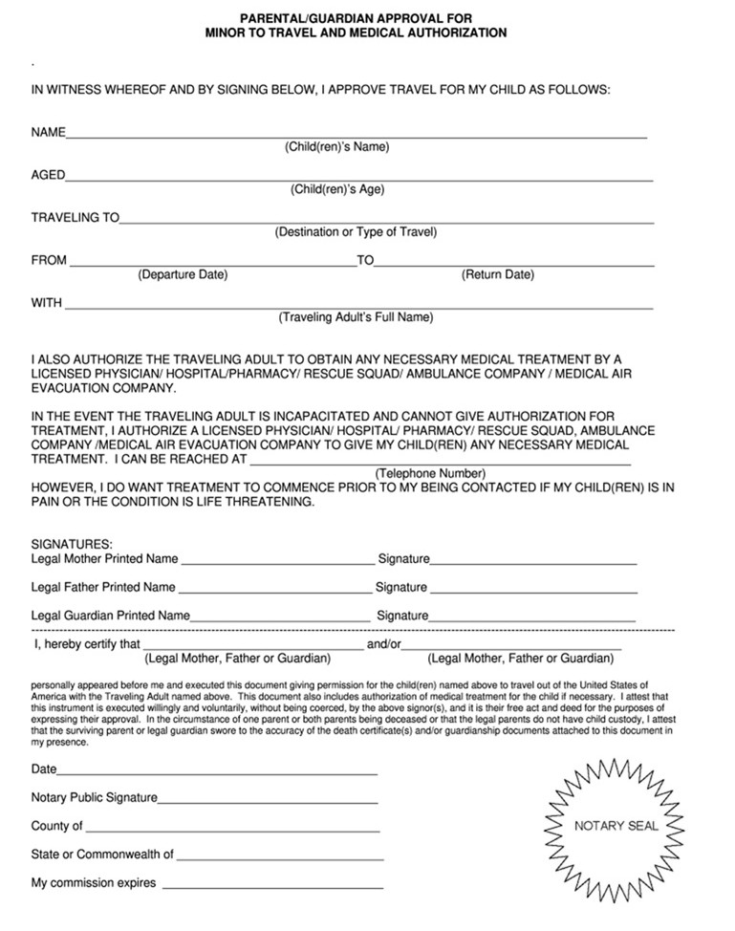

NOTES

IMPORTANT DATES

August 11th Practice begins.

September 6th AAA Boston Breakout

October 6th Junior Bruins Golf Tournament

November 9th-11thVeteran’s Weekend Tournament

November 21st Peewee Major $10,000 Drawing

November 28th- November 30th Springfield Pics Tournament

December 20th Team Christmas party (Corrib Pub & Restaurant)

January 16th- 18th MLK Freeze

February 12th- 22^{2nd} QUEBEC CITY

March 9th E9/BHL Playoffs

