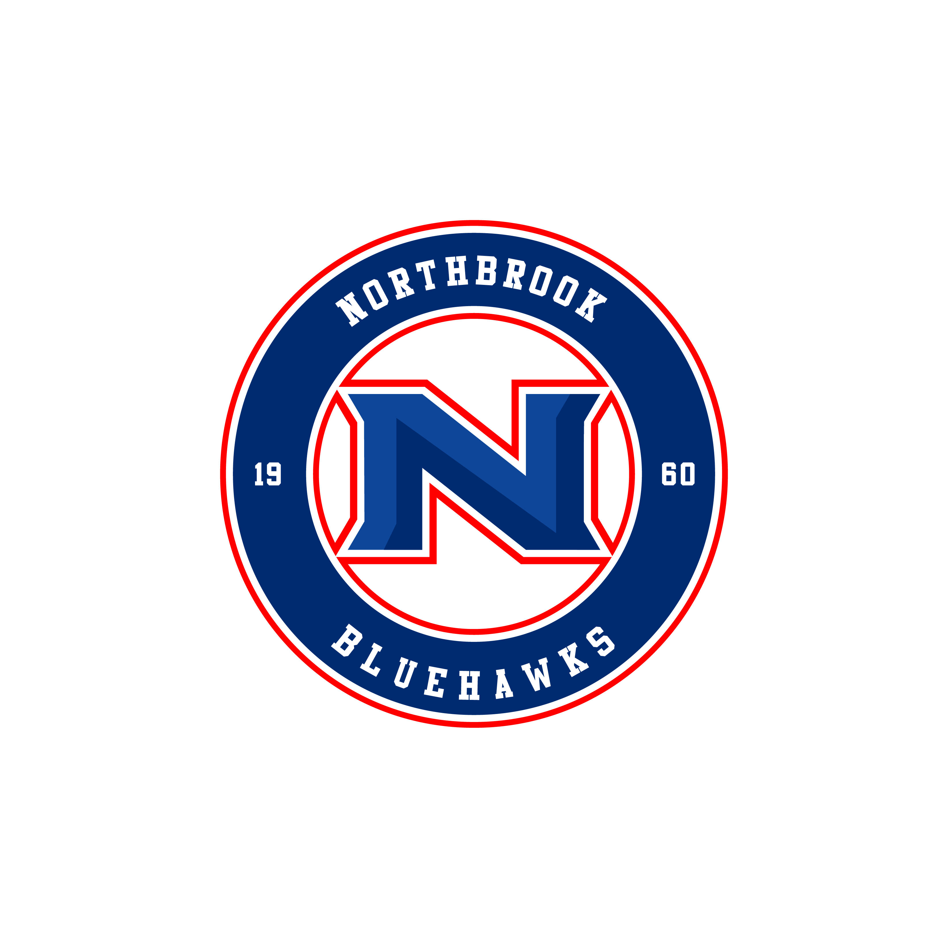  Northbrook Bluehawks  PW AA  Goalies  Skaters  Coaches  Head:  (Head Coach Ph)  Asst: | Northbrook Bluehawks  PW AA  Goalies  Skaters  Coaches  Head:  (Head Coach Ph)  Asst: | Northbrook Bluehawks  PW AA  Goalies  Skaters  Coaches  Head:  (Head Coach Ph)  Asst: | Northbrook Bluehawks  PW AA  Goalies  Skaters  Coaches  Head:  (Head Coach Ph)  Asst: | Northbrook Bluehawks  PW AA  Goalies  Skaters  Coaches  Head:  (Head Coach Ph)  Asst:
Northbrook Bluehawks  PW AA  Goalies  Skaters  Coaches  Head:  (Head Coach Ph)  Asst: | Northbrook Bluehawks  PW AA  Goalies  Skaters  Coaches  Head:  (Head Coach Ph)  Asst: | Northbrook Bluehawks  PW AA  Goalies  Skaters  Coaches  Head:  (Head Coach Ph)  Asst: | Northbrook Bluehawks  PW AA  Goalies  Skaters  Coaches  Head:  (Head Coach Ph)  Asst: | Northbrook Bluehawks  PW AA  Goalies  Skaters  Coaches  Head:  (Head Coach Ph)  Asst:

