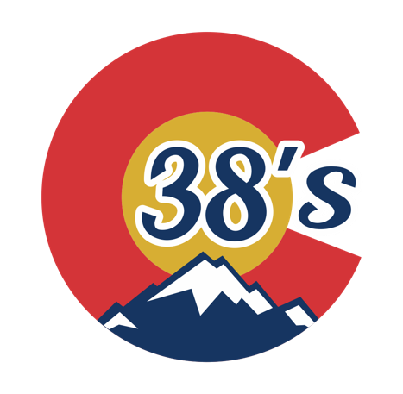

2022 Colorado 38’s Spring Program
Welcome to the home of an elite spring hockey program

The Colorado 38's mission is to provide an opportunity for players looking for a premier spring program in a completely neutral and pressure-free environment. The industrious and extremely rewarding culture is a necessity for our athletes to not only develop as hockey players, but also well beyond the rink.

Colorado: The 38th state to join the union in 1876.

Levels/Divisions Offered
The Colorado 38’s program is offering multiple divisions.
- 10U
- 12U
- 14U
- 16U
  - There will only be one team per level

Tryouts/Evaluations
Tryouts will take place on March 7th, 8th and 9th. There will be a non-refundable tryout fee of $50.
Monday, March 6th, 2022
- 6:15-7:15 PM - 16U – Edge Ice Arena
- 7:30-8:30 PM - 14U - Edge Ice Arena
Tiuesday, March 7th, 2022
- 5:00-6:00 PM - 16U - Edge Ice Arena
- 6:15-7:15 PM - 10U - Edge Ice Arena
- 7:30-8:30 PM - 12U - Edge Ice Arena
Wednesday, March 8th, 2022
- 5:00-6:00 PM - 10U - Edge Ice Arena
- 6:15-7:15 PM - 12U - Edge Ice Arena
- 7:30-8:30 PM - 14U - Edge Ice Arena

Travel Tournament
We are planning on taking a team at each level to an out-of-state tournament pending interests to travel. If you do NOT wish to travel, this will need to be declared upon registering. The travel tournament will be picked within the coming weeks. We are strongly considering the TCS Utah Mountain Cup, May 5th-7th.

Travel Tournament Fees
Travel tournament fees are not included in the spring registration. An additional fee of $200 will be assessed which includes tournament fees and coaches travel expenses.

Dryland/Off-Ice training
Players participating on a Colorado 38’s team will receive professional off-ice training once per week.

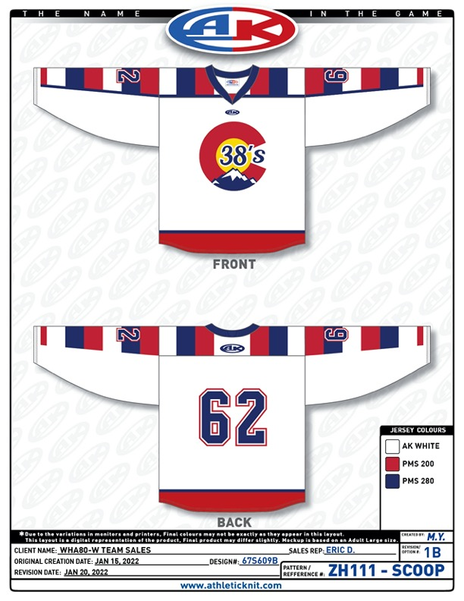
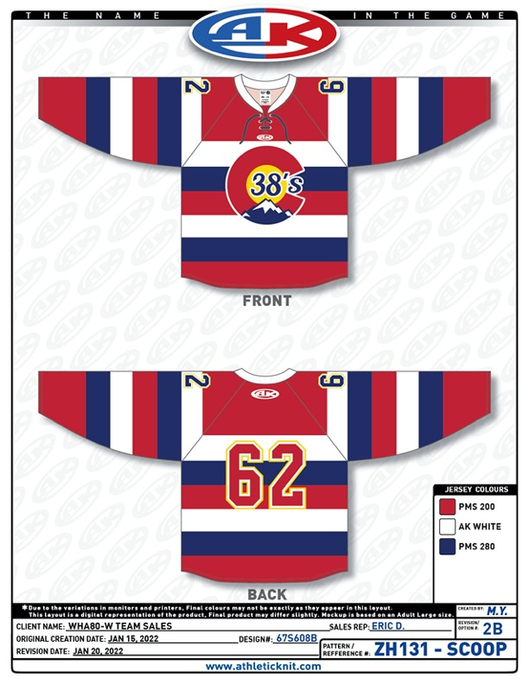
To register, head to www.colorado38s.com

