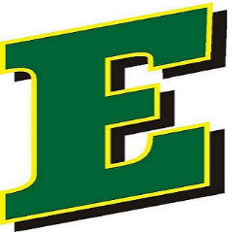

DC Everest Youth Baseball

Board Member Application
Below is the application form for volunteers interested in joining the 2026 DCEYB Board of Directors and Key Positions.

Please fill out the form if you are considering joining and would like to nominate yourself for a specific role. Nominations for any position within the Board of Director roles must be posted to the public 14 days in advance to September’s annual board meeting. Key position roles will be approved in the October board meeting once the new Board of Directors is approved in September. Submit your application to dceyb.registrations@yahoo.com by September 7, 2025.

Board member duties are listed in the Org chart and commitment level is expected to be 1 full year. Prospective Board members should always begin by attending board meetings throughout the season.

Name Phone Number:

Email

Please select role(s) you would like to be considered for the 2026 Fiscal Year.

Executive Board of Director Role nomination:
***To be considered for Executive position, you must have served on any other role on the board in the past.
- President
- Vice President
- League Advisor
- Treasurer
- Secretary

Board of Director Role nomination:
- Tournament 8U-10U Commissioner
- Tournament 11U-15U Commissioner
- Babe Ruth Commissioner
- Majors Commissioner
- AAA Commissioner
- A/AA Commissioner
- T-Ball Commissioner
- Concessions Manager

Key Position Role nomination:
***These roles will be approved during the October’s board meeting with the newly voted in Board of Directors
- ADVERTISING LEAD
- APPAREL/UNIFORM LEAD
- COACH/PLAYER DEVELOPMENT LEAD
- EQUIPMENT LEAD
- FIELD/FACILITIES LEAD
- INVENTORY LEAD
- PARRENT COMMITTEE LEAD
- REGISTRATION LEAD
- SCHEDULING LEAD
- VOLUNTEERING LEAD

Comments about how you will contribute to DCEYB as a board member:

Name of current board member to vouch for you:

