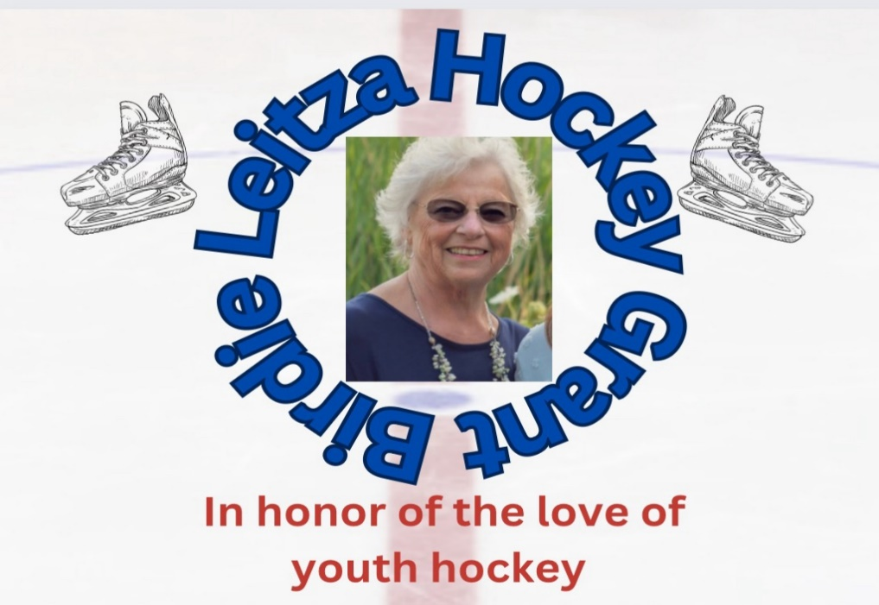
We are very excited to announce our 2nd annual Birdie Leitza Hockey Grant! We will be splitting proceeds from the Alumni Game, 6 ways. A grant will be awarded to one player at each age level. Thank you to everyone who participated in our Alumni Game this year. You helped make our vision a reality so we can continue to give back to our children!
Applications for the grants will be accepted until FALL Tryouts. Winners will be announced at our Welcome Back to Hockey Event scheduled for September 6, 2025. Winners need not be present to win.
For all those interested in applying for a grant, please complete an essay on the topic below, according to your age group.

*6U ($250 Grant) – What is your favorite thing about playing hockey?
*8U ($250 Grant)- Who is your favorite teammate and why?
*10U ($500 Grant)– How have you helped your teammates during your games?
*12U ($500 Grant) – Why is being part of the Kenosha Komets hockey team important to you?
*14U ($500 Grant) – How has hockey shaped who you are, off the ice?
*18U ($500 Grant) – What has playing hockey taught you about working through challenges?

Please submit your essay with cover sheet to Shelly Rudy, either with a hard copy or through email at promotions@kenoshakomets.com by FALL tryouts.
Winners will be selected anonymously. Thank you for your continued support and Good Luck!
Kenosha Komets Board
Birdie Leitza Hockey Grant
Please complete the form and attach it to your printed or emailed essay.

Skater Name_________________________________________

Skater Birth Year______________________________________

Best Contact (_____)___________________________________

Parent Name_________________________________________

You do not need to be present at the Welcome Back to Hockey Event to win the grant, but we would love to see you there!

