2022 HUHS ATHLETIC DEPARTMENT GOLF OUTING AND DINNER
Hartford Golf Course – Friday August 12
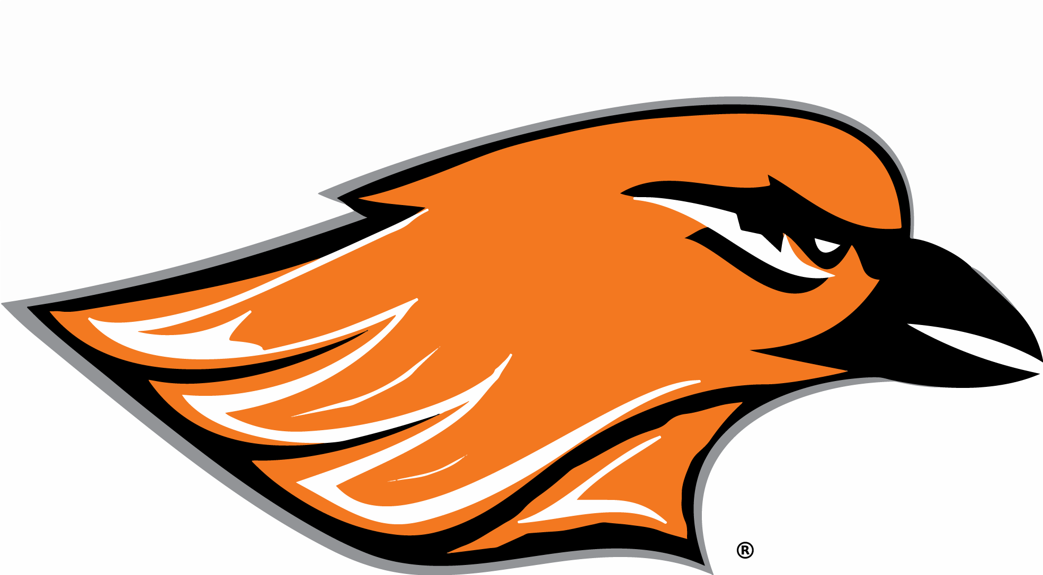
Golf 1:00
Social 6:00
Dinner/Auction 6:30 Chandelier Ballroom
2022 SPONSORSHIP OPPORTUNITIES
EVENT SPONSOR - $5000
Your Company/Family will be the Exclusive Sponsor for the 2021 Golf Outing
Includes 2 Free Foursomes and your name on the towel that each golfer receives at registration
CART SPONSOR - $2500
Your Company/Family name will be on every golf cart as the Exclusive Cart Sponsor
Includes 1 Free Foursome and your name on the towel that each golfer receives at registration
BEVERAGE CART SPONSOR (2) - $1000
Your Company/Family name will be on the Beverage Cart as golfers receive free beverages during the outing
Includes two free golfers
PINT GLASS SPONSOR - $500
Your Company/Family will be recognized at dinner as each golfer receives a Hartford Athletics Pint Glass
DRIVING RANGE SPONSOR - $500
Your Company/Family name will appear on the range as golfers warm up for the outing
Includes one free golfer
TOWEL SPONSOR - $300
Your company name will appear on the towel that each golfer receives at registration
HOLE SPONSOR - $150
Your Company/Family name will appear on a sign placed on a tee box for all golfers to see
PAR 3 CONTEST SPONSOR
Your Company/Family can donate an item valued over $100 to be used in the “Closest to the Hole” contest
AUCTION OR RAFFLE ITEM
Your Company/Family can donate an item that could be used in either the auction or raffle at dinner

Donor Name: _______________________________ Company Name: ________________________________

Mailing Address: ______________________________________________________________________________

Phone Number: ________________________ Email Address: _________________________________

Please send all sponsorships to: Hartford Union High School
Attn: Scott Helms
805 Cedar Street
Hartford, WI 53027
Please schedule a time with Scott Helms to bring all auction or raffle items to the Main Office at HUHS or we can always pick them up.

