**Darien Phantoms Hockey Club**



**Manager’s Handbook**

**2025-2026 Season**

CONTACTS: 4

MANAGER’S CHECKLIST: 5

Become a Manager: 5

USA Hockey Volunteer/Manager Number 5

SafeSport Completed ASAP (all) 5

Register with AAU: 5

BACKGROUND SCREENING: 5

First email (all) 6

Assistant Coaches (all) 6

Attend Manager Meeting (all) 6

Roster (all) 6

Slush Fund (all) 6

Accounting for Slush (all) 7

Weekly Reminder (all) 7

Scheduling 7

Website Calendar (all) Crossbar 7

Arrange scorekeeper for all HOME games (all) 7

GameSheets 7

Referees (all) 8

Clock (all) (recommended) 8

Get Familiar with your League 8

ICE SCHEDULING: 9

TEAM ROSTERS / OFFICIAL ROSTERS: 9

BUG (BACK-UP GOALIE): 10

REFEREES: 11

SCRIMMAGE GAMES: 12

GAME CLOCK AND SCOREKEEPING: 12

REPORTING SCORES: 12

EQUIPMENT POLICY: 13

NECK GUARD POLICY: 13

SPIRIT WEAR: 13

RULES & ETHICS: 14

ZERO TOLERANCE: 14

Locker Room: 15

24-HOUR RULE: 15

PROPERTY DAMAGE POLICY: 15

TOURNAMENTS: 15

SLUSH FUND POLICY: 16

SAFETY & RETURN TO PLAY POLICY: 18

BASELINE CONCUSSION TESTING 18

SOCIAL MEDIA AND ELECTRONIC COMMUNICATIONS POLICY: 18

INJURY POLICY: 19

DARIEN PHANTOMS WEBSITE: 19

TRAVEL: 19

PHANTOMS AFFILIATES & WEBSITES: 20

DARIEN PHANTOMS CORE VALUES 21

CUHL HOCKEY LEAGUES 23

CUHL Season Calander 27

# [CONTACTS](https://www.chicagohawkshockey.com/about/contacts/29466):

**USA HOCKEY:** [**usahockey.com**](http://www.usahockey.com)

[**CUHL**](https://www.chicagounitedhockey.com/)**:**

[**AAU USA:**](https://www.aausports.org/)

**President: Amanda Hanlon**

[**hawkspresident@chicagohawks.com**](mailto:hawkspresident@chicagohawks.com)

**Vice President / DIBS-Volunteer Coordinator: Pat Tagler**

[**vicepresident@chicagohawks.com**](mailto:vicepresident@chicagohawks.com)

**Hockey Director: Steve Poapst**

**spoapst@chicagohawks.com**

**Director of Early Player Development Steve Climo, 8U, 6U, Little Hawks, DHL**

[**u8andhouse@chicagohawks.com**](mailto:u8andhouse@chicagohawks.com)

**Manager Liaison: Rennie Santilli**

[**managerliason@chicagohawks.com**](mailto:managerliason@chicagohawks.com)

**Cell: 248-931-1624**

**Ice Scheduler:**

**icescheduler@chicagohawks.com**

**Registrar: Brian Casey**

[**registrar@chicagohawks.com**](mailto:registrar@chicagohawks.com)

**Treasurer: Dan Knotts**

[**treasurer@chicagohawks.com**](mailto:treasurer@chicagohawks.com)

**CUHL Referee Scheduler or Cancellation:**

[jordanmannskating@gmail.com](mailto:jordanmannskating@gmail.com)

**Equipment Manager / Spirit Wear: Nick Skweres**

[**equipmentmanager@chicagohawks.com**](mailto:equipmentmanager@chicagohawks.com) **/ spiritwear@chicagohawks.com**

**Rules and Ethics: Suzy Ravasio**

[**rulesandethics@chicagohawks.com**](mailto:gognibene@sbcglobal.net)

**Secretary: Suzy Ravasio**

[**secretary@chicagohawks.com**](mailto:secretary@chicagohawks.com)

**CSDHL & CUHL Representative**: **Pete Bilecki**

**Peter.bilecki@db.com**

**Scorekeeping: Tony Zasowski**

**tonyz1947@yahoo.com**

**NIHL Representative & Fundraising: John Janda**

**[johnjandajr@att.net](mailto:fundraising@chicagohawks.com)**

# MANAGER’S CHECKLIST:

## [Become a Manager](https://www.chicagohawkshockey.com/team-manager-resources/become-a-manager/29508):

## USA Hockey Volunteer/Manager Number

Manager’s USA Hockey number:

* Go to the website just like you did for your child
* Register as a manager. Free of charge
* Give this number to the registrar (Brian Casey: [registrar@chicagohawks.com](mailto:registrar@chicagohawks.com) ) so he can add you to the roster
* Complete SafeSport ASAP
* Background Screening if new manager, good for two years.

## SafeSport Completed ASAP (all)

* **You cannot be added to the roster until complete**

## Register with AAU:

<https://aau.uventex.com/events/event/334300>

Darien Phantoms

## BACKGROUND SCREENING:

* All coaches, assistant coaches, and managers must be screened by the AAU. Managers, coaches, and assistant coaches who have not been screened may not be on the ice or in the locker rooms with the skaters. All volunteers and employees age 18 or older are required to be
* screened and have completed SafeSport training prior to such volunteer or employee having access to youth participants.
* [Website](https://www.ncsisafe.com/Members/SelfRegBatchCode.aspx?srb=35615801): https://www.ncsisafe.com/Members/SelfRegBatchCode.aspx?srb=35615801

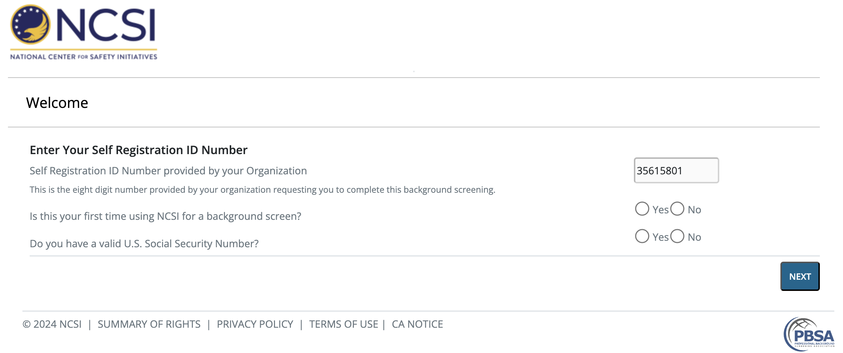

## First email (all)

1. Coaches receive the contact list typically 24 hours after the team assignments. Ask them to send it to you.
2. Send out a team e-mail making introductions:
   1. Let them know you will be collecting slush fund to cover the following
      1. Tournament fees
      2. Scorekeeper fees
      3. Team neck guard
      4. Slush fund

## Assistant Coaches (all)

Please find out from your head coach who your assistant coaches will be. Once you find out, send each assistant coach an email requesting they send you their **AAU Hockey Number**. Once you have their AAU Hockey number, forward that to Brian Casey: [registrar@chicagohawks.com](mailto:registrar@chicagohawks.com) so he can add them to your roster.

**\*\*Reminder** No coach can be added to the roster without completing SafeSport and age-appropriate coaching modules.**

## Attend Manager Meeting (all)

* Slush Policy
* Red helmets mandatory
* When fees are due and consequences if you don’t comply
* Neck guard
* Mouth guard policy, if applicable
* Slush Fund Fee

## Roster (all)

* Review the roster and confirm all team members are included
* Print off copies for manager book

## Slush Fund (all)

* Speak with your coach regarding expectation for tournaments. (see Slush Fund Policy)
* Tournaments can run anywhere from $1500+ for entry fee and sometimes includes a separate referee fee. Refer to Slush Fund Policy for details in regards to paying for coaches’ (head and one assistant coach) hotel rooms.
* Try to get a feel for number of home games you’ll have so you know how much you’ll pay out for scorekeeper fees. Email Tony Z each week with your HOME game schedule [tonyz1947@yahoo.com](mailto:tonyz1947@yahoo.com) ($30 per game, subject to change).
* Each skater, including the goalie, pay equal amounts

## Accounting for Slush (all)

* Use the spreadsheet template “google sheet” on the website to account for funds
* Maybe find a person who can be your team “banker” (optional)
* Must be prepared to show accounting to a questioning parent
* Slush Fund accounting will be required to be turned in to DPHC – see handbook

## Weekly Reminder (all)

* + Give updates every week either Sunday or Monday morning to confirm ice schedule for the week (games, practices, etc.)
  + **Don’t forget to include goalie clinic**

## Scheduling

* Go to League website
  + Read and understand or ask questions
  + Ask for help during scheduling from an experienced manager
* Prepare your calendar
* Review Master Ice Schedule
  + Mark off days that our ice is not available
* Review the calendar with your coach and confirm days he may not be available.
* Schedule games during league scheduling – via email, signup genius, phone, or texting.
* After you scheduled your games, follow league rules on how to enter your games

## Website Calendar (all) Crossbar

* Add all scheduled games to your calendar
* Add all practices and goalie clinics to your calendar
* If you have not done so already, please set up an account
* Once your team is finalized you will be given admin access for your team
* Crossbar Link: <https://www.crossbar.org/>
* Crossbar Help: <https://help.crossbar.org/en/>

## Arrange scorekeeper for all HOME games (all)

* For all HOME games you will need to contact a scorekeeper
* [tonyz1947@yahoo.com](mailto:tonyz1947@yahoo.com) ($30 per game, subject to change).

## GameSheets

**iPads are used and issued by the Chicago Hawks Hockey Club (CHHC)**

* Gamesheets link: <https://help.gamesheet.app/article/29-training-videos>
* You will be provided league keys
* Please make sure you arrive in enough time to login and load your league key
* Load your game prior to handing the iPad to the score keeper

## Referees (all)

* CUHL will schedule your referees
* Don’t pay referees directly
* All referees

## Clock (all) (recommended)

* Print off the directions for using the clock (on Phantoms website)
* Keep in your folder just in case a scorekeeper is late.

## Get Familiar with your League

* Visit their website and read all rules and regulations
* Chicago United Hockey League, CUHL: [Link](https://www.chicagounitedhockey.com/)
* Chicago Hawks Hockey Club, Phantom Page: [Link](https://www.chicagohawkshockey.com/about/darien-phantoms/40637)

**NOTES:**

# ICE SCHEDULING:

**Ice Scheduler:**

**icescheduler@darienphantomshockey.com**

You will receive your schedule for the fall season. If you will not be able to use your designated ice slot, inform the ice scheduler as soon as possible of any ice that is to be unused (these slots will go into a pool of open ice slots for other teams to request). The Ice Scheduler will send a weekly ice schedule to all coaches, managers, and to the rink. At that time, you need to verify your schedule and verify any slot you will not be able to use. Your team will be held accountable for unused ice. If you schedule an away game on a home slot, you will receive a banked ice slot for use during the season when open ice becomes available. You will not receive a banked sheet if your team decides to play in a tournament because it was your choice to give up the ice.

# TEAM ROSTERS / OFFICIAL ROSTERS:

**Registrar: Brian Casey**

**registrar@darienphantomshockey.com**

* **Sunday September Sunday 7th rosters are due to CUHL**
* **Friday October 31st is the last day to submit roster adjustments**

**FORMS ARE AVAILABLE ON THE PHANTOMS WEB SITE: Weblink: “**[**Click Here**](https://www.chicagohawkshockey.com/about/darien-phantoms/40637)**”**

* Phantoms Volunteer Policy **Waived for Phantoms**
* Waiver of Liability – Zero Tolerance
* Locker Room Damage Report
* Rules & Ethics Incident Report
* Return-to-Play Policy
* Scoresheet Label Template
* Slush Fund Budget Template
* AAU Roster Template
* AAU Scoresheet Template

Your official team roster will be generated by Brian Casey, Phantoms Registrar. He will receive the list of players for each team after tryouts are completed and will generate a roster form for each team. Please notify him ASAP if you are informed a player is not going to play on your team.

**Only coaches and assistant coaches are allowed on the ice during practice and on the bench during a game.** To be on the ice or the bench, you must be on the roster. Managers ARE NOT coaches. Also, only **registered Phantom skaters** are allowed on the ice during practices. Siblings, friends, etc., are not allowed on the ice during practice. If you want an older sibling to be on the ice coaching, that sibling will need to become a student coach (forms are available from Todd Lipinski).

You will get your certified roster on the AAU site. This is your team’s official roster. **Do not** make any changes to the roster that you receive. **Do not** write names in on your roster or mark out any names. Any changes to your roster must be done via Supplemental Rosters (see below) and must be approved by the Phantoms Registrar and certified by the AAU registrar. You need to communicate all changes to Brian Casey.

It is important that you keep a copy of your official roster with you at all games. You may be asked to validate a skater or coach’s information by presenting a copy of your roster to the opposing team.

It is essential that all skaters on the ice during a practice or game are registered Darien Phantom Club members. This is the only way that the Darien Phantoms Hockey Club, the coach, and each of the skaters are covered by insurance. If a skater is not on the official roster, none of the skaters or the coaches who are on the ice will be covered should an injury occur. You are responsible to assure that all the skaters on your team are listed on the official roster.

## BUG (BACK-UP GOALIE):

**All teams must list two *(2)* goalkeepers in order for their roster to be certified by the AAU Registrar.**  If you have only one goalie on your team, Brian Casey will be letting you know who your BUG will be. Brian Casey will add the BUG to your roster and sometimes it’s a supplemental roster. Any questions, please email Brian Casey, **registrar@darienphantomshockey.com**. If a BUG isn’t available, the game must still be played. A forward/defenseman will have to dress as a goalie for the game.  The game cannot be cancelled.

# REFEREES:

Referee Scheduler:

Jordan Mann

[jordanmannskating@gmail.com](mailto:jordanmannskating@gmail.com)

Cell:

CUHL will schedule your referees. We will have a league representative who we can contact regarding referees in regards to game changes or scrimmages. Once we get the contact information for our designated rep, we will forward it to you.

If you are changing a game, you will need to make sure you inform the league rep for refs. It is very important to avoid not having refs for your game or being charged for a ref that comes to a game that was changed. Please do this ASAP to allow enough time for the change to guarantee referees. Also, if you did change a scheduled home game, please also contact [**icescheduler@darienphantomshockey.com**](mailto:icescheduler@darienphantomshockey.com)and include the team, time, rink and new date and time. Make sure to include the other team’s manager on the email. Don’t forget to email Tony Z, your score keeper if you’re using his services.

[tonyz1947@yahoo.com](mailto:tonyz1947@yahoo.com).

**Please note: Under Mite AAU rules, games are allowed to be played with one referee.**

# SCRIMMAGE GAMES:

Do not schedule a practice game without discussing with the head coach and the Mite Director! If they have agreed to your team playing a scrimmage game, you need to email league ref rep with the information (date, time, rink, opposing team, etc.) and then you will get confirmation the referees have been scheduled. Please also copy Deanne.

Your team’s slush fund is responsible for referees for a scrimmage game. AAU/CUHL will bill the Club and Phantoms Treasurer Dan Knotts ([treasurer@darienphantoms.com](mailto:treasurer@darienphantoms.com)) will let you know what to pay the club. NEVER PAY REFEREES DIRECTLY.  Approximate cost will be $62 per game, but this is subject to change.

# GAME CLOCK AND SCOREKEEPING:

Scorekeeper – cost $30 a game - email Tony Zasowski at [tonyz1947@yahoo.com](mailto:tonyz1947@yahoo.com). He will help get your games covered. NOTE: If you cancel a game and forget to inform Tony and he or one of his scorekeepers shows up for that game, you are responsible for paying Tony or the scheduled scorekeeper double the fee. That fee is paid from your team’s slush fund. Current rates for 2025-2026 is $30 per mite game

# REPORTING SCORES:

The CUHL has adopted a new scoring system called [GameSheet](https://help.gamesheet.app/). This is an iPad app-based system in place of your scoresheet. This will automatically update and submit scoring to the CUHL. Once the season starts you will receive team specific manger info provided by the CUHL. Once you receive this information you are able to set up the GameSheets for your induvial HOME games. Scoring and penalties will be done right on the app! Also, no internet is needed during games in order to use. There are many tutorials right on the Gamesheet website [www.gamesheetinc.com](http://www.gamesheetinc.com).

**EQUIPMENT INFORMATION:**

**Nick Skweres:** [**equipmentmanager@chicagohawks.com**](mailto:equipmentmanager@chicagohawks.com)

Socks, shells, and warm-up suits are provided by the Darien Phantoms as part of your fees. Name plates are included with the jerseys.

*Players are not allowed to trade jerseys, shells, or socks with another player. Each jersey number is issued to a specific player and must be worn all season.

*All players must have a Home (light) and Away (dark) jersey and socks.

*Replacement socks are available for purchase.

Instruct your team to ALWAYS bring both jerseys to all games. Unfortunately, the league may issue fines if a team is without both jerseys, which will be passed on to the team to pay.

# EQUIPMENT POLICY:

The Club requires red helmets for players on all teams (excluding In-House, Silver Mites and goalies). Players who do not have the required red helmet will not be allowed to play in league and/or tournament games. For the 2025-2026 season, matching shells/covers will be provided to go over the player’s pants.

# NECK GUARD POLICY:

Players must wear neck guards for all on-ice activities. If a player is observed on the ice without a neck guard, the official will remove that player from the ice until he or she is in compliance.  Neck guards must be worn according to the manufacturer’s specifications. They must fit properly, not oversized, pushed down, unzipped, rolled over, taped or in any way altered. If they are modified in any way, they are not neck guards and the player will be removed. Failure to leave the ice will result in a delay-of-game penalty. A misconduct penalty shall be assessed to any player or goalkeeper of that team for a subsequent violation during that game. The definition of a neck guard is: Neck guards are specifically designed by the manufacturer to protect the neck. They are clearly labeled as such. There is the shirt type that zip up or the band type that attach with Velcro.  Arm bands, head bands, ear warmers, plain turtlenecks, and mock turtlenecks are not neck guards.

# SPIRIT WEAR:

**Nick Skweres:** [**equipmentmanager@chicagohawks.com**](mailto:equipmentmanager@chicagohawks.com)

As your first step in getting permission to use the Phantoms logo, please check with Nick Skweres. Nick will then check with the Board and get you an answer. Managers, individuals, and teams are not authorized to use the logo without expressed consent from the Darien Phantoms Hockey Club.

Spirit wear is available on the website for purchase and individual team fundraising is discouraged. Should there be any questions, again, please direct them to **Nick Skweres**.

# RULES & ETHICS:

**Rules and Ethics: Suzy Ravasio**

[**rulesandethics@chicagohawks.com**](mailto:gognibene@sbcglobal.net)

All infractions of **ZERO TOLERANCE** must be reported immediately (coach, parent, skater, etc.). The Phantoms have adopted the Zero Tolerance By-Law and added a Drug and Alcohol policy as well. The Club will conform to these standards

To report issues which you think are a violation, contact **Suzy Ravasio** ASAP after the occurrence. Your issue must be documented in writing. Send that documentation to the above email address at Darien. The Incident Report Form is located on the website.

Chicago United Hockey League Rules & Ethics Committee:

The Rules & Ethics Committee shall be selected pursuant to the By-Laws of CUHL.

CUHL has adopted the USA Hockey's Players code of conduct, Parents Code of Conduct, and Coaches Code of Conduct. All matters pertaining to violations of the (a) the foregoing, (b) CUHL’s By-Laws or (c) CUHL’s Playing Rules, arising in connection with CUHL games or activities (either on or off the ice) by any CUHL member organization, player, coach, parent or other individual affiliated with a CUHL member organization, will be referred to CUHL’s Rules & Ethics Committee for hearing and determination of any discipline. The range of discipline the Rules & Ethics Committee may impose upon such member organization, player, coach or other individual affiliated with a CUHL member organization includes fines (only as provided for in CUHL’s By-Laws), probation, suspension or a recommendation to the CUHL Board of Directors that such member organization be expelled from CUHL.

All Decisions of this Rules & Ethics Committee are final. No appeals will be considered other than those that are legally provided under the laws of the State of Illinois or Rules and Bylaws of AAU.

## ZERO TOLERANCE:

The Darien Phantoms Hockey Club supports Zero Tolerance. These policies will apply to ALL parents, players, team managers, and coaches.

**All members acknowledge Zero Tolerance when registering their player.**

# Locker Room:

There **must** be an adult who has been screened and completed SafeSport training in the locker rooms **at all times**. The coaches have been notified of this rule and must assure that there is someone in the locker room. If they or one of their assistants are not going to be in the locker room, then they must have made arrangements for a screened male adult who has completed SafeSport training for boys’ teams and screened female adult who has completed SafeSport training for girls’ teams to be in there at all times. Our liability insurance will not cover incidents where an incident occurs and a screened adult was not present. For the safety of all of our skaters, please make sure that there is someone in the locker room at all times! Your team will be responsible for any damages that occur to the locker rooms at our or opponents’ rinks. Presence of an adult will prevent any damages from occurring. Parents who have not been screened **may not** be in the locker room. This rule is for the protection of the skaters, parents, and the Darien Phantoms Hockey Club.

# 24-HOUR RULE:

If a parent has a concern about a game situation, playing time, or other event, the parent needs to wait 24 hours before contacting the coach, directors, or manager. This time period is meant to help buffer any emotional response that may result from a particular situation during a game, practice, skills session, or team event.

# PROPERTY DAMAGE POLICY:

**Team managers are strongly recommended to check the condition of the locker room before and after all practices and games.** Report any problems or damages you observe to the rink manager immediately. It would be unfortunate for any team to be blamed for damages done by another group**. REMEMBER, YOUR TEAM WILL BE HELD RESPONSIBLE FOR ANY DAMAGES REPORTED DURING YOUR ICE SLOT**

Assessment for damages will be as follows:

1. Team Fines

2. **Plus,** Cost of Damages

3. Damages to the boards or glass can be upwards of $400. Advise your skaters and coaches not to hit slap shots at the boards or glass.

# TOURNAMENTS:

For mite tournaments this year, you will receive a list of tournaments from the Club that your team will enter. Do not enter any other tournaments without the permission of the mite director or hockey director.

Tournaments are stay-to-play which means your player needs to stay at a specified hotel. Your team manager will send hotel information, preferred room rates are available for a limited amount of time. Families are expected to book hotel rooms well in advance to adhere to stay-to-play policy and pay best rate. Managers will get Tournament information from the club and be contacted by the tournament director to coordinate hotel rooms for stay-to-play rules.

**Please do not forget to email Deanne and let her know you will not be using your ice for the dates of the tournament.**

# SLUSH FUND POLICY:

* **Chicago United Hockey League (CUHL) Slush Fund Policy**: The parent/guardian of the player agrees to pay their player’s portion of the team's slush fund. The slush fund can cover a variety of team expenses including, but not limited to, scorekeepers for regular season games, qualified coaching travel expenses, playoff-related expenses, scrimmage games, referee costs, coaches' gifts, practice jerseys, team parties, and tournaments. The parent/guardian also agrees to pay their portion of tournament-related expenses. Please be prepared - some teams may choose to participate in tournaments early in the season, as early as the end of September. Tournaments can be either local and/or out of state/country which will be determined by the majority of the team or head coach. The parent/guardian is responsible for paying their portion of the tournament fees and non-parent head coach’s hotel room(s).  If the team has a non-parent assistant coach, the assistant coach’s travel expenses and hotel room(s) will also be covered by the team.  (Maximum of two coaches’ hotel rooms per tournament). Parent/guardian will pay their portion of the slush fund regardless of whether their player is able to participate in the tournament(s).  Payment will be made to the team manager.

**For All Players** – **Slush Fund Travel Reimbursement Policy:**

* Trips greater than 350 miles (including but not limited to Blaine, Cleveland, Pittsburgh, Nashville) from Darien Sportsplex: Airfare and vehicle rental fee will be covered by team slush for a non-parent head coach and one (1) non-parent assistant coach for the duration of the games/tournament. Every effort should be made to book the lowest airfare possible by scheduling as far in advance as possible. Rental car classification must be intermediate or compact. Gas, mileage, and meals are not reimbursable expenses. If the coach should choose to stay longer or arrive earlier, any additional costs will not be reimbursed by the team.  If coach/s assist with other teams, all expenses will be shared equally between teams. Any trips 350 miles or less are considered to be drivable, and expenses will not be reimbursed by the team (including but not limited to St. Louis, Detroit, Madison, Indianapolis).
* If at any time during the current season the parent/guardian cannot/will not pay the slush funds due to the manager, their player will NOT be able to practice or play in any scheduled games. The player will not be able to participate until payment has been made or an arrangement has been approved by the Darien Phantoms Hockey Club Board of Directors. If a head coach is a parent, grandparent, or other relative of a player on the team, the team is not required to pay for the head coach’s hotel room(s). This shall be the case so long as the head coach and respective player share a hotel room.

**For All Managers –** Slush funds must be made available to any parent on your team at their request. The Slush Fund form is on the website under the Managers tab. This form **must** be used for all teams’ slush accounting. Slush fund accounting must be sent to [managerliaison@chicagohawks.com](mailto:managerliaison@chicagohawks.com) and cc: [treasurer@chicagohhawks.com](mailto:treasurer@chicagohhawks.com) no later than Dec 1, 2025, and Feb 28, 2026, or end of season, whichever comes first. Slush funds are only to be used for above-stated items. Please understand the slush fund belongs to the team. For any expenses outside of the above, the majority of the team must agree. Costs for tournaments are for fees, referee fees, coaches’ hotel rooms, and a team party. Slush fund may not be used for coach meals or gas expense unless majority of team agrees. **When in doubt, ask!**

# SAFETY & RETURN TO PLAY POLICY:

Any player, who in the opinion of a coach, athletic trainer, or physician exhibits any signs, symptoms, or behavior consistent with a concussion (such as loss of consciousness, headache, dizziness, confusion, or balance problems) shall be immediately removed from play and practice.  The player may not return to play and/or practice without written clearance by a qualified healthcare professional.

**Please see website for Return-to-Play Policy:** [**Link Here**](https://www.chicagohawkshockey.com/team-manager-resources/links-forms/29513)

**Questions?** Please contact Steve Poapst, Hockey Director, at [spoapst@chicagohawks.com](mailto:spoapst@chicagohawks.com).

## BASELINE CONCUSSION TESTING

ImPACT Baseline concussion testing will be required for all players mites-midgets. Players 12 and over will be provided with a link to perform the baseline at home with parent oversight. Players 11 and under will have their baseline concussion test performed at an assigned time with parent oversight. Information will be provided after tryouts. All baseline tests should be completed within a week after receiving notice.

**No player will be allowed to participate in any on-ice activities without completing baseline testing**.

# SOCIAL MEDIA AND ELECTRONIC COMMUNICATIONS POLICY:

The Darien Phantoms Hockey Club (“Club”) is committed to developing individuals with “leadership, commitment and outstanding character” on and off the ice.  To that end, we will require strict adherence to the following social media and electronics communications policy by all Club members, coaches, and their families as a condition of their participation in the Club:

The Club will not tolerate its members participating in any form of electronic communication that is deemed by its Rules and Ethics Committee to be derogatory, hateful, vengeful, or otherwise disrespectful to the Club, any member of the Club, any coach of the Club, or any other person(s) associated with any other hockey club or organization.  This includes, but is not limited to, communications deemed harmful to the goodwill or reputation of the Club, any member of the Club, any coach of the Club, or any other person(s) associated with any other hockey club or organization. This further includes, but is not limited to, sending a text or email about the Club, any member of the Club, any coach of the Club, or any other person(s) associated with any other hockey club or organization that is intended to abuse, bully, humiliate, or harass.

Any communications that are deemed to violate this policy will be reviewed by the Club’s Rules and Ethics Committee for possible sanctions up to and including expulsion from the Club and further reporting to AHAI.

# INJURY POLICY:

The Darien Phantoms injury policy allows a proration of fees to any player who is off the ice for a period greater than six weeks due to an injury that occurs on-ice during a Phantoms game or practice.  A note from a medical doctor confirming the injury is required. COVID-19 diagnoses/absences are not included and therefore not eligible for a refund under this policy. Only one injury refund is allowed per player per season regardless of whether the subsequent injury is a recurrence of the first injury or a completely new/different injury.

For purposes of the refund policy, we assume that the season starts September 1 and ends on the last day of February – so a 181-day season.  For example, if a family paid $2,000 for their player for the season, it breaks down to $11.04/day. If the player is injured and misses seven weeks of hockey, you are entitled to a $540.96 refund (49 days X $11.04/day).

# DARIEN PHANTOMS WEBSITE:

Managers are responsible for updating and maintaining their team’s page and calendar on the website [www.chicagohawkshockey.com](http://www.chicagohawkshockey.com). The webmaster will give you access to your team’s page. Your log-in and password will be the same that you use to register your player.

All games should be posted immediately after scheduling to the calendar for your families. All practices, skills, off ice, and goalie clinics should also be posted.

Managers are required to post all game scores promptly.

Managers may also post team news. However, under no circumstances should player’s names be posted. Please use first names and initial of last name. (example: Joe P.) Photos may be posted only if names are not shown.

Please submit any news on your team, including tournament wins or other team events, to our marketing and social media coordinator at [marketing@chicagohawks.com](mailto:marketing@chicagohawks.com)to post on the Club’s home page and social media. Make sure to include a 2-3 paragraph write-up and photo. Under no circumstance is a team to start their own social media pages with the Club’s name or bearing any resemblance to the Club. Send us your news! We want to brag!

# TRAVEL:

Members will be responsible for coordinating their own travel this year.  If teams are able to travel out of state for games, the Club will not coordinate any airline travel or buses and/or incur that expense.

# PHANTOMS AFFILIATES & WEBSITES:

* **Chicago United Hockey League: chicagounitedhockey.com**
* **AAU: Non Athlete Membership**
  + **https://aau.uventex.com/events/event/334300**
* **Mite Director: Steve Climo** [**u8andhouse@chicagohawks.com**](mailto:u8andhouse@chicagohawks.com)

The Phantoms are committed to the ongoing development and promotion of competitive youth amateur hockey in Illinois. We are dedicated to the athletic development, personal growth and sportsmanship of youth hockey players. We encourage the development of our players as teammates, as well as individuals, teaching them valuable lessons that can be applied long after they leave the rink. Our coaches and instructors utilize a variety of cutting-edge on and off-ice training techniques that provide our players with a competitive advantage while maintaining a positive, fun environment.

**PROUD TO WEAR ONE OF THE COOLEST LOGOS IN MITE HOCKEY, THE PHANTOMS STRIVE TO:**

* Inspire a lifelong love of hockey
* Cultivate family, friendships and fun
* Build strength of character on and off the ice
* Develop athletes to their greatest potential

# DARIEN PHANTOMS CORE VALUES

The Core Values you see here reflect our mission and what is truly important to our organization. What it means to "Be a Phantom" is an idea that can be embraced by our leadership, coaches, instructors, players, and families within the organization.

Fun – Hockey is a fun and exciting game, and playing it should make you feel happy.

Teamwork – There is no "I" in team and good teammates work together to make great things happen.

Respect – It is important to show respect for yourself, your teammates, your coaches and your opponents of and off the ice.

Responsibility – When you're responsible, your coaches and teammates will count on you to do the things you're supposed to do.

Sportsmanship – Good sports have a positive attitude, play fair, cheer for their teammates and always shake hands with the other team.

We are thankful for your support and will continue to work hard on behalf of all Darien Phantoms families.

Sincerely,

Amanda Hanlon – President

[hawkspresident@chicagohawks.com](mailto:hawkspresident@chicagohawks.com)

# CUHL HOCKEY LEAGUES



**Updated every Season as needed to be used as reference. Check with official website for most up to date Rules, Links & Forms - [Here](https://www.chicagounitedhockey.com/officials-resources/rules-links-forms/39552)**

* + 1. Playing times for all games (seeding round, regular season and playoffs) will be stop-time periods, except as set forth below. The host team will schedule at least sixty minutes of rink time for any game with eleven or twelve minute periods.

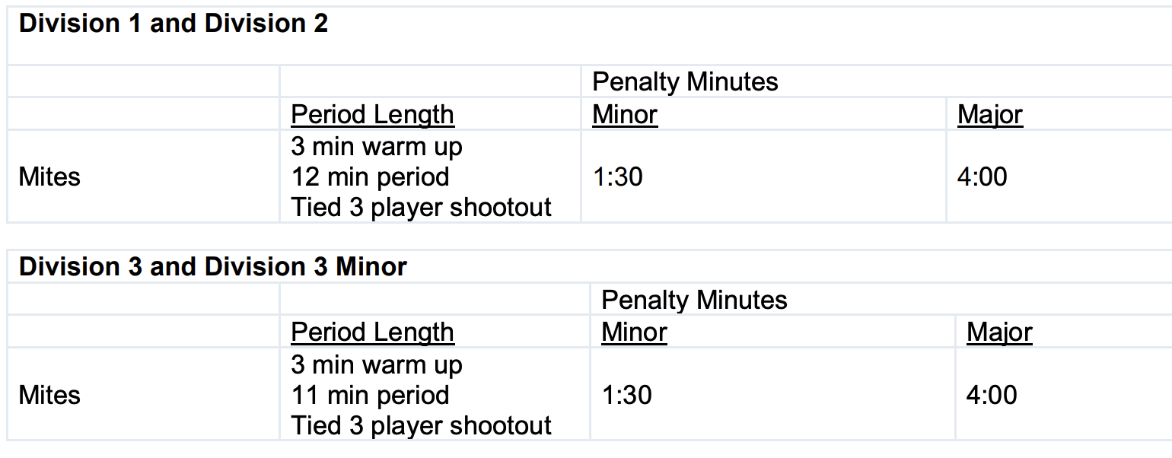

* + 1. The playing time and all CUHL rules pertaining to playing time for the game must be explained to the referee and the timekeeper by the home team before the start of the game.
    2. If the stop-time periods as specified cannot be played because of a team being late, the game shall be rescheduled by agreement between the coaches. In addition, the minimum time for the warm-up preceding the game shall be no less than three (3) minutes. Further, in the event of an injury, the third period time must be agreed upon by both coaches to finish on time. Notwithstanding the provisions of this rule, should the competing coaches agree to play the game not in compliance with these playing times, penalty times and clock operation, once the game is started, the results of that game will be absolute and final. If the game is tied at the end of regulation, both tied teams will execute a 3 players shootout. Three different players from each team must be selected at the end of the third period of regulation. If the score remains the same at the end of the shootout the game will end as a tie.
    3. For CUHL League Games (seeding round, regular season and playoffs) each team shall be entitled to call one (30) second time out. This is in addition to any “Officials Time-Out.” Teams shall receive any extra timeout during overtime periods in playoff games only.
    4. Slaughter Rule/”Running Clock”

1. At the point that a five (5) goal deficit exists in the third period, the clock should remain running with the following exceptions: • a. Penalties- the clock should be turned off to list the penalty minutes and turned on at face-off. b. Injury and Official Time-Outs- the clock should be turned off until the ensuing face-off.
2. At the point in the third period when a five (5) goal deficit first arises, the clock should be turned off to record the goal and not restarted until the ensuing face-off.
3. The clock should remain running if a goal is scored by either team, and the five (5) goal differential still exists. However, if the losing team scores a goal to narrow the deficit to four (4) goals, then the clock is turned off to record the goal, and not restarted until the ensuing face-off occurs, at which point normal stop time will again be kept.
4. If a play is stopped and a penalty expires, the penalized player should not return to the ice until play resumes.
5. Invoking the slaughter rule is MANDATORY and is not subject to negotiation between opposing coaches, or referees.

CUHL does not permit running time EXCEPT under the slaughter rule. There are NO OTHER EXCEPTIONS! Should a HOME team run out of assigned ice time and be required to vacate the ice surface with time left on the clock, the scorekeeper will note the time remaining on the score sheet. The remaining time left in the game will be played with the responsibility on the offending HOME team to ensure the conclusion of the game in the following manner:

* + - 1. The first time the two teams meet at the offending home teams’ rink, the incomplete game will be finished prior to the start of the new game.
      2. In the event the only remaining game between the two teams is at the affected visiting teams’ rink, the affected visiting team will make every effort to conclude the unfinished game prior to the start of their scheduled game, and any additional cost to have the original game completed will be borne by the original home team.
      3. If no games remain between the two teams, it shall be the responsibility of the original home team to conclude the game prior to the season’s end or the seeding round end
         1. The home team is responsible for furnishing a scorekeeper, a timekeeper and referees.
         2. Not less than fifteen (15) minutes before the game the manager or coach of the home team must verify that the officials are qualified and tell the visiting coach or manager of the fact. CUHL games can be played with one referee present as long as that ref is comfortable proceeding with the game on their own. In the event properly qualified officials are not present for the game, the home organization must explain the circumstances to the coach of the visiting team. At that point both teams can agree to use other qualified options to officiate the game. Any question about the qualification of the officials must be raised before the start of the game, and if these questions cannot be satisfactorily answered and the officials not deemed qualified to officiate the scheduled League game, the game shall be played as a practice game, or the visiting team may leave the rink and require the game to be rescheduled. Once a game has been started with the understanding that it is an official CUHL game, the officials have been automatically accepted by both teams. The use of the ice as a “practice” game is optional. When games are not played because the home team does not have required, qualified officials, the home team shall have the responsibility to make concessions to the convenience of the visiting team in rescheduling.
         3. Game Misconduct Penalty - A player or coach who receives a game misconduct penalty in a League game must serve that penalty by being suspended from the next already scheduled CUHL game. If that team's next scheduled sanctioned AAU game is not a CUHL game, the player or coach must still serve a suspension in the next already scheduled CUHL game (in addition to the next scheduled sanctioned AAU game). A Game Misconduct Penalty may not be served in a practice game. Any Game Misconduct may come under the review of the Rules and Ethics Committee. Documentation must be provided to Rules and Ethics if the suspended game is not a CUHL game. For clarification of this rule, contact the Rules and Ethics Committee.
         4. A player who is assessed a penalty in a CUHL league or CUHL playoff game for “Fighting” or “Fisticuffs” will be suspended for the next three (3) already scheduled sanctioned AAU Hockey games, excluding practice games, and not including the game in which the penalty was assessed. The three game suspension must be served in CUHL games or non-CUHL playoff games or any combination of such games, but not in practice games.
         5. The official CUHL score sheets are for CUHL league, seeding, or playoff game use only. Do not use for any practice, house or non-CUHL games. Each team’s manager is responsible for making sure that all copies of the CUHL official score sheet are filled out completely using the proper name of the team as given by CUHL division, and is signed by both coaches and all referees. Each score sheet must contain all rostered players in numerical order. The following designations must be entered on all copies of the score sheet next to the player’s name when that player is not skating: Absent – ABS, Injured – INJ, Suspension – SUSP. In addition, all suspended players must be listed on the score sheet under suspensions.
         6. Teams will be assessed a loss and subject to fines if they play a league or playoff game with an ineligible player. If a team plays an ineligible player during a playoff game, that team is eliminated from further playoff competition.

1. “Out of area” rule. This rule requires the remaining CUHL clubs shall not be required to travel out of area for a league game.

Should a “HOME” game for out of area team be played at another club’s home rink, then that club shall be responsible to pay for the ice, and pay for and schedule the officials. Out of area team may, if they so choose, provide the minor (off-ice) officials.

The “VISITING” team, which decided NOT to travel, will pay all costs.

If a game cannot be played at another club's home rink and must be rescheduled due to the fact that no on-ice officials are present for the game or due to the fact that ice is not available for the game, the "VISITING" team, which decided not to travel, will be assessed a fine not less than $250.

# CUHL Season Calander

[Season Schedule](https://www.chicagounitedhockey.com/coaching-resources/season-calendar/61510)

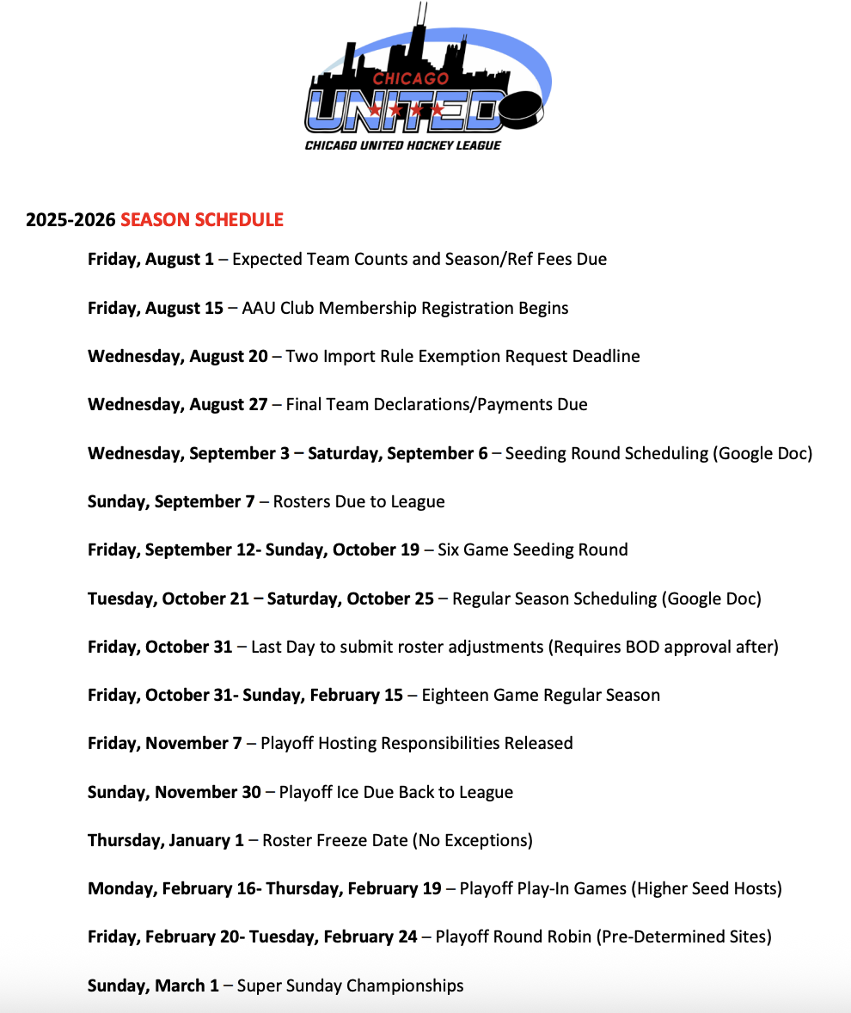

**Appendix:**

**Revision Log:**

Rev. 8/30/2024

* Season modification from 2022 to 2024/2025 season (Rennie)

Rev. 8/17/2025

* Season modifications from 2024 season to 2025-25 (Rennie)