

ROCKETS HOCKEY CLUB MANAGERS MANUAL
Edited and Updated 8-27-25kw

Introduction and Welcome!

These materials will hopefully provide you with a step-by-step process for managing a Rockets hockey team. Many of the suggestions relate to teams that will attend tournaments, but most are applicable to house teams as well.

You have likely become a manager because you know the coach, received the recommendation to be manager from someone who knew both you and the coach, or you simply volunteered. In most instances you already know a good deal about hockey and even managed a hockey team. If so, maybe these pages will give you a few new ideas. If not, these pages will give you most of the guidance that you need. Many of your questions can all be answered on Missouri Hockey’s Team Manager Resource Page.

If you have any questions, please contact Rob Skinner at execdirrockets@gmail.com.

Good luck and have a great year!

Contents

Important dates 3
Requirements for Managing 4
Now that you are a Manager 4
Initial parent/player meeting 4
MoHockey website 5
Declaration games scheduling procedure 5
League game scheduling procedure 5
Scheduling practice games 6
Game Cancellations 6
Team Contact Information 7
Communication using Team Page 7
Financial 7
Trading Ice With Other Rockets Teams 8
Uniforms 9
Official Roster 9
Tournament information 9
Tournament/out of town trips 10
Team Pictures 10
Rink Addresses 10
Discipline 11
Problem Solving 11
Off-ice Officials scheduling(Time & Score keepers) 12
Score sheets/clock responsibility 12
Score Sheets 13
End of the year/party/awards/coaches’ gifts 13
GENDER EQUITY POLICY – Co-Ed Locker Rooms 13
MO Hockey Contact Information 14
Final Note 14

Important Dates - the most up to date information can be found at Missouri Hockey Youth Division web page under Resources -> YD League Information & dates

Important Dates
August 1st - Preliminary Declarations Due
Sept. 1st - Final Preliminary Declarations Due and Teams Entered into Crossbar

Sept 6th & 7th Coach and Manager Meetings

Sept. 9th - Declaration Season Electronic Scheduling Opens
16U, 18U Midget Electronic Scheduling Opens

Sept. 11th - Declaration Season Electronic Scheduling Closes
16U, 18U Midget Electronic Scheduling Closes

Sept. 17th - Declaration Season Begins

Sept. 19th - Midget League Games Begin

Oct. 27th - Regular Season Team Placements Finalized

Oct. 28th - Regular Season Electronic Scheduling Opens for 10U, 12U, 14U

Nov. 1st - Regular Season Electronic Scheduling Closes for 10U, 12U, 14U

Nov. 6th - Regular Season Games Begin for 10U, 12U, 14U

Nov. 8-9-10-11 – Team Photos Sessions at the Off-Ice Facility

Nov. 30th - LAST DAY TO RESCHEDULE GAMES WITH NO FEE

Dec. 31st - Application & Payment for Tier II National Qualifier Tournament Due

Jan. 31st - Last Day for 16U and 18U Midget Games

Feb. 6th - Feb 8th - 16U & 18U Midget Playdown

Feb. 15th - Last Day for 10U, 12U and 14U Regular Season Games

Feb. 20th - Feb 22nd - BNC Playdown Weekend (10U, 12U, 14U)

Feb. 21 - No 16U or 18U Midget Games

Requirements for Managers
1. Complete USA Hockey registration for yourself as a Manager/Volunteer: (no fee)
https://membership.usahockey.com/
2. Complete a background check through Missouri Hockey website:
https://www.missourihockey.org/nationalscreeningprogram
The Rockets will reimburse the cost for your background check
3. Complete SafeSport online course: (no fee)
https://www.usahockey.com/safesporttraining
Now that you are a Manager
Meet with your coach immediately after the team and coaches are set. Unless you have managed with your coach before, you should meet with them to discuss several matters, including the following:
- Who will take responsibility for scheduling games(Declaration/League), practice games and ice trading.
- Number of tournaments the coach would like to attend.
- How many tournaments will be out of town vs. in town? 1-2 out of town is typical, 2-3 total is typical.
- Social/team bonding events.
- Team Budget
Managers will submit score sheets after home games to Missouri Hockey. Instructions can be found at: MoHockey Website Instructions
Initial parent/player meeting
The initial meeting with the parents and players should be held as quickly as possible. The Rockets Off-Ice facility can be used by contacting Rob Skinner or schedule a meeting room at one of the rinks before a practice. Notification of the meeting can be done by email and add it to the Team Schedule on your Rockets web page schedule. At the initial meeting with the parents and players, you plan to discuss the following matters:
- Introductions of Coaches and Manager
- How Many tournaments to attend(at least two) – vote if necessary
- Team Budget - Recommended amount of contribution for team fund/vote if necessary.
- Volunteers: - Arranging Team activities for the team in town & out of town during trips. - - Team Treasurer – Handles team funds and Disbursement of funds
- Organize pre-season and post-season party
- Special events helpers
- Scorekeepers and Timekeepers for all home games
- Penalty box volunteer for home and away games (It is a good idea to set up a Google Spreadsheet with the game schedule for volunteers to sign up for games.)
- Team Guidelines - Coach to discuss
- Explain Declaration Season, League Season, and Play-offs.
- Have a Q&A
Missouri Hockey Website
- All HOME games (Declaration and then League games) will need to be entered on the Missouri Hockey
scheduling website - www.mohockeyyd.org Under Resources -> Website Instructions
- Once games are complete, scores must be entered by the Home team within 48 hours and a copy of the
white score sheet must be uploaded to the Missouri Hockey Web Site.
- Website will require user id and password to access. You will be issued this by the Club Registrar-
Jill Rowland/Kevin Whitworth.
- Once your schedule is set on your Missouri Hockey Team Division page you can link your Dec. Season
or League season schedule from your Mo-Hockey Team page to your Rockets Website Team page by:
a. Go to your Rockets Team page
b. Go to schedule
c. Click on “Imports” button on right side of page
d. Follow directions to sync Mo-hockey schedule to your Rockets team page schedule
Declaration Games scheduling procedure
- Coaches and team scheduler will attend a Declaration Scheduling Meeting September 6 or 7. Details will be discussed at that meeting. This meeting may be held virtually via Zoom.
- Scheduling can be done during the meeting and then continue online with other coaches/managers by contacting them via phone or email, if you are unable to schedule with them during the initial meeting. We suggest you get as much done as possible at the meeting, if allowed.
- During Declaration Season, Head Coaches may be required to complete a post-game survey on-line through Missouri Hockey. A link will be supplied by Missouri Hockey once the game schedule is set.
- The number of games (usually 3 to 4) that need to be played by each team will be communicated at the Missouri Hockey Coach’s Meeting

- Once Missouri Hockey sets the number of declarations games to play, the Rockets will issue your team Game Ice. (These will be full sheets of ice assigned to your team only to be used for Dec. Games)
League game scheduling procedure
- Missouri Hockey will determine division placements and number of games to be played by October 27th.

- Coaches/Managers will schedule games online with other coaches/managers by contacting them via phone or email or at the scheduling meeting. Do not procrastinate, get your schedule done.

- Only Home games, once confirmed, need to be entered into the Missouri Hockey scheduling website. For directions to enter games into MoHockey, go here. ( Mo-Hockey YD web page under Resources)

League game scheduling procedure , con’t

- Scores must be entered into the MoHockey website within 48 hours after the game, along with a copy of the score sheets
- Once Missouri Hockey sets the number of League games to play, the Rockets will issue your team Game Ice. (These will be full sheets of ice assigned to your team only to be used for Games - any extra full sheets not used for League games can be used for Practice games or full ice practices.
Scheduling Practice Games
- If you want to schedule practice games, you will need to contact Jill Rowland at adoh.rockets@gmail.com to schedule referees. Practice Games ONLY. Mo-Hockey will schedule officials for Dec. & League Games
- Both the Home and Away teams must have a Certified Roster before they can request referees.
- Practice games can be within teams at your level or other levels within your division or out of town.
- The Rockets will pay for referees for 3 practice games during the season.
- The format to be emailed to Jill Rowland when scheduling referees is as follows:
  - Managers Name and Phone number
  - Date of Game
  - Start time of Game
  - Rink Location of Game
  - Duration of Game - i.e. 1 hour 15 minutes
  - Division of teams playing - i.e. 14U A3
  - Home team - i.e. Chesterfield Falcons 14U A3
  - Away team - i.e. St. Louis Rockets 14U A3
- MIHOA(Referee Association), mandates that referee requests for practice games be submitted at least 6 days before scheduled practice game. MIHOA will not guarantee officials on any request under 5 days.
Game Cancellations

Declaration and League games may only be canceled at the discretion of the Missouri Hockey Division Commissioners.

For any information on Changing, Postponing or Canceling a game, please see the Missouri Hockey web site at
https://www.mohockeyyd.org/team-manager-resources/team-manager-resources-how-to-s/2155

Click here for the Missouri Hockey Youth Division website for league commissioner contact information. Games cancellations not approved by the appropriate commissioner will be subject to a financial fee assessment plus the rescheduling fee. Games that have to be canceled in accordance with rules stated above, do not incur the $100 rescheduling fee.

Team Contact Information

There are several pieces of contact information that you should have for your team, and some things your families should have:
- A roster with contact information handy – this can be pulled directly from the Team page on the Rockets website using your login information. Families may like to have this, at least with phone numbers.
- A simple roster with player name and jersey number.
- It is important to have a list of all the team’s contact information in your division. It can easily be found on your Missouri Hockey Team page under “Contacts”. You can also start to gather that information at the Coach’s meeting. This is critical when scheduling games, communicating issues that may come up, or planning practice games.
- A list of tournaments that you are registered for and who runs them.
A list (emailed from Rockets) with all the other coaches and managers within the Rockets organization.
Communication through Rockets Team page
Rockets Hockey has a website powered by Crossbar and an email system for communication. If you are managing a team, email is the best way to communicate. If you do not wish to use Crossbar, then you can create a distribution list within your email system of choice(ie. Gmail) and send mass emails to your team members. You may want to send a weekly email with the schedule (although if families subscribe to the calendar electronically, this should be less of an issue), but it is often nice to check in weekly.
All communication from Rockets Hockey will come via email. It is important to obtain good email addresses from your families, it is also important to ensure the family updates their personal information on the website if it changes.
Financial

Every team needs a team fund. Consider a treasurer to handle financial matters. Many teams set up their own account, but some do not. Think about what you would like to be able to pay for (create a budget) – how many tournaments, social events, apparel – It is important to communicate with your coach about this. Once you have an idea about the cost for the season, recognize how many players you have and distribute the cost evenly among them. For example, if you estimate your season costs to be $3000, and you have 15 players on the team, that is $200/player, whereas if you have 12 players, it is $250. Anything over $250.00 is a large request and should be well thought out before it is done. If you need a higher amount from your families to cover expenses this should be discussed with those families before the amount is set. Please keep receipts/records for all expenditures. Additionally, please arrange for any coaching reimbursements for coaches prior to your travel dates especially if the coach is not a parent and/or a paid coach. The Rockets do not reimburse coaches for travel expenses. This should be allocated from the team fund. We have sample budgets available. Just ask.
Coaches/Managers will be reimbursed for their USA Hockey registration fee, background check fee, Age Modules, and CEP clinics. There is a special form for both Managers & Coaches to fill out & turn into the Rockets by 12/31.

Trading Ice with other Rockets teams
Throughout the season, and especially during scheduling, you may come across a time you might need to reach out to find game ice that is not on your schedule. The first step is to find a team you’re sharing ice with and see if they would be willing to give up their half on the day you need it and you will give up your half on another day to give them a full sheet.
If that is not an option, check the Ice Trade Document: 25-26 Rockets Team Trade & Block Dates
This Ice Trade Document will be sent out by the Rockets at the beginning of each season. It is a Google Sheet where all teams can list only their ½ Shared Sheets they cannot use, due to conflicts or other planned activities.
If you have a FULL sheet you cannot use, you must contact Rob Skinner as soon as possible for help to reallocate the full sheet of ice.
Need ice - check the Trade Sheet first to see if there are open sheets available at times you need. If you still cannot find ice, but desperately need it to schedule a League game, reach out to Rob Skinner and he will do their best to find a sheet that works for your team’s schedule.
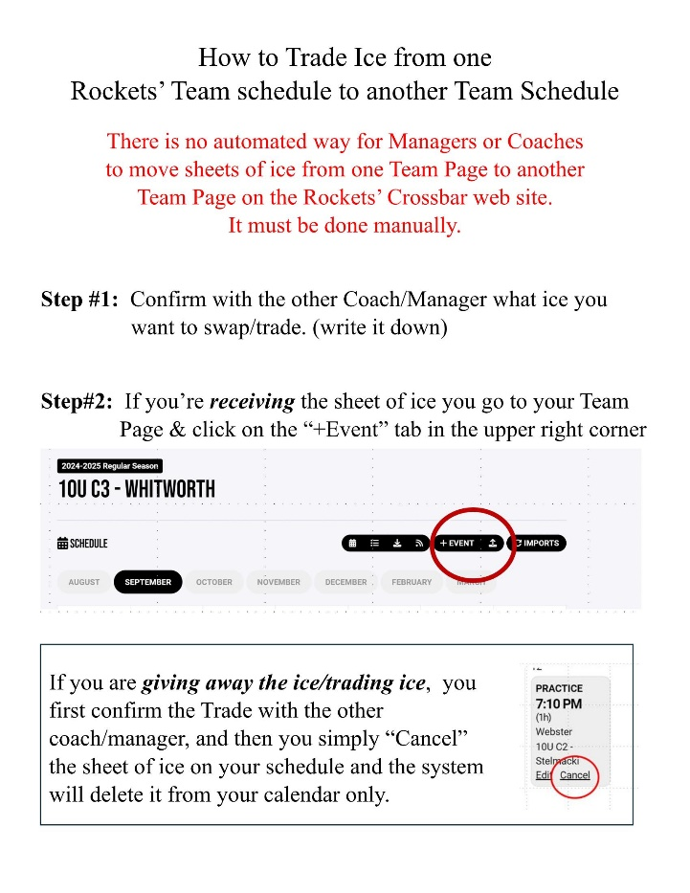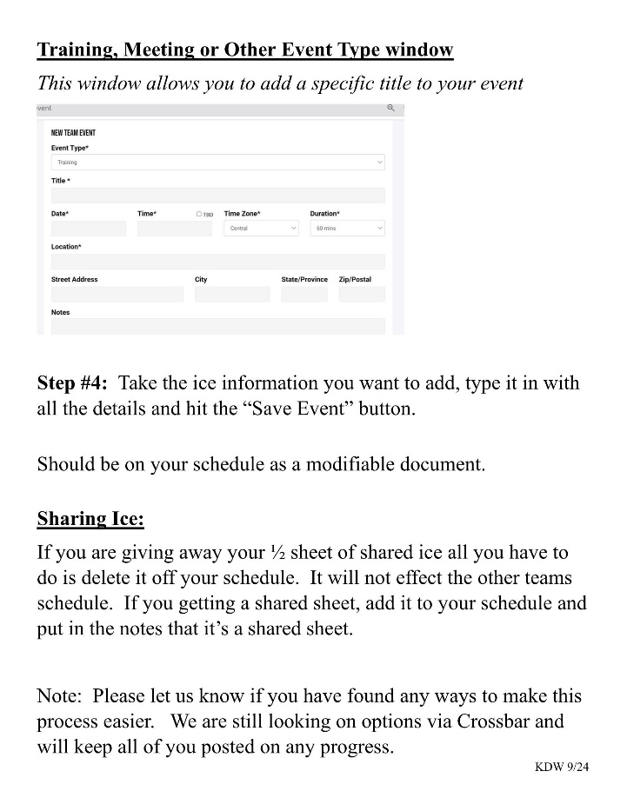

Uniforms
- Jerseys and socks are purchased through the Rockets and can take up to 90 to 120 days for delivery– contact Rob Skinner at execdirrockets@gmail.com.
- Your jersey number will follow you each season you play with the Rockets.
- It is best to carry your jerseys on hangers.
- Please do not wear game jerseys and game socks at practice.
- Wash jerseys periodically on cold/cold cycles and hang to dry.
Official roster

Jill Rowland, Registrar, will submit your roster for certification with USA Hockey and once it is approved, USA Hockey will automatically send the link to your Head Coach. Be sure to double check and make sure all your players and coaches are listed and that none of your player/coaches are redlined. If a either are redlined, there is a piece of his coaching information that is not current or for 18U players that their SafeSport has expired. If you see the coach redlined, please reach out to Jill Rowland. You will need the official roster for your tournaments. We will also make sure to verify Birth Dates on your USA Hockey Certified Roster. You will not need to carry birth certificates with you.
Tournament Information

When considering tournaments, always consider a trip out of town. They can be fun and a better opportunity for the team and the parents to get to know one another. Research and choose your team’s tournaments wisely and early. If you have your tournaments chosen before the Mo-Hockey’s League Game scheduling starts, you will know which weekends to avoid for league and practice games. If you wait to schedule tournaments, you may have conflicts with practice ice which cannot be resolved by a trade or you will have conflicts with league games which are difficult and expensive to re-schedule. Big tournament weekends are Thanksgiving, Martin Luther King weekend and President’s Day Weekend.

Tournament sources are:
- Talk to fellow managers, coaches, and/or parents within the club and outside the club
- A variety of tournaments can be found on the Rockets website under Resources>Tournaments
Companies like Big Bear, My Hockey Tournaments, and Ultimate Hockey Tournaments have tournaments all over the country.

“B” tournaments are usually more difficult to find than “A” tournaments. Some “B” teams may want to play up into an “A” tournament for a number of reasons; however, speaking with the tournament chairperson will give you more information regarding bringing your team to that specific tournament. Finding “C” level tournaments is even harder. Most tournaments consider “C” level a HOUSE level. House levels, are different across the country.

You don’t want to take your team to a tournament where they will lose every game by a huge margin. Be selective of the tournament and remember your families are paying their own way and would rather not attend if the games are going to be brutal.

Tournaments/Out of town trips

Tournaments and out-of-town trips should be scheduled as early as possible. Tournaments require at least four steps.
- Complete the tournament application (they may request a Certified Roster)
- Arrange hotel accommodations – typically this is through the tournament organization.
- Obtain directions to hotel and tournament site and distribute them to the parents
-Apply for your Travel Permit as soon as your tournament spot is confirmed. Click here the form here.
-Travel Permit fees range from $12 to $50 depending upon when you request it.

Requests made 21 days or more prior to travel $12
Requests made between 8 & 20 days prior to travel $25
Requests made 7 days or less prior to travel $50

Once you receive your invoice, you will be able to pay online by CC card or via an ACH transaction from a
checking account. You should receive your Travel Permit about one week before departure. If you have not received your permit 3 days before you leave, call Deb Hellwig at (314) 568-5377 to inquire about the status.

You do not need to apply for a travel permit for any trip, even overnight, if the trip is within the league play area which includes Springfield, Illinois; Springfield, Missouri; Jefferson City, Missouri and Northwest Arkansas. When in doubt, email Deb Hellwig at dahellwig@att.net. MoHockey to ask if a travel permit is required. Remember that out of town trips, not just tournaments, require a travel permit if the destination is outside of the league playing area.
If the tournament committee ask for Birth Certificates inform them that all Rockets players are have been certified and verified on the USA Hockey Certified Rosters, so no hard copies of birth certificates are required.

Team Pictures

Team pictures will be held at the Rockets Off-Ice Facility. Tom Paule Photography will be suppling a special link to schedule your team’s Photo Session. That link will be forward to all managers in September.
Session Dates: November 8 & 9 7:00am to 3:00pm
November 10 & 11 5:00pm to 9:00pm
Once you receive the Scheduling Link, please schedule your session ASAP. Once you schedule it, be sure to notify your parents of the date and time plus add it to your Team page schedule. Order Forms for parents will be available at the Off-Ice Facility on the day of the Photo Session.
Rink Addresses
A link to the addresses of all of the various rinks can be found here.

Problems and Discipline

Players

You should generally leave player discipline to the coach and the player’s parents. If you observe any problem with a player, notify the coach to handle the issue. This includes the condition of the locker room after games and practices. As the coach controls ice time and the “exertion level” of a practice, their word to a player carries more weight than a manager’s word. Obviously, this advice must be tempered with some judgment.

Parents/Spectators

Use the USA Hockey Code of Conduct as a guide. A parent or spectator whose actions or words, which are not in compliance with the USA Hockey Code of Conduct, should be gently and quietly reminded that such behavior is not appropriate. Repeated or serious violations should be reported to Rockets Executive Director, Division Liaison of your division, and/or Director of Hockey. What constitutes “repeated or serious” violations must be left to your good judgment. Here are some examples: cursing from the stands after being told to stop; any inappropriate touching of a player; any threats toward referees, coaches, parents, or players; physical violence; ejection from the rink premises; ejection from the spectator area. If necessary, seek the advice of the Executive Director or the Director of Hockey. Do not allow problems to continue, especially serious problems, without notifying Mike Richards, the Rockets Director of Hockey at rocketsdirectorofhockey@gmail.com and Rob Skinner, Executive Director of Hockey at execdirrockets@gmail.com

Coaches

Although this is a very infrequent problem, it can be the most difficult. If you notice issues relating to the coach, such as the examples mentioned in the prior section, contact the Director of Hockey, Mike Richards.

Locker Monitoring

It is a USA Hockey policy that a USA Hockey Registered Locker Room Monitor be present in the locker room at all times. Locker Room Monitors must be listed on the Certified Roster.

Zero Tolerance

USA Hockey has a zero-tolerance policy for misconduct by parents, players, coaches and others. Managers should exercise every reasonable effort to assist with compliance with zero tolerance. USA Hockey has various materials to provide help with its zero-tolerance policy. Part of the goal of zero tolerance is to ensure that problems with conduct cease before they become persistent or major problem.
Problem solving with in Team

If parents contact you regarding a problem, feel free to address that problem if you are able and comfortable doing so. If the problem is more than you feel comfortable handling, reach out to our Director of Hockey, Mike Richards.

Scheduling Off Ice Officials (Scorekeepers & Timekeepers)

You must arrange for parents to run the clock and keep the score sheet for all Home games. You also need to schedule a volunteer to work the penalty box for all Home and Away games with younger players.

Often managers perform one of these roles. The clock operator and the scorekeeper are more than what those terms suggest; they are off-ice officials and therefore must remain neutral.

The ON-ICE officials are in charge; the off-ice officials work for and are subordinate to the on-ice officials.

- The off-ice officials should be trained on how to run the clock and keep the score sheet. The first time that anyone does either task, they should have one person in the “box” that is experienced and can provide guidance with the task to be performed. We strongly suggest that parents use the time that the kids are practicing on ice to practice running the clock. Especially putting up penalties.

- The off-ice officials must not coach from the “box” and must maintain an outwardly neutral attitude. This does not mean that an occasional, short, spontaneous cheer will be criticized.

- If off-ice officials have questions they should ask the on-ice officials at the next stoppage in play.

- Off-ice officials should feel free to ask for clarification of calls on the ice, for example, to keep the score sheet properly and to be certain that players are released from the penalty box at the correct time. Off-ice officials cannot act to change or influence any call by the on-ice official.

- Off-ice officials must not criticize on-ice officials; problems deserving of criticism should be reported to the appropriate authority, i.e. MIHOA via their web site. http://www.mihoa.com/complaints.html

- Any problems with players in the box should be immediately referred to the on-ice officials.

Score Sheets/Clock Responsibility
The Home team will provide a score sheet, a scorekeeper and a person to run the clock/scoreboard.
Scoreboard manuals and cheat sheets for all our home rinks can be found on the Rockets Website under Resources>Score Board Directors for Home Rinks.
Directions on how to fill out a score sheet can also be found on the Rockets website under Resources> Score Sheet Direction-Missouri Hockey.
Instructions on How to Keep a Scoresheet
- The Home team will be responsible for submitting the final score and the score sheets onto Mo-Hockey’s
website. You will need to take a picture of the score sheet and upload it to Mo-Hockey’s Website when
you load the score.
- Rockets teams will be notified to pick up their packet of score sheets at the Rockets indoor facility once
we receive them from Missouri Hockey.
- Failure to enter the scores online by the set time frames will result in a financial assessment of $10 to the
offending club at the discretion of the MAIHA-YD Executive Committee or President.
- Instructions to enter games can be found here: Missouri Hockey Youth Division | Website Instructions
Scoresheets

Managers are to supply score sheet for all Home games. Here are a few of tips on score sheets:
- Have pre-made Roster labels that include the player’s names & jersey numbers, Coach’s names with CEP
ID numbers & CEP levels on the labels. You need 3 labels for every score sheet. There is a roster label
template available on the Rockets web site.
Link: https://www.rocketshockey.com/team-manager-resources/misc-forms-and-documents/51994
- Coaches may sign the score sheet before the game begins. Referees may take care of that.
- Rockets have “Score Sheet Directions” on the Rockets website under Resources. Print a copy to carry with you to each game. We suggest sending a copy to all your parents. One suggestion is to have a scrape pad of paper to write down what the Referee tells you for goals/assists and penalties, then transfer to the score sheet when time permits. This helps to avoid making mistakes on the score sheet.
- Be sure that you have the correct league id number on all score sheets. Game ID number can be found on the Mo-Hockey web site.
End of the year/party/coaches’ gifts
The coaches’ gifts can be handled out of the team fund or by a separate collection. Get an idea of what the coaches might like, the amount of money spent is less important than a good memory of the team. The party may be held at a restaurant, bowling alley, or at a volunteer’s house. Start making arrangements approximately 30 days before the last ice time. Be sure to give notice by email and enter it into your Rockets Team page only. The party costs can vary substantially. Costs can be taken from the team fund or from a separate collection.
GENDER EQUITY POLICY – Co-ed Locker Rooms
The issue of co-ed dressing arrangements in locker rooms continues to come up, and USA Hockey is frequently asked to provide some type of guideline about dealing with such situations. Teams, leagues, associations and USA Hockey need to recognize that there are gender equity issues to deal with when managing a co-ed locker room setting. Both female and male privacy rights must be given consideration and appropriate arrangements made.
USA Hockey’s member organizations should consider the following:
- Recognize that it is an issue that must be dealt with and that favoring one group over another can produce legal ramifications.
- Recognize that the ideal situation of using two, separate dressing rooms is not possible in many ice rink/arena settings;
- Recognize that it is an issue that will increase in visibility as girl’s/women’s participation in USA Hockey continues to grow; and
- Recognize that it is an issue for members who are participating as players, coaches and officials.
Our recommendations, made in conjunction with the Girls’/Women’s Section, the Coaching
Education Program and the Officiating Program are as follows:

NOTE: Make certain that at least one properly screened adults(Locker Room Monitor) are present in locker room settings to supervise. Locker Room Monitors must be listed on the USA Hockey Certified roster. Arrange to provide supervisors who are of the same sex as the children they are to protect. Please follow Coaching Ethics guidelines.
- Where possible, have the male and female players undress/dress in separate locker rooms; then convene in a single dressing room to hold the coach’s pregame meeting;
- Once the game is finished, hold the coach’s post game meeting; then have the male and female players proceed to their separate dressing rooms to undress.
- In those cases where separate facilities are not available, have one gender enter the locker room and change into their uniforms. That gender then leaves the locker room, while the other gender dresses. Both genders would then assemble in the locker room and hold the coach’s pre-game meeting.
- Following the game and the coach’s post game meeting, where separate facilities are not available, the second gender group enters the locker room and undresses, while the first group waits outside until they have undressed and left the room. Once the second group leaves, the first group enters the locker room and undresses.
NOTE: Taking turns is a means of ‘reasonable accommodation’, so neither gender group is neither favored, nor is “the ones who always have to wait” and it’s fair, failing to establish some type of similar procedure, or failure to seriously consider the privacy issues will likely lead to complaints and/or lawsuits. By being proactive on this issue, everyone [coaches, players, officials, volunteers and parents] can enjoy the sport without the worry of legal actions or the invasion of privacy concerns arising.

Lastly, reinforce to all players, coaches, officials, volunteers and parents that your organizations are going to take this issue seriously. It is not acceptable under USA Hockey’s By-Laws –Policies on Physical and Sexual Abuse – for members to be observing the opposite gender while they dress or undress. Members and volunteers who violate USA Hockey’s policies, or who violate the privacy rights of others, could be subject to appropriate discipline.
Your attention to this topic and to preventing problems arising from this issue will be greatly appreciated. We are grateful for your cooperation and assistance in providing an enjoyable, safer experience for USA Hockey’s membership.

Final Note

As team manager you can set the tone for the whole off –ice experience for your parents and players, while your coach sets the tone for the on-ice experience. Please make it a good and positive one. Please take your responsibilities seriously but have fun with it and cherish every moment you get to spend in the lives of your children and all the other great kids and parents on your team. We are lucky to get this opportunity to share this game and this time with our kids and all the old and new friends we make in hockey.

Thank you for your time and commitment.

At any time if you have any questions, please feel free to contact: Rob Skinner / execdirrockets@gmail.com

MO Hockey Contact Information 11648 Gravois Rd. , Suite 110, St. Louis, MO. 63126, Phone: (314) 842-6466
Fax: (314) 842-6227 byrnawilliams@mohockey.org

Link to Mo-Hockey Forms: http://www.mohockeyyd.org/Forms.jsp

