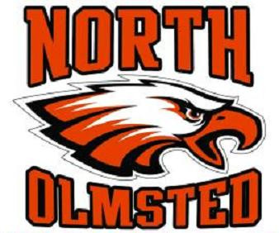

Dear Potential Sponsor,

Youth hockey is one of the fastest growing sports in the Cleveland area with more than 30 organized local programs offering both entry level and competitive travel team opportunities for boys and girls from 5-18 years.

We are seeking sponsorships for the North Olmsted Hockey Club (NOHC) – a not-for-profit organization that will consist of 12 teams for the 2025-2026 season based out of North Olmsted, Ohio. The teams range in age from 8 and under (“Mites”) to 13-14 (“Bantams”), and consist of players from many West side suburbs and beyond. The travel teams participate in the (CSHL) Cleveland Suburban Hockey League, and represent a wide range in terms of the level of competition that each team will face. The teams will all be playing an aggressive schedule (1-2 games per week from early November through early March) and may play teams from Ohio, Michigan, Pennsylvania, Canada, and elsewhere during local and out-of-town tournaments.

Company sponsorships are vital to the success of youth hockey programs; your participation is key in helping to defray costs associated with travel tournament registration fees, ice time, and team equipment / apparel. There are three levels of sponsorship that will benefit both your business as well as the associated NOHC team; the benefits of each level are listed in the sidebar.

Thank you for your consideration and we hope you can be part of our team.

Best Regards,

Missy Leonhardt
Missy Leonhardt(President@nohc.net)
President – North Olmsted Hockey Club

Eagle $1000

- This top-level sponsorship will feature a custom text advertisement with a web link of your business on the NOHC web page
- An opportunity to post special business promotions or coupons on our web page
- Targeted email promos can be delivered to our entire member organization
- Your business name included during home game announcements, where possible

Talon $500

- A custom text advertisement with a web link of your business on the NOHC web page
- An opportunity to post special business promotions or coupons on our web page
- Your business name included during home game announcements, where possible

Wing $250

- A custom text advertisement with a web link of your business on the NOHC web page

www.NOHC.net

Organization Name: ____________________________________________________________

Address: ____________________________________________________________

Phone Number: ____________________________________________________________

Key Contact: ____________________________________________________________

Company Web Address: ____________________________________________________________

Contact Email: ____________________________________________________________

Sponsorship

Eagle □

Talon □

Wing □

Other □

For NOHC use only:

Team Name: _______________________________________________________

Player Name: _______________________________________________________

Credit Yes □ No □

North Olmsted Hockey Club (NOHC) Tax ID: #23-7305881
Please make checks payable to NOHC and send to:

NOHC
26000 Lorain Road
North Olmsted, OH 44070

Questions? Please contact Club President, Missy Leonhardt
(440) 539-1200
President@nohc.net

