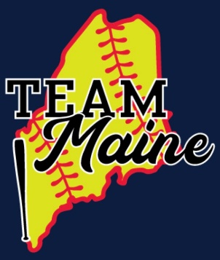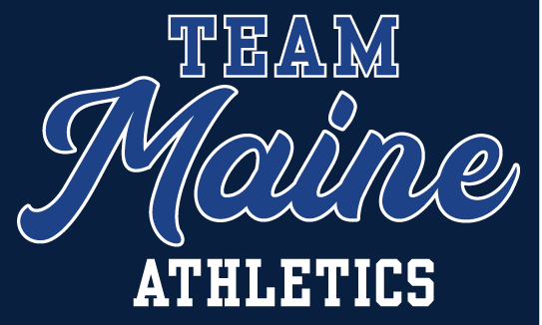

2024/2025 TEAM MAINE ATHLETICS PLAYER CONTRACT

To participate in the Team Maine Softball/A.C. Maine (TEAM Maine Athletics), including practices, scrimmages, regular season games, tournaments, and/or any other team activities- players must follow the guidelines outlined within this contract. Any violation of the contract agreement can expose the player and parent to suspension, expulsion or any other disciplinary action the coach, board of directors or ownership deems appropriate.

Behavior

- The player must always conduct themselves as representatives of their families and their community.
- Profanity or sudden outbursts of negative emotion will not be tolerated in any situation or setting. The coaching staff will deal with intentional premeditated outbursts or negative behavior harshly and promptly. Other types of negative conduct, even though unexpected on the part of the player or parent, may also be subject to punishment.
- Each player will be polite and courteous to team members, opponents, coaches, fans and officials.
- Punching, shoving or otherwise physically attacking anyone will not be tolerated.
- The player must always in all aspects of their lives, attempt to reflect well on the team and the program.
- Cell phone use is prohibited in the dugout and during games.
- Behavior outside of TEAM Maine Athletics (school, community, etc.) can and will be reviewed as necessary by coaches, owners and board of directors if such actions may reflect the overall representation of the club and its members. Matters deemed serious by those members may result in suspension, and dismissal from the club.

- Practice

- Individual coaches will set policies for practice attendance and participation. However, it is expected the players will attend training sessions and communicate with coaches when time is missed. Players who attend minimal amounts of these sessions may not see the same playing time as it relates to (missing plays, or review situations, etc.).
- Parents / Guardians will arrange transportation for the athlete promptly following the conclusion of practices and games.

- Games

- The player must be on time and in complete uniform in order to participate.
- The athletes should arrive for their games in proper attire with all appropriate gear for participation.
- Sportsmanlike conduct is expected of all participants. Inappropriate behavior may result in suspension or dismissal from the team.
- The player must receive approval from the coach and/or director to participate in a secondary team other than Team Maine (unless Little League or Town ball).

- Chemical Health Policy

- No player shall distribute, dispense, possess, use or be under the influence of any alcoholic beverage, malt beverage or fortified wine or other intoxicating liquor nor tolerate any such activity by any other player.
- No player shall unlawfully manufacture, distribute, dispense, possess, use or be under the influence of any narcotic drug, hallucinogenic drug, amphetamine, barbiturate, marijuana, anabolic steroids, or any other controlled substance nor tolerate any such activity by any other player.
- No player shall distribute, dispense, possess, use or be under the influence of any tobacco-related substance at any time nor tolerate any such activities by any other player.
- ALL matters around substance usage and/or abuse will be reviewed individually. Outcomes of that review by coaches, ownership and the board will decide the fate of the individual(s) involved.

- Playing Time

  - The coach, through his/her assessment of game situations, player skills, attitude, player development and team need will determine game playing time/positioning. There is no guarantee, stated or implied, of playing time or playing position. In tournaments, coaches will do their very best to be sure everyone will play in pool play. However, drop dead times, and run rules may not make this possible in every game. Playing time is not guaranteed during elimination play.
  - It is the player’s job to discuss playing time questions with the coach, not the parents.

I understand and agree to the above guidelines for participation in the Team Maine organization. I understand that if the guidelines are not followed, suspension, expulsion or any other appropriate enforcement action may be enforced without reimbursement of tuition or other funds.

Player Name: _____________________________________

Signature: ________________________________________

Parent Name: _____________________________________

Parent Signature: __________________________________

Date: _____________

