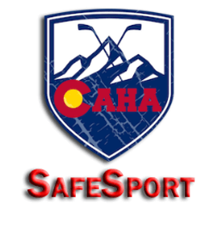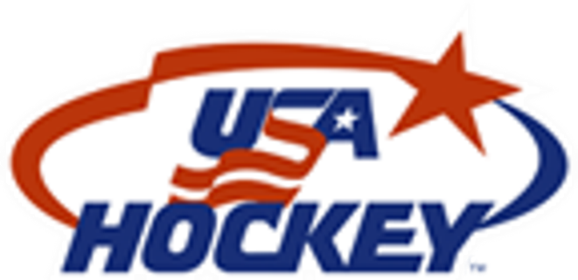
CAHA SafeSport Oversight – Updated Process & Role Clarification

To enhance the integrity and consistency of SafeSport investigations across Colorado hockey organizations, CAHA (Colorado Amateur Hockey Association) will now assume full responsibility for managing and resolving all SafeSport-related investigations. This shift allows local organizations to focus on education, compliance, and proactive safety measures.

New Process Overview
1. CAHA’s Role in SafeSport Investigations
CAHA will:
- Serve as the central authority for receiving and investigating all SafeSport reports.
- Ensure investigations are conducted in accordance with USA Hockey and Center for SafeSport protocols.
- Maintain confidentiality, impartiality, and thorough documentation throughout the investigative process.
- Communicate outcomes and necessary actions to relevant parties.
Note: Local organizations should not conduct their own investigations. All reports must be escalated to CAHA or Center for SafeSport.

2. Responsibilities of Organization SafeSport Coordinators
Local SafeSport Coordinators will now focus on compliance, education, and member support. Their responsibilities include:
✅ Training Compliance
- Monitor and ensure all coaches, volunteers, officials, and staff complete SafeSport training annually.
- Track training completion using USA Hockey’s registry or approved tracking systems.
✅ Background Screening
- Verify that all required individuals have completed background checks through USA Hockey’s designated provider.
- Maintain up-to-date records and follow up on pending screenings.
- Background Screening and SafeSport Training will be in conjunction with Organization Registrars.
✅ Locker Room Monitoring
- Ensure that locker room monitors are rostered for all youth practices and games.
- Ensure monitors understand their role and responsibilities.
✅ Member Education
- Provide educational resources to players, parents, and staff about SafeSport policies and distribute materials on topics such as abuse prevention, boundaries, and reporting procedures.
✅ Reporting Guidance
- Act as a resource for members who have questions or concerns about SafeSport.
- Guide individuals on how and where to file a report, including:
- Directing them to USA Hockey’s reporting portal https://usahockey.i-sight.com/portal for non-sexually related cases, Center for SafeSport https://uscenterforsafesport.org/report-a-concern/ for sexually related cases or contact CAHA at safesport1@coloradohockey.org for questions or guidance.
- Explaining what constitutes a SafeSport violation
- Assisting with documentation and communication with organization staff as needed

Reporting Protocol
If a member witnesses or experiences misconduct:
- Do not investigate internally or hire an outside entity. Please comply with USA Hockey and Center Policy.
- Report to Center for SafeSport at https://uscenterforsafesport.org/report-a-concern/ for sexual case USA Hockey at https://uscenterforsafesport.org/report-a-concern/ for non sexual or contact CAHA at safesport1@coloradohockey.org
- Provide support to the individual and ensure they feel safe and heard.

Benefits of the New Structure
- 🛡️ Centralized investigations ensure fairness and consistency, confidentiality, and avoidance of conflict.
- 📘 Clear division of responsibilities reduces confusion and risk.
- 👥 Empowered coordinators can focus on education and prevention.
- 🔍 Improved transparency and accountability across all organizations.

