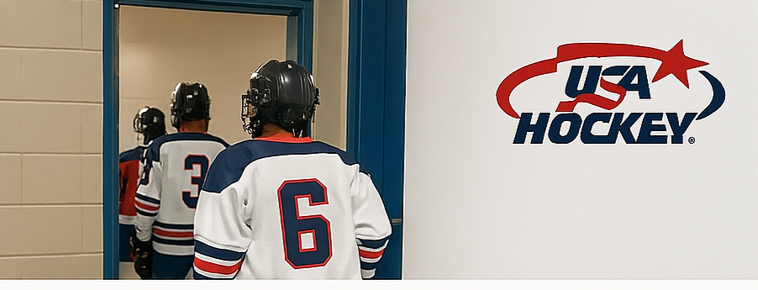
🛡️ Protecting Our Athletes
Your Role in Locker Room Safety
Locker room monitoring protects privacy, prevents misconduct, and builds trust. Your presence helps ensure every athlete feels safe, respected, and supported.
✅ Key Responsibilities
- Two-Deep Rule: Always have two screened adults present.
- Same-Gender Monitoring: Assign monitors who match the athletes’ gender whenever possible.
- No Cell Phones or Cameras: These are strictly prohibited in locker rooms.
- Privacy First: Athletes must change in designated private areas.
- SafeSport Compliance: All monitors must complete training and pass background checks.
Concerns
- Unscreened adults entering locker rooms
- Cell phone use or photography near athletes
- Confusion about gender-specific monitoring roles
- Failure to document and report concerns
In the Locker Room
- Athletes must change in private areas only.
- Monitors should remain present until all athletes have exited.
- Report any concerns immediately to the designated SafeSport contact.
📘 Need Support or have Questions:
https://www.usahockey.com/resourcesanddownloads
https://uscenterforsafesport.org/
safesport1@coloradohockey.org


