January 2025 – Board of Directors Meeting, Nox’s on 8
Attendees – Nick Druga, Kim Rios, Holly Levin, Kate Koch, Jordan Snead, Kirk Howard, Julie McDermott, Alan Bresnei, Nick Cushion, Theo Nelson
Not attending – Joshua Dadeboe
Board of Directors report:
- March 29th/30th will be the first Weekend of the spring
- Housekeeping
  - 1st month of every quarter will be in person
  - Google Doc – follow as a guideline
  - Meeting Minutes – will have a motion at each meeting to accept the minutes
    - Minutes will be published 1 week prior to the director meeting
  - Motion to accept the AGM meeting minutes: Alan/Jordan
    - Accept the minutes 1 week from this meeting
      - Unanimous
- The new website is NOT FRAUD
- Google Doc Run Down – Snapshots of activities below by board member
  - Sponsorship
  - TOPSoccer
    - 2 of the larger balls, 2 balls that make different sounds, plow type of wheelchair support, professionally printed handouts, pamphlets, etc.
    - New Club for TOPS – Pittsburgh Dynamo
  - In House
    - No lead
  - ICL
    - Coaches for the new year
    - Evaluations for the players
    - 58 registered – will increase
  - Travel
    - U12 boys need more support with coaches (currently 0 coaches)
    - Will be looking to do MS team
    - Teams are together until they are NOT – even if they have new coaches
  - Parent Involvement
    - Working on Spring Fling
    - Easter egg hunt this year?
    - Advertise for the parent committee – what we want to get done this year
  - Field Management
    - Follow-up
    - Field nights under the lights
    - Biles field on Sundays?
  - Volunteer sign-up manager – Jamie Druga
    - Mechanism to validate the sign up
    - Each account owner now has the capability to show/review their hours
    - Can payout the $100 if they choose prior to the season.
    - Mechanism to eliminate the times that they did not show up for their shift
  - Concession stand
    - Lock/unlock the door from remote location
  - Jr. Referee Assignor
  - Talk through in February – easier to click in and schedule
    - Spring Parent meeting set the date
    - Team building – sent out the preliminary structure to review and compare to details
      - Academy nights – important to stay in place
      - Change to age groups by age level vs. birth year
        - We need to remember that literally everyone will be going through this at the same time (the clubs will be using collaboration)
        - Will review in February for more details and building
        - We will socialize to review the details for team building
- President – Nick Druga
  - 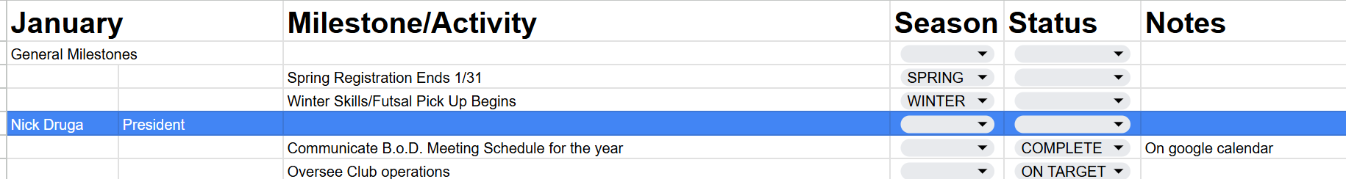
- Vice President – Kim Rios
- Registrar – Holly Levin
  - 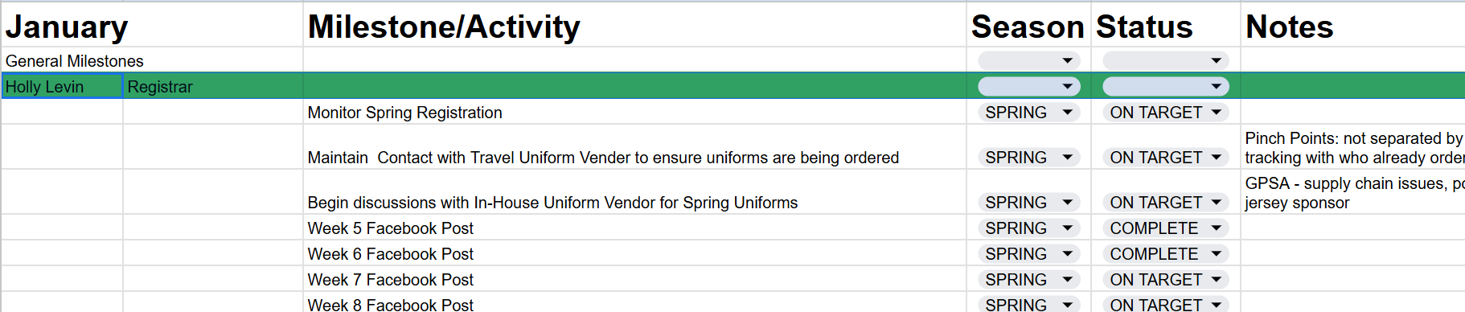
- Secretary – Kate Koch
  - 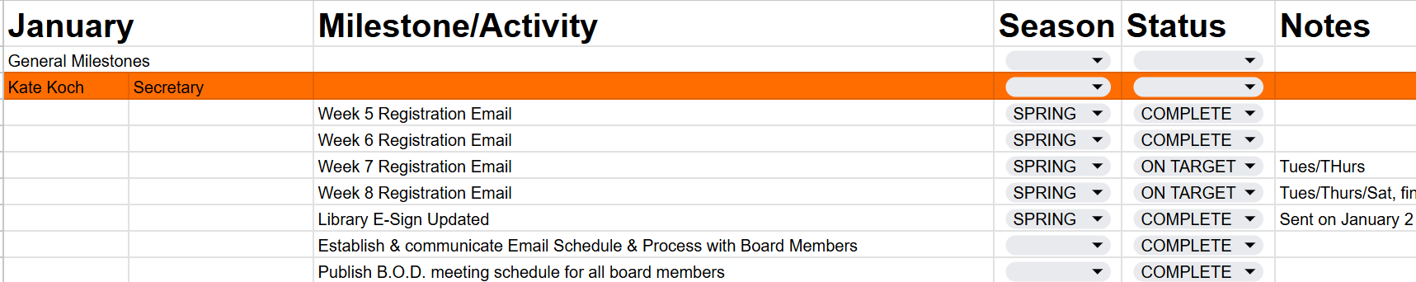
- Treasurer – Joshua Dadeboe – Josh emailed
  - Update on the finances
  - $20,771.44 in net Spring registration to date
    - Financial transaction from Sportsconnect to Crossbar has been smooth.
  - Account Balances: $164,199.40 total
    - Savings: $113,324,40
    - Dollar Bank (operating): $46,475.37
    - Venmo: $2,843.65
    - PayPal: $1,555.98
  - Deposit of volunteer checks should occur this month once they clear review.

- Board Reports
  - Open –Director of In House
    - 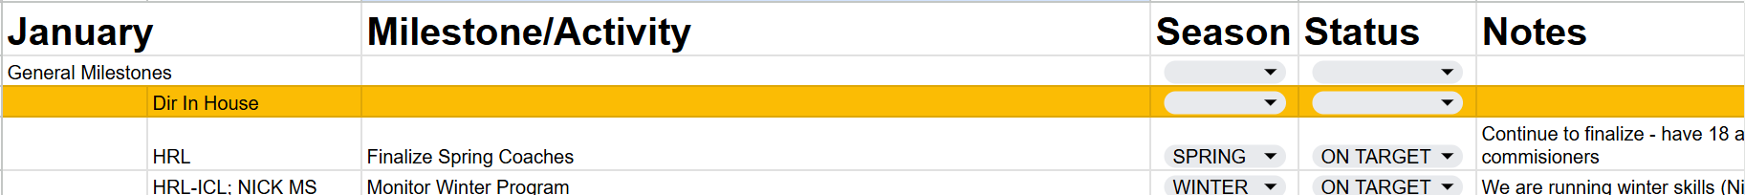
  - Kirk – Director of TOPSoccer
    - 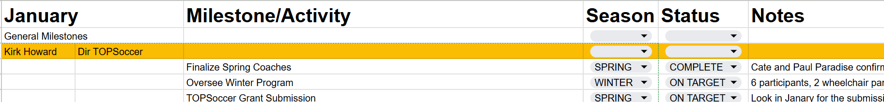
  - Mike – Director of ICL
    - 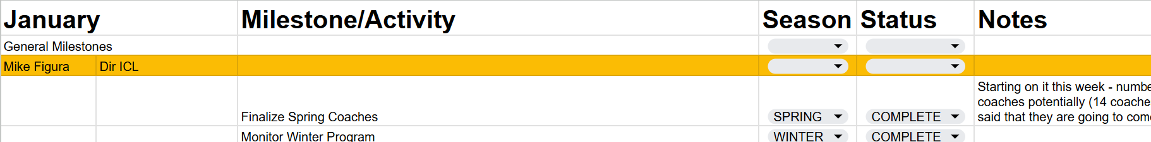
  - Julie – Director of Travel
    - 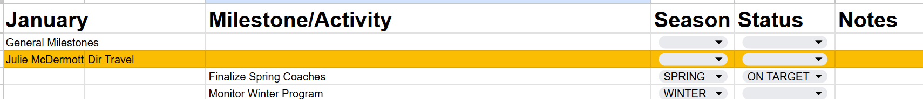
  - Jordan – Director of Risk Management
  - Theo – Director of Parent Engagement
    - 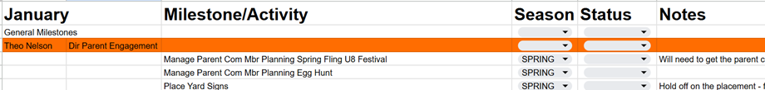
  - Nick – Director of Fundraising
    - 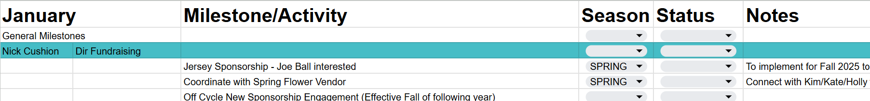
  - Alan – Director of Fields and Permits
    - 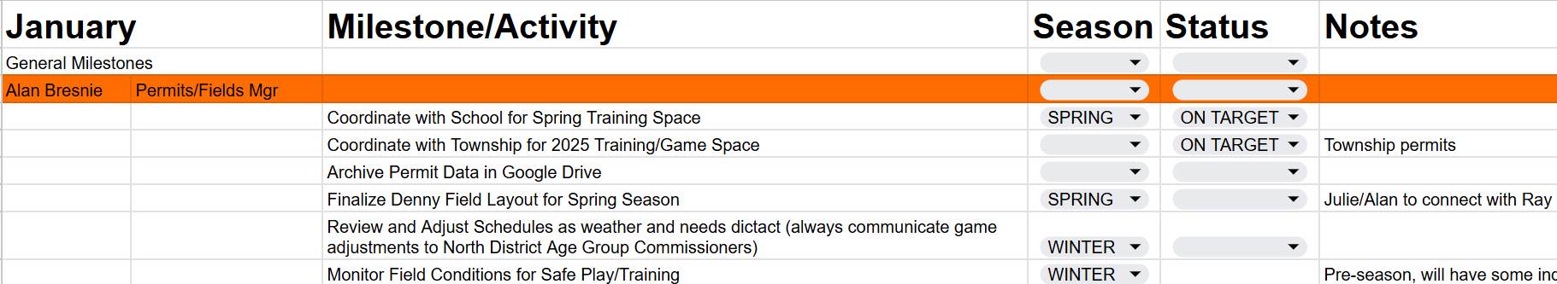
- New Business
  - Motion: Appoint interim positions
    - Motion: Kirk/Nick C
      - Kim Rios – Interim Vice President
      - Theo Nelson – Interim Director Parent Volunteer Coordinator
      - Jamie Druga – Interim Sign up Coordinator
      - Discussion – N/A
    - Motion accepted unanimously
  - Motion: Install a new Keyless door entry on our brand new man door – $400 threshold
    - Motion: Kate, Second: Jordan
      - Can unlock from afar
      - Won’t have multiple keys out
    - Motion accepted unanimously
  - Motion: U6 Goals
      - Motion: Re-net the small goals for training or U5/U6 goals – threshold $1000
      - Motion: Alan, Second: Theo
      - Were originally goals for U8
      - May need to purchase 1 new goal due to odd number of goals
    - Motion: accepted unanimously
  - February Item: Upstairs Shelving
    - Alan reviewing for February $3500 door installation and cost of keypad lock – Upstairs and Downstairs
- Open Discussion:
  - Email address for fundraising – Nick
  - Check alias details with Joshua
  - Reschedule the February meeting due to Super Bowl
- Motion to adjourn:
  - First: Julie Second: Theo; Meeting adjourned at 8:18PM.

