Meeting minutes | 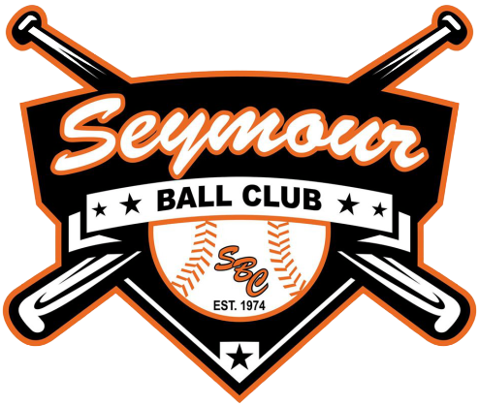
01.13.2025

Date: |  | Called to Order: |  | Secretary:
02.10.2025 |  | 6:40 P.M. |  | Cassie Sedlacek

In attendance |  | Approval of minutes
Jason Woodford, Todd Barnhardt, Cassie Sedlacek, Teri McFadden, Martelle Mikkelson, Katie Williams, Jason Bowe, Nicole Owen, Christa Ball, Beth Vrablic, Lindsey Sipple |  | The minutes were reviewed from January 27th meeting and approved.

Meeting Minutes
- Introduction to T-ball scheduled for upcoming Sunday (04.16) at 3:00 p.m. 11 children signed up so far. Planning for up to 20. Both Stars and Flames programs will have players there to support the event. Cookies and water will be provided.

- Registration Update: 35 baseball, 44 softball, 11 t-ball. Last years numbers were 122 baseball, 84 softball, and 42 t-ball. Registration is set to close March 2. Discussed some ideas for pushing registration, including more activity on social media posts, yard signs, and flyers at local businesses. Todd B. made a motion for Travel Ball players (Stars and Flames) to receive a $20 discount for signing up for league (Open for three weeks until registration closes). Seconded by Katie W. Motion Carries. Stars and Flames directors/coaches will be responsible for communicating this to teams.

- Christa B. reminded board members to respond to email with questions for Board Member spotlights. Please take time to respond.

- Sponsorship Update: Most of these have gone up except for a few email addresses that may have changed. Currently, we have not received any responses or checks. If we end up with more sponsors than teams given registration numbers, there will be preference for those requesting to sponsor a specific team. Discussed Nicole getting contact information for Allied Fence from Paul. We would like to also get a sign for them given discount that was provided on fencing for new field. Discussed connecting with new owners at Fox Run. Jason W. will get them tournament dates as well as dates for March board meetings to invite them to attend.

- Fever Fest Update: Close on one act. Currently have band for Friday night and two openers for Saturday. Working to get offer out for headliner. Fever Fest Sponsorship packets are out. Precision Pipeline is in for $15,000 and Pepsi for $10,000.

- Discussed differences in age brackets for softball which may come up at upcoming meeting. USA and NAFA are now both switching to September 1st dates (USA was using September 1st). We will switch to September 1st dates next year (allow some flexibility this year).

- New Field: Fence is done and grass is in. Green Oasis will aerate grass in spring. Grading work is mostly complete. Working on plan to get water in (can work with Green Oasis, as they are sponsors). Working on plan for getting footings put in under dugouts. Town may want to co-invest in bleachers. Bases, etc. will be ordered from Chippewa Valley Sporting Goods. Looking for someone to do masonry work for dugouts. Recommendation to reach out to BAC North.

- Grant Updates: Todd B. is working to fill in papers for the DNR grant, which is due May 1st. Because we do not yet have estimates for bathroom/concession projects, grant application this year will be submitted to recoup half the funds for new field and for work on field 1. Katie W. volunteered to work on MLB Brewers/Twins grants.

- Discussed putting a committee together to work on getting information for upcoming projects (i.e., bathrooms, concessions, etc.)

- Todd B. proposed an additional baseball tournament (Sunset Tournament) to run August 15-17. It would be similar to the Dust the Rust Tournament, and would be estimated to net $12,000 to $13,000. Would bring in volunteer organizations to run the concession stand. Would just need the items for the concession stand. Todd B. would be responsible board member and Paul W. would be coordinator. Discussed that we would need to check with the town and get approval. Jason W. will reach out to town. Martelle M. makes motion to hold tournament (pending town board approval). Teri M. seconds. Motion carries.

- Garbage service has been switched to GFL. Waste Management contract will end next month.
- Reminder of CVBL and CVGFL Meetings on February 23rd at Wagners (beginning at 5:30). Jason W. will print agendas.

- Discussed our contract with the town. $3500 a year for use of park. Basically paying for electrical service. Also contract so anyone else wanting to run a tournament/use the fields would need to pay a significant fee/provide own concession items.

Meeting Adjourned
Meeting was adjourned at 8:01 P.M.

Upcoming Business
- Technical Updates for the Club
- Bylaws (need to set meeting for executive committee review)
- Follow-up on Progress with league and softball budgets
- Ongoing Updates: Raffle, Fever Fest, Registration, Grants, Financials
- From last meeting: Hit, Pitch, and Run
- New owner of Fox Run to attend board meeting
- Follow-up on Town decision for additional baseball tournament

Next meeting
02.24.2025| 6:30 p.m. Fairfield Inn Eau Claire

