How to Sign Up for Volunteer Opportunities
From a computer, click on the word ACCOUNT in the upper left corner of your screen and log into your Crossbar account if not already logged in. Once logged in it should list your player(s) under participants.

Click on VOLUNTEER on the menu on the left side of the screen.

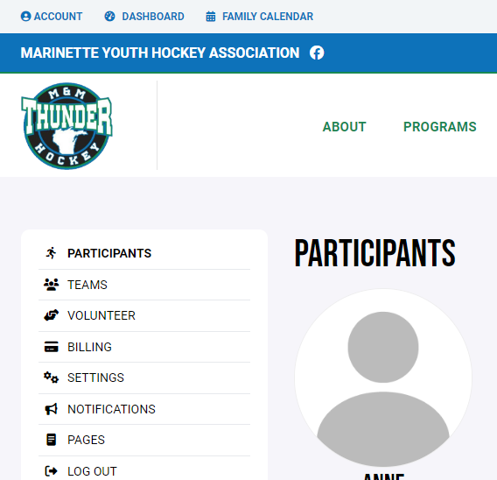

Once in the Volunteer screen you will see the total required volunteer hours for that player and the volunteer opportunities that are currently available. To sign up for any of the opportunities click on the MORE INFORMATION button at the bottom of the section.

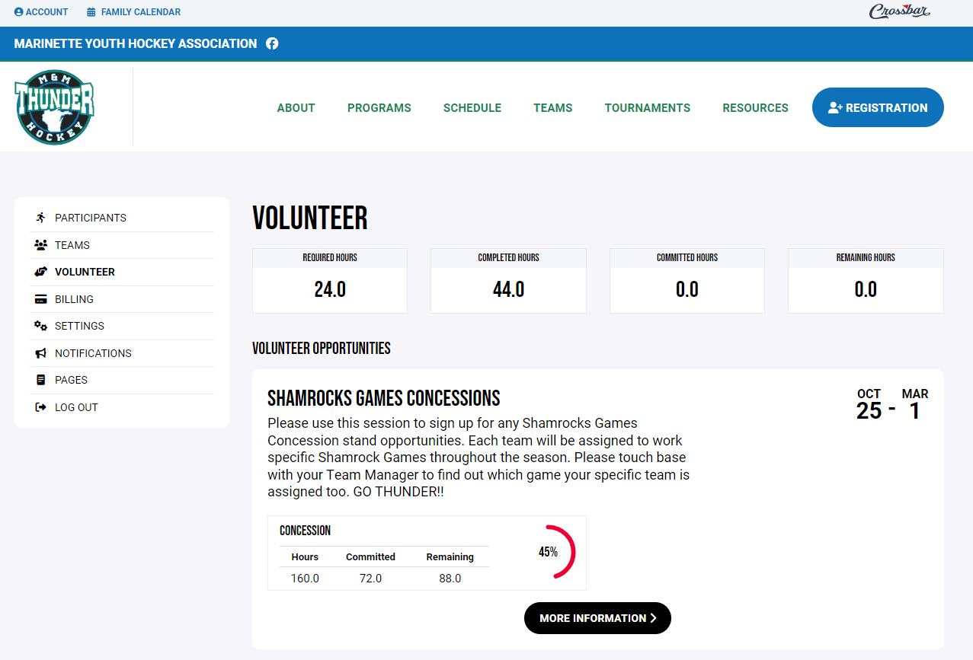

Once in the volunteer opportunity section you will see a list of all possible opportunities for this volunteer session. Click on the plus sign for the shift you want to sign up for. This will bring up a list of adults registered on the account. Select which adult is going to fill the shift. You can sign up for multiple shifts by repeating the same steps.
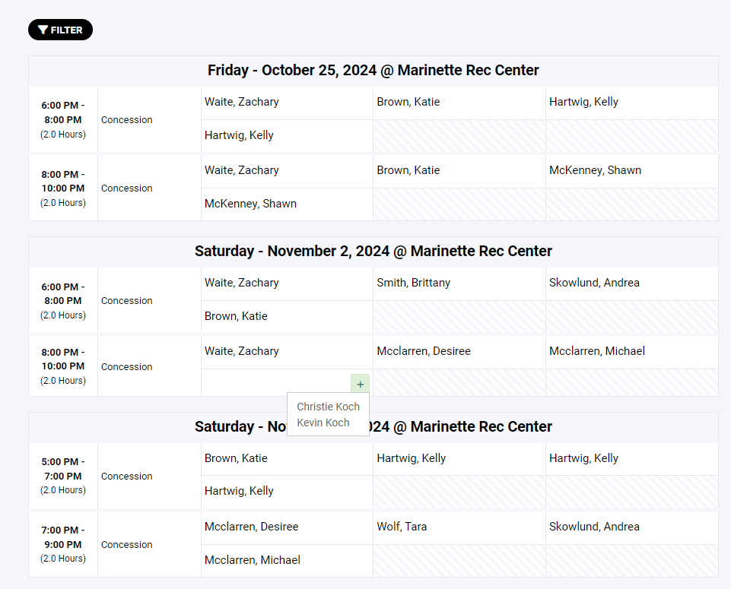

You can navigate back to the main page by clicking on ACCOUNT and VOLUNTEER.

On this Main Page you will see all Volunteer Opportunities that you have signed up for.

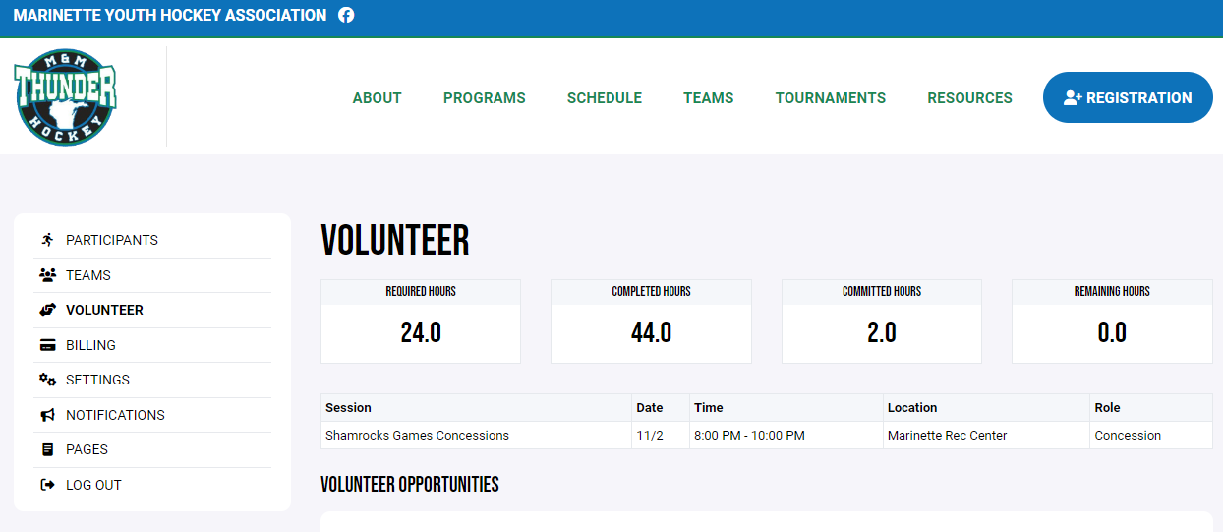

If you need to cancel a shift that you signed up for you can follow these same instructions except instead of clicking on the plus sign to add your name, you will click on the minus sign to remove your name.

**Note** You can only cancel shifts up until 4 days prior to the scheduled shift**

If you have additional questions or run into any problems, please contact the Volunteer Coordinator for assistance.

