

Junior Falcons Hockey Club Tuition/Payment Policy 2026-2027 Season

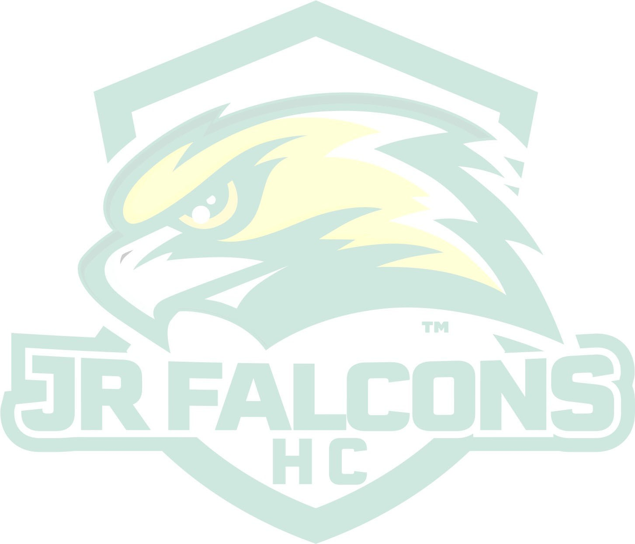
The Junior Falcons Hockey Club (JFHC) Board of Directors would like to remind everyone of the program’s Tuition/Payment Policy. As JFHC is a non-profit 501C(3) organization, it must fully recover the costs associated with the program. This Tuition/Payment Policy has been developed to reduce JFHC’s risk associated with the non-payment and/or delinquent payment of tuition fees and assist to alleviate the administrative cost burden related to the collection of tuition fees.
In general, tuition has been established to ensure that JFHC’s covers all costs associated with operating the program. A few of the costs which can be associated with operating the program may include, but are not limited to, the following:
- Practice ice, clinics, league fees, player evaluations, equipment, insurance, coaching education program (CEP) clinics, and administration.
- Apparel
- USA Hockey and/or Massachusetts Hockey coaching clinic & registration fees.
- Annual Accounting fees

Outstanding Tuition Balances

NO player will be permitted to participate in tryouts/evaluations for the 2026-2027 season unless all tuition and/or fees from any previous season have been paid in full. There will be NO exceptions made to this policy.

Prior Year(s) Payment Arrangements
JFHC main coed membership will be participating in the Valley Hockey Associates for the 2026 2027 season. Please be advised that prior payment arrangements are no longer applicable.
Payments must be made as indicated on page two (2) of this document. There will be NO exceptions.

Registration/Player Tryouts
All players must pay a player tryout fee. Players will not be considered registered until the registration fee has been received. The player / tryout fee of $60.00 is Non-Refundable. There will be NO exceptions made to this policy.

Player Contract Commitment Payment & Notification
To reserve a roster spot, all families MUST electronically sign the player team assignment contract and pay their registration payment towards the 2026-2027 season. No player will be placed on a team/roster prior to receiving this payment. If this payment is not received before the deadline date, the player may forfeit any placement earned during player evaluations and placed on the waitlist. There will be NO exceptions to this policy.
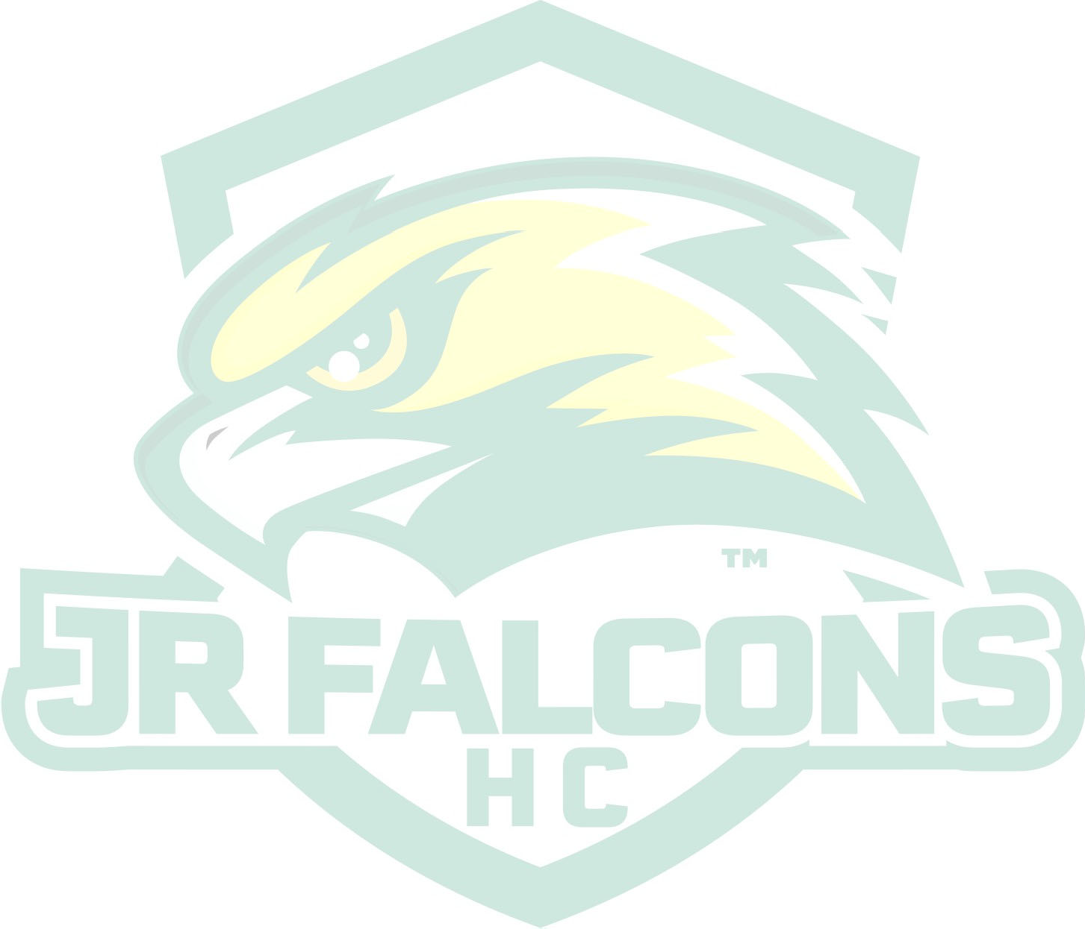
All players and Goalies who tryout for a 2026/2027 season team will be notified of the team selection on or before April 1, 2026. Any players who are not in good standing will be removed from the active roster and placed on the waitlist.
Jr Falcons will run a calendar raffle for all full season players to take part in selling. This offers a chance for you to raise a minimum of $150 and that charge will be added to your final payment, should you choose not to participate with the fundraiser. This is the only required raffle and will run for the month of November.
Tuition Payment Schedule
The tuition payment schedule for the 2026-2027 season is as follows:
 | Payment Due | Squirt - Bantam | U8 Mites | U18-Midgets
Registration | 04/15/2026 | $150.00 | $150.00 | $155.00
1st Payment | 05/15/2026 | $195.00 | $144.50
2nd Payment | 06/15/2026 | $195.00 | $144.50
3rd Payment | 07/15/2026 | $195.00 | $144.50 | 1st payment/ $160.00
4th Payment | 08/15/2026 | $195.00 | $144.50 | 2nd pymnt / $160.00
5th Payment | 09/15/2026 | $195.00 | $144.50 | 3rd pymnt / $160.00
6th Payment | 10/15/2026 | $195.00 | $144.50 | Final /$160.00
7th Payment | 11/15/2026 | $195.00 | $144.50
8th Payment | 12/15/2026 | $195.00 | $144.50
9th Payment | 01/15/2027 | $195.00 | $144.50 or $294.50
10th Payment | 02/15/2027 | $195.00 or $345 | Final $144.50
Final Payment | 03/15/2027 | $195.00
Total | Total | $2,295.00 or $2,445.00 | $1595.00 or  $1,750.00 | $795.00
 | Payment Due | Sq-Bantam Goalie | U18 – Midget Goalie
Registration | 04/15/2026 | $150.00 | $155.00
1st Payment | 05/15/2026
2nd Payment | 06/15/2026
3rd Payment | 07/15/2026
4th Payment | 08/15/2026 | $135.00 | 1st payment / $110.00
5th Payment | 09/15/2026 | $135.00 | Final / $110.00
6th Payment | 10/15/2026 | $135.00
7th Payment | 11/15/2026 | Final $135.00 or $285.00
8th Payment | 12/15/2026
9th Payment | 01/15/2027
Final Payment | 02/15/2027
Total | Total | $690.00 or $840.00 | $375.00

Tuition Auto Monthly Payment
Credit Card, Debit Card, and ACH option may be selected on family account within the jrfalcons.org website will automatically be charged on the designated payment date as outlined by the 2026-2027 payment schedule. A monthly processing/convenience fee will be assessed by the merchant for use of credit/debit cards.

Tuition Late Fee
A late fee of $30.00 will be assessed on any player who fifteen (15) days or more past the above payment schedule. Any returned checks and/or credit card payment(s) decline(s) will be assessed an additional late processing fee of $30.00 automatically added to the player(s) online account.

Multi-Player/Sibling Discounts (Travel Team Only)
Families with more than one (1) JFHC Mite - Bantam player are entitled to the following tuition discounts:
- Families with a 2nd JFHC participant will pay $50 less on his/her tuition cost.
- Families with a 3rd JFHC participant will pay $100 less on his/her tuition cost.
All multi-player/sibling discounts will be applied to the eligible participant’s FINAL tuition payment.

Tuition Assistance
The JFHC Board of Directors realizes that, on occasion, financial difficulties do create issues for families. However, JFHC expects that payments for outstanding tuition balances be made on time, and in full. Financial hardship requests must be submitted to the TCYHA Treasurer in writing prior to the current tuition payment due date(s) and will be granted on an individual case-by-case basis.
Please note while we are pleased offer financial aid, the maximum award cannot exceed 50% of the tuition

No Pay/No Play
In the event that any player has not paid his/her tuition in full or made arrangements for an alternate payment plan with the JFHC Treasurer by the above tuition payment schedule, then that player may not be allowed to participate in JFHC activities (on-ice practices and/or games) until such time as the outstanding tuition payment has been made in full. We fully understand youth hockey is expensive and life throws us curves, however, it is your responsibility to communicate and work with us to ensure your payments are made timely.

Tuition Refund Requests
Any player wishing to withdraw from JFHC must do so in writing to the JFHC Board of Directors prior to the scheduled payment date May 15th 2026. Once JFHC has received a signed player contract and the registration payment, the remaining unpaid balance is contractually binding between the player(s) legal parent(s)/guardian(s) with the JFHC organization. Tuition refund requests will be considered only as account credits upon a written request to the JFHC Board of Directors for cases of illness and/or hockey related injury that prohibit the player from participating in the sport of ice hockey for the balance of the 2026-2027 hockey season.
NO refunds will be granted for any reason other than the aforementioned. Refunds will NOT be granted for the following reasons: player is leaving JFHC to join another organization (hockey related or not); player is leaving JFHC to play for a high school team; player is leaving JFHC due to dissatisfaction and/or problems with coaches, teammates, ice officials, and/or leagues. Any contract unpaid balances after the refund/withdrawal date of May 15th 2026 or when a player contract is signed is expected to be paid in full as outlined by the payment schedule. No exceptions.
Insurance, player evaluation fees, and USA Hockey and/or Massachusetts Hockey registration fees are not refundable at any time for any reason. The timeframe in which a tuition refund check will be issued, if approved, may be subject to availability of program funds.
In the event of a full startup delay (no hockey related activities of any kind) due to health-related matters, monthly payments made on players accounts will remain as credits and will not be subject to any forfeiture or loss.

