Directions to the new facility at Legacy Junction:

Head east on Highway 13. Legacy Junction is the junction between Hiway 13 and 834. This is about 4 minutes outsiide town.
Turn north
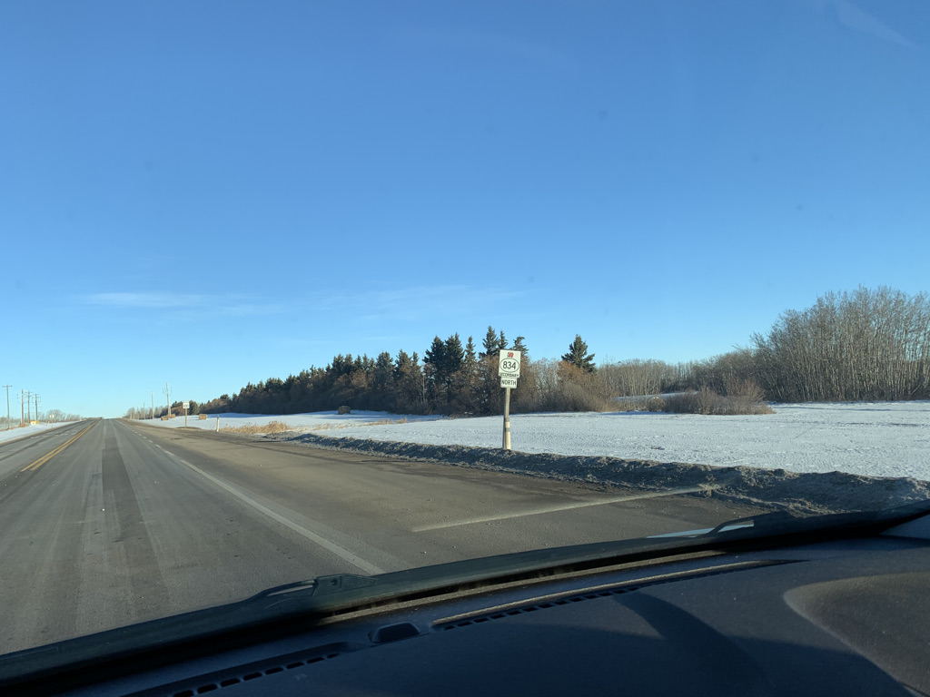

Turn west here and go to the end of the cul-de sac
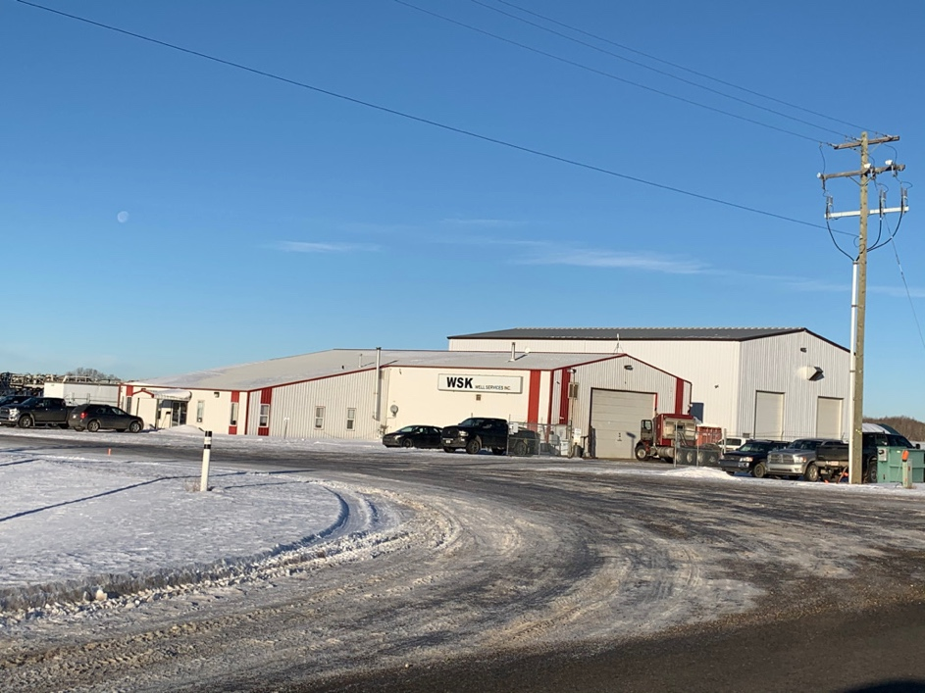

This is the precision volleyball building
