
2025-2026 FUNDRAISER
Collect donations and win prizes!
Proceeds will benefit the Steamboat Skating Club, including programming, training, and scholarships.
Skater Name:__________________________________
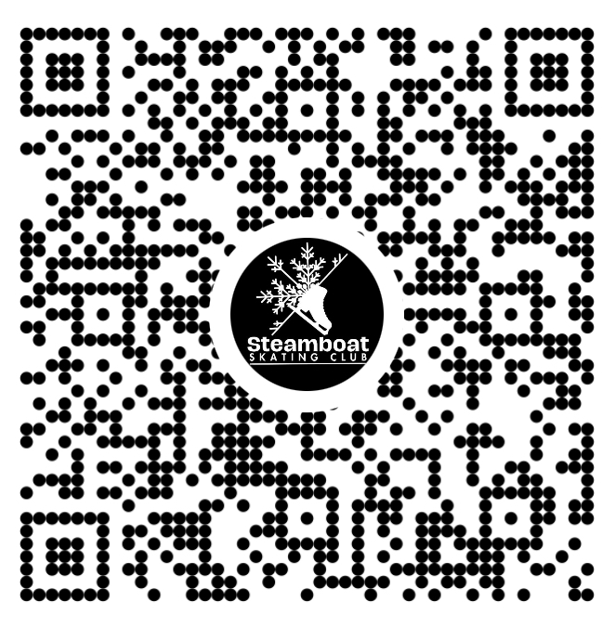
Parent/Guardian Name & Phone Number:______________________________________
Skater Fundraising Goal:__________________

All forms & money due by XXXXX
100% skater participation = Pizza Party!

DONOR NAME | PHONE # | DONATION AMOUNT | HOW THEY PAID  Cash/Check # /Venmo | DATE MONEY IS COLLECTED
Questions? Email finance@steamboatskatingclub.org
CLUB USE ONLY
Total Donations: ______________ Total $ Received______________________
Prize Level: ___________________ Prizes Ordered? Y / N

