Registering Your Player

- If you are on a computer, click "Sign Up" in the upper left corner above the EYHA logo.
If you are on mobile, click the menu button in the upper right corner and choose "Sign Up"
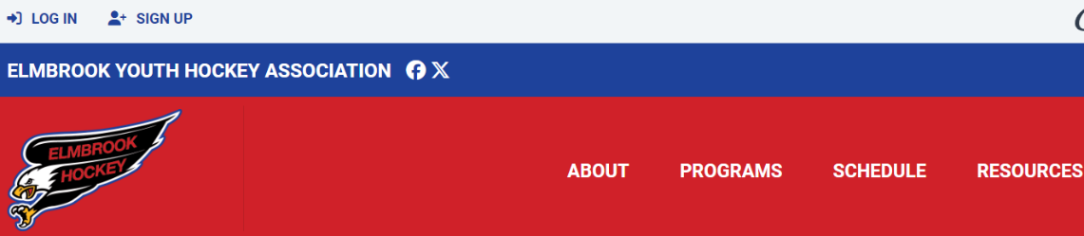
- Enter your email/password. You will receive an email to activate the new account. All parents who wish to receive team emails must sign up for an account.
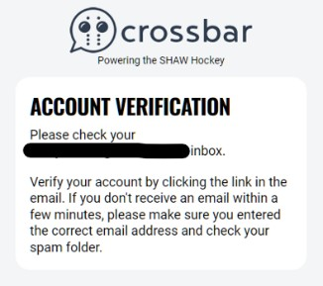
NOTE: All parents who wish to receive team emails must sign up for an account. In future seasons, you will re-use your account to register your player and access other features described below. You can add spouses / additional parent to the player account via email during the registration process.

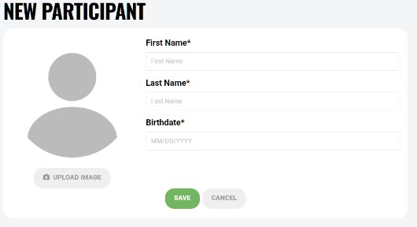
- Once you are logged into your Crossbar account on our website, click on "Account" in the upper left, and then on the giant PLUS under "Participants". Add your players first name, last name, and birth date. You can optionally add an image. Then click "Save".
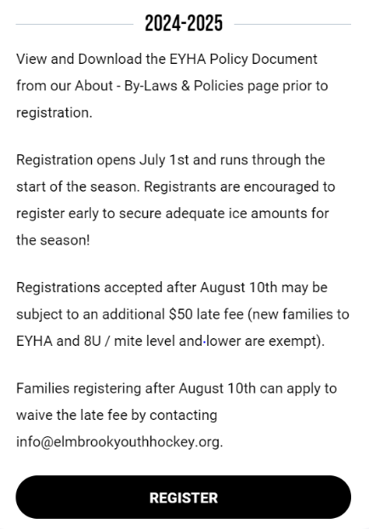
You can also add new participants during the registration
process.

- Select “Programs” from the top menu bar and select “Elmbrook Youth Hockey” or “Learn to Play”

- Click the Register link on the right side of the page.

- Select the player you wish to register.

- Follow the next steps which will guide you through the rest of the registration process.

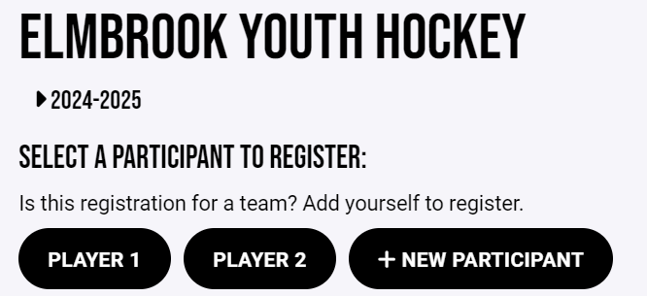
- Complete payment and click “complete registration”.

