Team Managers on Crossbar

- Schedules
  - Three viewing formats: Week ahead in main page, “schedules”, and “games”
  - Adding or changing events – ALWAYS INCLUDE SCHEDULER@FVYHA.COM
    - DO NOT use the “+Event” button on your team page for games!
    - Adding with the “+Event” only adds to your team page and shows in your teams Family Calendar. This does NOT add it to the master schedule and therefore does not show to the rest of the club and most importantly the ref scheduler.
    - You can use this feature for team social gatherings, or ice additional private ice purchases, but all other events must go through scheduler.
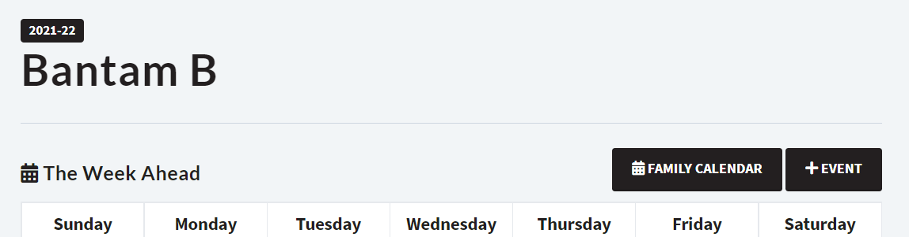
- Communication
  - Team News Feed – Found on your team page. When anyone posts, it prompts an email as well. Individuals can reply under each string. This is NOT sent to the app in any format. Parents control their own email prompts under “Settings” on the team page.
  - Team Chat – Found in the app – this can be used for quick updates, sends alerts like text messages to those using the app. This is not connected to the website in any way.

- Scoring Games
  - On the web browser (not app), on your team page click “Games” on the left hand side or from the black dropdown arrow if mobile. Note: this does show in “Schedules”, must be in “Games”
  - Click “Score” under specific game and enter score. Click “Save Score”
  - “Score” will show up AFTER start time of scheduled game.
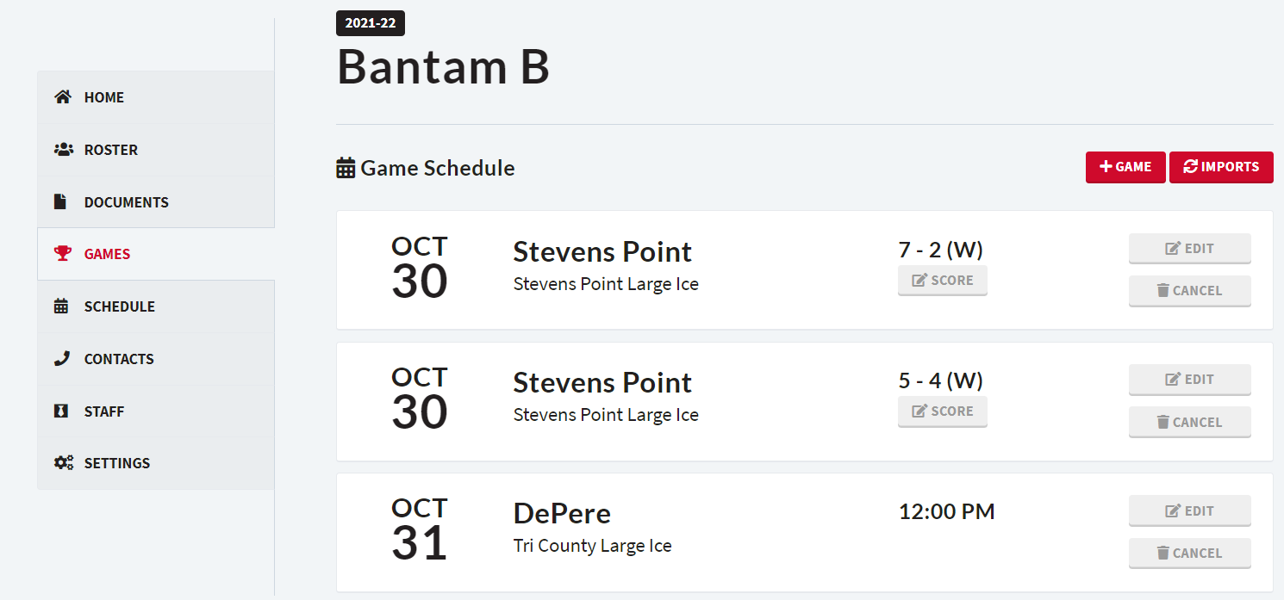

- Availability
  - There is an option to enable availability tracking for players. This is on a team basis if you want it enabled.
  - Click “Setting” on lefthand black option list. Click “Enable Availability”
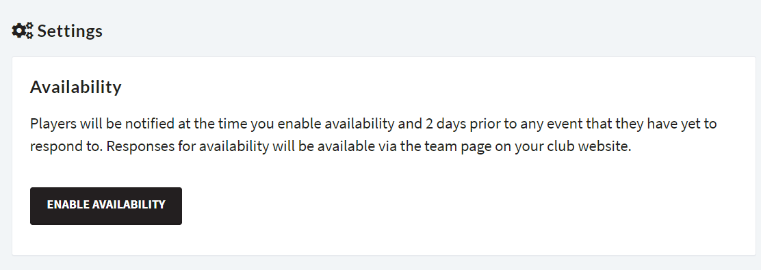

- Volunteering/Game Duties
  - As volunteer sessions are visible to the entire club, you’ll need to track volunteer duties separately.
  - Options: Each game through Newsfeed/Chat
  - Create a Sign-Up Genius with each game and duty and post the link to the team page

