Mitchell Memorial Club
Youth Football and Cheer

Emergency Action Plan
(EAP)

Table of Contents

- Emergency Action Plan Personnel……………………………...3
- Roles of First Responders……………………………………….3
- Emergency Equipment…………………………………………..4
- Medical Emergency Transportation……………………………..5
- Emergency Medical Event………………………………………5
- Non-Medical Emergencies………………………………………6
- Environmental Issues and Protocols…………………………….6
  - Air Quality…………………………………………………6
  - Heat Index…………………………………………………7
  - Lightning…………………………………………………..7
- Practice Field EAP………………………………………………8
- Game Field EAP………………………………………………...9
- Nichols Middle School EAP…………………………………….10
- Emergency Contacts……………………………………………..11

Emergency situations may arise anytime during athletic events. Expedient Action must be taken in order to provide the best possible care to the sport participant in an emergency and/or life-threatening conditions. The development and implementation of an emergency plan will help ensure that the best care will be provided.
As emergencies may occur at any time during an activity, the MMC Youth Program Coaches must be prepared. This preparation involves formulation of an emergency plan, proper coverage of events, maintenance of appropriate medical emergency equipment and supplies, utilization of appropriate medical emergency personnel, and continuing education in the area of emergency medicine and planning. Hopefully, through careful pre-participation physical screenings, adequate medical coverage, safe practice and training techniques, and other safety avenues, some potential emergencies may be averted. However, accidents and injuries are inherent with sports participation, and proper preparation on the part of the MMC Youth Program Coaches should enable each emergency situation to be managed appropriately.

Emergency Action Personnel
During typical athletic practice or competition, the first responder to an emergency is typically an MMC Youth Program Coach. Coaches on site are trained in CPR/AED and First Aid.

Roles of the First Responders
The development of an emergency action plan cannot be complete without the formation of an emergency team. The emergency team may consist of a number of healthcare providers including emergency medical technicians, certified athletic trainers, coaches, managers and possibly bystanders. Roles of these individuals within the emergency team may vary depending on the various factors such as the number of members of the team or the athletic venue itself. There are five basic roles within the emergency medical team.
- The first and most important role is establishing safety of the scene and immediate care of the athlete. Acute care (immediate care) should be provided by the most qualified individual on the scene. Individuals with lower credentials should yield to those with more appropriate training.
- EMS activation may be necessary in situations where emergency transportation is not already present at the sporting event. This should be done as soon as the situation is deemed an emergency or a life-threatening event. Time is the most critical factor under emergency conditions. Activating the EMS system may be done by anyone on the team. However, the person chosen for this duty should be someone who is calm under pressure and who communicates well over the telephone. This person should also be familiar with the location and address of the sporting event.
- Emergency Equipment retrieval may be done by anyone on the emergency team who is familiar with the types and locations of specific equipment needed. Coaches and assistant coaches are good choices for this role.
- Directing EMS to the scene is the fourth role. One member of the team should be responsible for meeting emergency medical personnel as they arrive at the site of the emergency. Depending on the ease of access, this person should have keys to any locked gates or doors that may slow the arrival of medical personnel. A coach or assistant coach may be appropriate for this role.
- Notify individuals designated on Emergency Contact Roster. Rosters are located on team page on MMC Youth Football and Cheer website, and in each team binder.

Emergency Communication
Communication is key to quick emergency response. Coaches/ assistant coaches and emergency medical personnel must work together to provide the best emergency response capability and should have contact information such as a telephone tree established as part of pre-planning for emergency situations. Communication prior to the event is a good way to establish boundaries and to build rapport between both groups of professionals. If emergency medical transportation is not available on site during a particular sporting event, then direct communication with the emergency medical system at the time of the injury or illness is necessary.
Access to a working telephone or other telecommunication device, whether fixed or mobile, should be assured. The communications system should be checked prior to each practice or competition to ensure proper working order. A back-up communication plan should be in effect should there be failure of the primary communication system. The most common method of communication is a cellular phone. At any athletic venue, whether home or away, it is important to know the location of a workable telephone. Pre-arranged access to the phone should be established if not easily accessible.
Emergency Equipment
All necessary emergency equipment should be at the site and quickly accessible. Personnel should be familiar with the function and operation of each type of emergency equipment. Equipment should be in good operating condition, and personnel must be trained in advance to use it properly. Emergency equipment available should be appropriate for the level of training for the emergency medical providers.
Every team is supplied with a medical bag containing first aid supplies. Also, MMC Youth Football and Cheer, provides an AED for use at the venues. AED is located at the field house by our practice fields, at assigned location at Nichols Middle School, or located with assigned EMT at games. First Aid kits are located with each head coach.
Emergency Medical Event
In the event an athlete or spectator becomes unresponsive:
- Immediately designate someone to contact 911.
- Designate someone to direct ambulance to emergency location.
- Check for ABC’s on patient, check airway, breathing and pulse (circulation).
- Begin CPR (if certified) if unresponsive, not breathing and no pulse detected
- Begin CPR (if certified) if unresponsive, gasping and no pulse detected
- Assign someone to retrieve AED
- Turn on and apply pads of AED and follow AED prompts
- Continue CPR if no shock advised, continue CPR if shock applied and once AED prompts to resume.
- Guardian to be notified as soon as EMS arrives and takes over care.
- If no guardian at field, head coach or director will go to hospital with athlete.
- Program Director Notified.
In the event an athlete suffers any other serious medical emergency:
- Immediately designate someone to contact 911
- Designate someone to direct ambulance to emergency location.
- Place patient in recovery position, on back, legs slightly elevated. Any other position where breathing can be controlled and no other injury may occur is also advised.
- Provide any first aid reasonably necessary.
- Guardian to be notified as soon as EMS arrives and takes over care.
- If no guardian at field, head coach or director will go to hospital with athlete.
- Program Director notified.
Medical Emergency Transportation
In the medical emergency evaluation, the primary survey assists the emergency care provider in identifying emergencies requiring critical intervention and in determining transport decisions. In an emergency situation, the athlete should be transported by ambulance, where the necessary staff and equipment is available to deliver appropriate medical care. Emergency care providers shall refrain from transporting unstable athletes in inappropriate vehicles. Care must be taken to ensure that the activity areas are supervised should the emergency care provider leave the site in transporting the athlete. Any emergency situations where there is impairment in level of consciousness (LOC), airway, breathing, or circulation (ABC) or there is neurovascular compromise should be considered a “load and go” situation and emphasis placed on rapid evaluation, treatment and transportation. In order to provide the best possible care for MMC Youth Football and Cheer, all athletes should be transported to the closest available hospital.
Non-Medical Emergencies
For the following non-medical emergencies; fires, bomb threats, severe weather and violent or criminal behavior, refer to the emergency action plan checklist for the particular venue and follow the instructions.
Environmental Issues and Protocols
Air Quality
Air quality is important due to forest fires or other events that may create an unsafe environmental exposure for athletes during outdoor sporting events. By understanding when the air is harmful, athletes, parents, and coaches can avoid certain outdoor physical activities and take preventative measures to protect themselves. Check the air quality at www.airnow.gov, and local weather channels and websites.
Air Quality Index Reference:
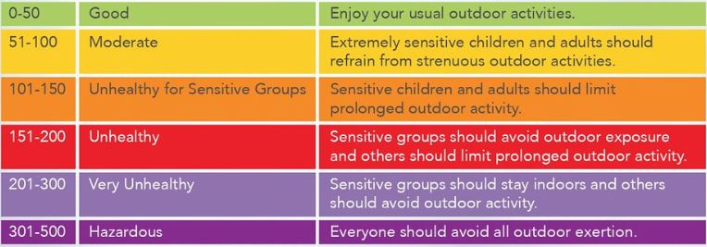
MMC Youth Football and Cheer will cancel all outdoor activities when the Air Quality Index exceeds 125. If adequate alternative indoor facilities are available we may utilize those.
Heat Index
A Heat index is an index that combines air temperature and relative humidity in an attempt to determine the human-perceived equivalent temperature. The result is also known as the “felt air temperature” or “apparent temperature”. For example, then the temperature is 90 degrees Fahrenheit with very high humidity, the heat index can be about 106 degrees Fahrenheit.
MMC Youth Football and Cheer will utilize the Heat Index Calculator on a designated phone app, such as OSHA’s HEAT App, to check the heat index prior to practices or games. MMC Youth Football and Cheer will cancel all outdoor activities when the heat index is above 104 degrees Fahrenheit. Below that, it will be at the coach’s discretion. However they must follow USA Football recommendations on allowing appropriate hydration and rest during high heat index practices and games.
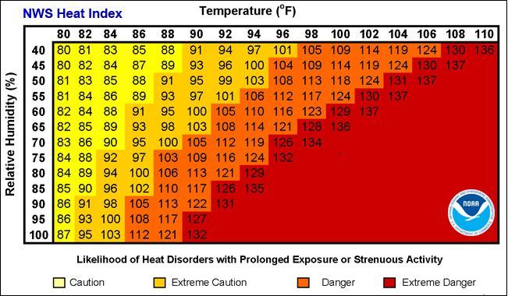
Lightning
In the case of lightning we will follow the recommendations of the National Weather Service on environmental issues.
- Practices and/or games shall be suspended immediately as soon as lightning is observed or thunder is heard.
- All athletes/officials/spectators should seek safe shelter
  - Safe structures are ones that are fully enclosed with plumbing, telephone, or electrical to ground the structure.
  - Fully enclosed automobiles or busses with the windows up. No golf carts or convertible cars.
  - Dugouts and gazebos are not safe shelters, secondary to not being grounded in case of a strike.
  - In no suitable shelter is available, avoid tall structures and objects (trees, light poles, etc.) which allow easy path to the ground. In an open field crouch with legs together, weight on balls of feet, arms wrapped around knees, and head/ears covered to minimize contact with the ground.
- Play will not resume for at least 30 minutes after the last strike of lightning or clap of thunder.
- The “My Lightning Tracker” app is available online for real-time lightning tracking.
Practice Field, Behind the MECC
Address: 219 North Main Street (Behind MECC)
26 Jackson Street (Peirce Playground entrance)
Middleborough, MA
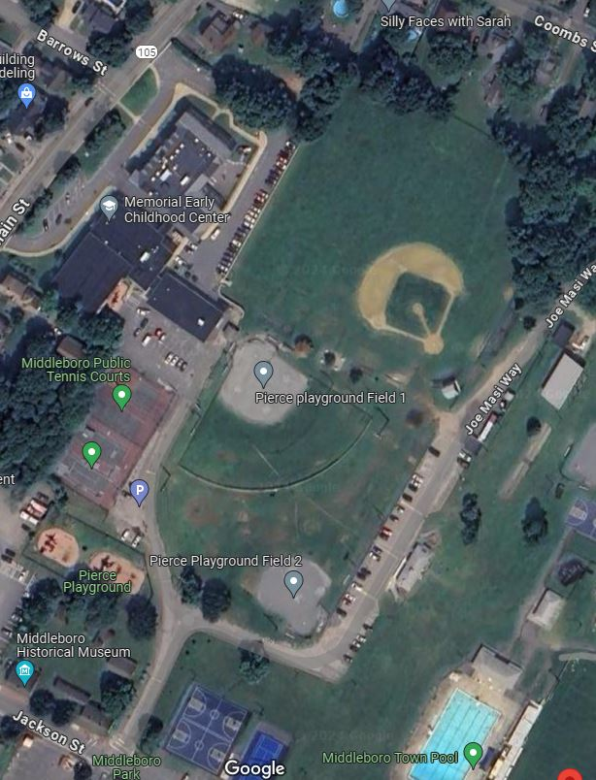
- AED will be located at Field house on Joe Masi Way by practice field. First Aid kits available with each Head Coach.
- EMS entrance can be made from Jackson Street through Play ground entrance, or behind the MECC, located at 219 North Main Street.
- Weather related emergencies require participants to seek shelter such as in their vehicles. The practice area does not have any indoor accessible areas for shelter.
- Evacuation routes shall be from behind MECC to North Main Street or from Peirce Playground parking to Jackson Street or Lincoln Street.
Battis Field
Address: Battis Field, Jackson Street
Middleborough, MA
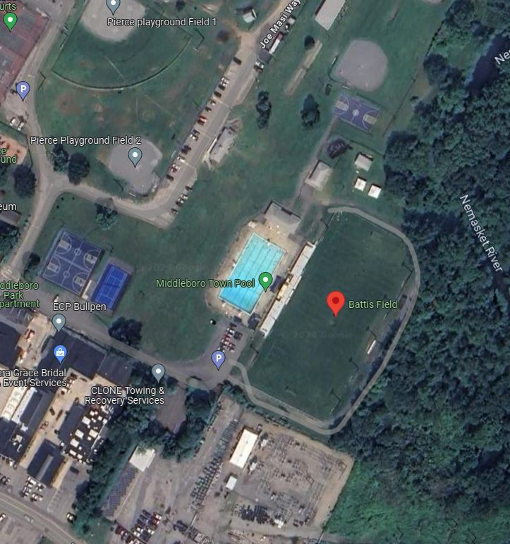
- AED will be located with the EMT/Paramedic located on Home Team Sidelines
- EMS entrance can be made from Jackson Street to the bottom of the hill behind Electric Department. Gate shall be unlocked prior to any games, however remain closed until required to be open for medical emergencies.
- Weather related emergencies require participants to seek shelter such as in their vehicles. The Battis Field area does not have any indoor accessible areas for shelter.
- Evacuation routes shall be from Peirce Playground parking to Jackson Street or Lincoln Street.
Nichols Middle School
Address: 112 Tiger Drive
Middleborough, MA

- AED will be located in the gym at installed position on wall.
- EMS entrance can be made from Wood Street to Tiger Drive. EMS should be advised to go to Gym entrance.
- Evacuation routes shall be from Parking lot to Tiger Drive to Wood Street.

