Board of Directors Meeting Minutes

October 16, 2024 @ 7:00 PM

In Attendance: John DeCaro Mark Passard Richard Oelkers
Korey Day Arlene Rinder Abby DeBonis Holly White Shannon Zink

Meeting Call to Order: 7:08 pm
Meeting Location: Mac Community Room

Approval to excuse absent Board Members: Powell Gallagher, Shawn Casey (MP/AD), motion carried
Approval of the October 16, 2023 Agenda: Motion made to approve Agenda, (KD/MP), motion carried
Approval of the September 18, 2024 Minutes: (MP/AR) motion carried
Approval of the Treasurer’s Report: Seeing changes now that we are back in season, expenditures are going up. Revenue down with about 30 fewer kids registered this year. Making some changes to “names” on some of the accounts from old teams to new teams, adjusting names of some expenditure categories. (KD/MP)

Items for Discussion:

Guest Concerns:
MAC update: Discussion on how the MAC does concessions, contacting the MAC regarding ice issues (see old business below). The restrictions on concessions and bake sales stems from rules from Parks & Recreation. The MAC should be seeing new flooring in the entryway, the new trophy case, and other upgrades soon. The MAC has been in touch with LiveBarn (https://watch.livebarn.com) to stream games at the MAC (FYI, LiveBarn is a subscription service).

Erica Arnold: Wanted to say thank you for the card and gift after being injured last month.

Committee Reports
- House Update (KD) – Jerseys are in, pretty painless process this year. Other items such as jackets, pants, etc. will be in over the next few weeks. Every team has had at least one game so far. State tournament schedule is mostly out, still a few that haven’t been announced yet, (posted at bottom of minutes). First house tournaments will be in a few weeks down in Kenai. 12A still looking for a few players for the tournament.
- Comp Update (JD) – 10/12 teams were seeded last weekend, every team was placed where they thought they would be. We have a 10 Minor, 10 Major, and a 12 Minor. There was also a State meeting last week, there are a couple of proposals on shrinking the State Board. Alaska has a large board with over 40 voting members, while California has over 10x the players with a 20 person board. One proposal would allocate “votes” to the number of registrants, this would hurt smaller associations. We have a continuing ref shortage state wide. U14 partnership team won the Termination Dust tournament.
- Girls Update (HW) – Selects registrations opens November 1st. Selects will be held December 20-22. First girls skate was held, next one is on Halloween.
- Future Planning Committee (JD) – Insurance rider in place now and we have now officially adopted Greuning Middle School (GMS) rink. Ravenwood is also available to us. Aaron Peterson is now working on maintenance ideas for the outdoor rinks. Rink will be available 5-9pm on Mon-Thu and 12-6pm on Sat. This will be set up as a “team” on Crossbar so anyone can look at the schedule and see who has it reserved. Aaron Peterson is working with ASD maintenance on getting water supply re-established to the GMS rink area.
- Tournament (MN) – Update below in New Business.
- Fundraising (DL) – Update below in New Business.
- 6U/8U Update (SC) – All teams have been playing games, and doing well. Wolverines players have been attending some practices to help out. Development has been going well. Working with the Wolverines about doing some “Team Nights” to bring our kids in groups to the games.

Old Business
- AK Goaltending (JD) – Monday morning we’ll have a twice per month goalie clinic open to all goalies in MHA. This will be split up by ages (one age group on the first session, next week would be the other age group). This will be a ½ sheet split with HS girls hockey.
- Available Ice (JD) – It’s very important to NOT call the MAC for ice issues and questions. All contact with the MAC regarding MHA ice must go through the Office Manager, Shannon Zink.
- Ice Process (JD) –

New Business
- Tree Decorating (AR) – The MAC is hosting a tree decorating contest, starting December 1st. Trees will go in the corners of the rink.
- Merry Merchant Munch (AR) – We can participate in this, but it’s a very full rink and we won’t have room for a table.
- Leftover Turkey Tournament Discussions (MR) – Leftover Turkey will be Fri-Sun after Thanksgiving. Tournament is full with teams in all divisions. Based on information from MAC, we won’t be staffing the concession stand and won’t be holding a bake sale during tournament.
- Fundraising (JD) – Discussion on how to handle fundraising banners, clarifying that MHA will cover the cost of the banner out of the amount donated ($2,000 minimum for banner, banner costs $200 to purchase).
- Pucks & Pints (JD) – Talked to Odd Man Rush about hosting Pucks & Pints this year. They have their large room available on Jan 25th. Would not need to deal with liquor license issues at this location, we’d only need to get one to deal with alcohol in the silent auction items. Help is needed for gathering silent auction items. Suggestion would be to have teams gather items either on their own or from talking to local businesses (donations). Also need volunteer help on the night of the event for set up and clean up. For pricing, our admission fee would need to account for a number of drinks included in admission (example, 2 drink tickets). Average price of a beer at OMR is $9. Last year we had 5 drink tickets included, but they were smaller sized than what is served at OMR. Motion made to hold Pucks & Pints at OMR on Jan 25th (MP/HW), unanimous vote, motion carried.

Electronic Business
- Alcohol Permit for Pucks & Pints – Motion made to apply to Alaska Alcoholic Beverage Control Board for an Alcoholic Beverage Auction Permit to allow for silent auction items that contain alcohol during the Pucks & Pints event. Distribution of funds raised due to the sale of gift baskets will be as outlined in previous MHA Board meetings. One hundred percent of silent auction proceeds at the MHA Leftover Turkey Tournament are given back to the MHA AK Blue Devils team that donated the silent auction gift basket. Permit fee will be paid for by MHA (AD/SC), unanimous vote, motion carried.
Next Meeting: November 20, 2024, at 7PM
Adjournment: 7:55 pm Motion to adjourn, AD/KD. Motion carried.

24-25 Season Board Meeting Dates:
July 17, 2024 January 15, 2025
August 21, 2024 February 19, 2025
September 18, 22024023 March 19, 2025
October 16, 2024 April 16, 2025
November 20, 2024 May 21, 2025
December 18, 2024 June 18, 2025

State Tounament Dates/Locations:

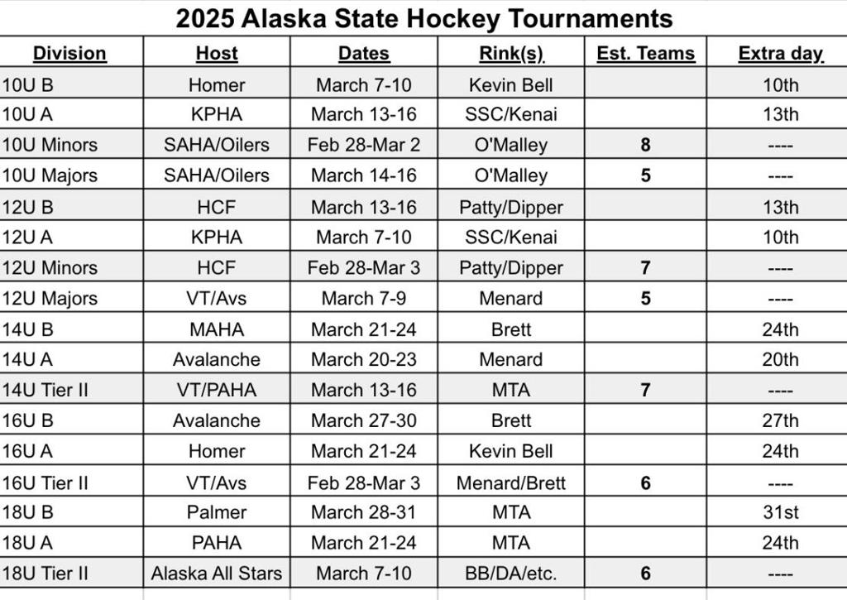

Board Members
  President - John DeCaro (JD) | Vice President – Moe Niederer (MN)
  Secretary – Richard Oelkers (RO) | Treasurer – Abby DeBonis (AD)
  House Program Director – Korey Day (KD) | Public Relations – Arlene Rinder (AR)
  Comp Program Director – Powell Gallagher (PG) | 6U/8U Coordinator – Shawn Casey (SC)
  Girls’ Coordinator – Holly White (HW) | Office Manager/Registrar – Shannon Zink (SZ)
  President - Joey Merrick (JM) | Vice President – Moe Niederer (MN)
  Secretary – Melissa Casey (MC) | Treasurer – Matt Kirby (MK)
  House Program Director – Amanda Bell (AB) | Comp Program Director – John DeCaro (JD)
  Volunteer Coordinator – Abby O’Neill (AO) | Public Relations –
  Coach Coordinator – | Girls’ Coordinator – Nic Dutton (ND)
  Player Development – | Office Manager/Registrar – Heather Calcaterra (HC)

