Board of Directors Meeting Agenda
January 27, 2024 @ 7:00 PM

Meeting Call to Order:
Meeting Location: Mac Community Room
Approval to excuse absent Board Members:
Approval of the January 27, 2024 Agenda:
Approval of the December 18, 2024 Minutes:
Approval of the Treasurer’s Report:

Items for Discussion:

Guest Concerns:

Committee Reports
- House Update (KD) –
- Comp Update (PG )–
- Girls Update (HW) –
- Future Planning Committee (JD) –
- Tournament (MN) –
- Fundraising (DL) –
- 6U/8U Update (SC) –

Old Business
- None

New Business
- Summer travel teams for 10u & 12u (HW) –
- 2025-2026 season 12u girls team (Birth years 2013 & 2014) (HW) –
- Handbook and bylaws change proposals (AP) –
- Pucks & Pints recap, future ideas (MP) –
- Coaching Interest Forms (JD) –

Next Meeting: February 19, 2025, at 6PM Work Session; 7PM General Membership
Adjournment:

22-23 Season Board Meeting Dates:
July 17, 2024 January 15, 2025
August 21, 2024 February 19, 2025
September 18, 2024 March 19, 2025
October 16, 2024 April 16, 2025
November 20, 2024 May 21, 2025
December 18, 2024 June 18, 2025

State Tounament Dates/Locations:

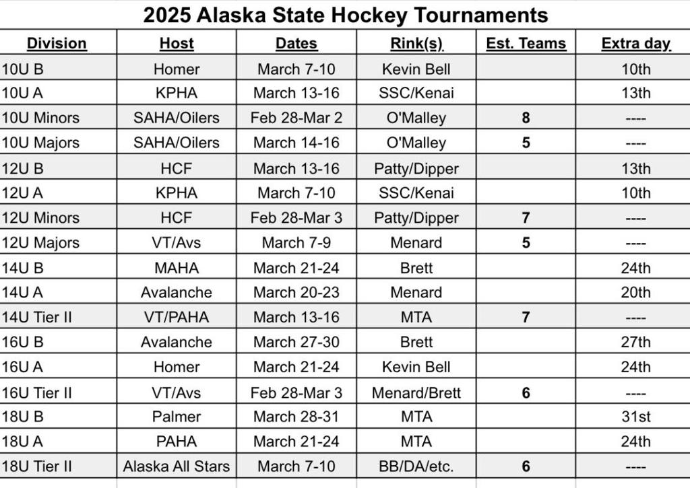

Board Members
  President - John DeCaro (JD) | Vice President – Mark Passard (MP)
  Secretary – Richard Oelkers (RO) | Treasurer – Abby DeBonis (AD)
  House Program Director – Korey Day (KD) | Public Relations – Arlene Rinder (AR)
  Comp Program Director – Powell Gallagher (PG) | 6U/8U Coordinator – Shawn Casey (SC)
  Girls’ Coordinator – Holly White (HW) | Office Manager/Registrar – Shannon Zink (SZ)
  President - Joey Merrick (JM) | Vice President – Moe Niederer (MN)
  Secretary – Melissa Casey (MC) | Treasurer – Matt Kirby (MK)
  House Program Director – Amanda Bell (AB) | Comp Program Director – John DeCaro (JD)
  Volunteer Coordinator – Abby O’Neill (AO) | Public Relations –
  Coach Coordinator – | Girls’ Coordinator – Nic Dutton (ND)
  Player Development – | Office Manager/Registrar – Heather Calcaterra (HC)

