Board of Directors Meeting Minutes

November 20, 2024 @ 7:00 PM

In Attendance: John DeCaro Mark Passard Richard Oelkers
Korey Day Powell Gallagher Arlene Rinder Abby DeBonis Holly White Shawn Casey Shannon Zink

Meeting Call to Order: 7:10 pm
Meeting Location: Mac Community Room

Approval to excuse absent Board Members: N/A
Approval of the October 16, 2023 Agenda: Motion made to approve Agenda, (MP/HW), motion carried
Approval of the September 18, 2024 Minutes: (MP/HW) motion carried
Approval of the Treasurer’s Report: Similar place as last year, spending a lot of time dealing with tournament registrations and collecting fees for these, ensuring that they are categorized properly. (MP/AR)

Items for Discussion:

Guest Concerns:
Question on players skating with two different teams (specifically “playing up” from one house team to another). There are different rules for comp & house rostering. With house as long as the coaches for both teams are ok with players on both sides we’ll allow it. MHA has been discussing this with ASHA and we’re clarifying this with the coaches. There has been an issue with 10B having a small roster and not having anywhere to pull kids up from since we don’t allow U8 kids to play up to 10B. Board will reach out to the U10 house coaches to discuss further.

Committee Reports
- House Update (KD) – 1st tournament a few weeks ago in Kenai. Coaches and Managers jackets have come in. Been a few issues with jerseys, but Team Shop has addressed those quickly.
- Comp Update (PG) – Teams are all playing, upcoming trip to Dallas for U10 major and U12 Minor, upcoming Leftover Turkey Tournament. State meeting is coming up in December, discussions on reducing the size of the board. Two main proposals for this are based on the number of registrants in each association. Selects are coming up in December.
- Girls Update (HW) – Next girls skate is December 16th. Girls selects is December 20-22. Ponytail registrations will open soon, tournament is April 11-13, 2025.
- Future Planning Committee (JD) – Discussed in below agenda item.
- Tournament (MN) – Ready to go for LOT. Only thing left to address is Muni permitting requirement to have a first-aid trained person on site at all times during the tournament.
- Fundraising (JD) – Pucks & Pints will be Jan 25th and Odd Man Rush. Still working on some details such as silent auction items, catering, etc.
- 6U/8U Update (SC) – Homer added a U8 jamboree, looks like all the U8 teams will be attending. Development is done for the year. After holidays we’ll be starting Learn To Play. Four new sets of goalie gear is in now.

Old Business
- None

New Business
- Outdoor Ice Update (JD) – We have officially adopted Ravenwood as well. Reserved Mon-Thu from 3-9pm. Between both rinks we have a lot of outdoor ice available and it’s ready to be used by teams. Plow contract has been issued and he has plowed once already. Aaron Peterson has been working with ASD facilities on hot mopping GMS rink, not sure if he can also do Ravenwood. Starting to look into how we could do our own MHA hot mop and water access at GMS.

Next Meeting: December 18, 2024, at 7PM
Adjournment: 7:34 pm Motion to adjourn, AD/KD. Motion carried.

24-25 Season Board Meeting Dates:
July 17, 2024 January 15, 2025
August 21, 2024 February 19, 2025
September 18, 22024023 March 19, 2025
October 16, 2024 April 16, 2025
November 20, 2024 May 21, 2025
December 18, 2024 June 18, 2025

State Tounament Dates/Locations:

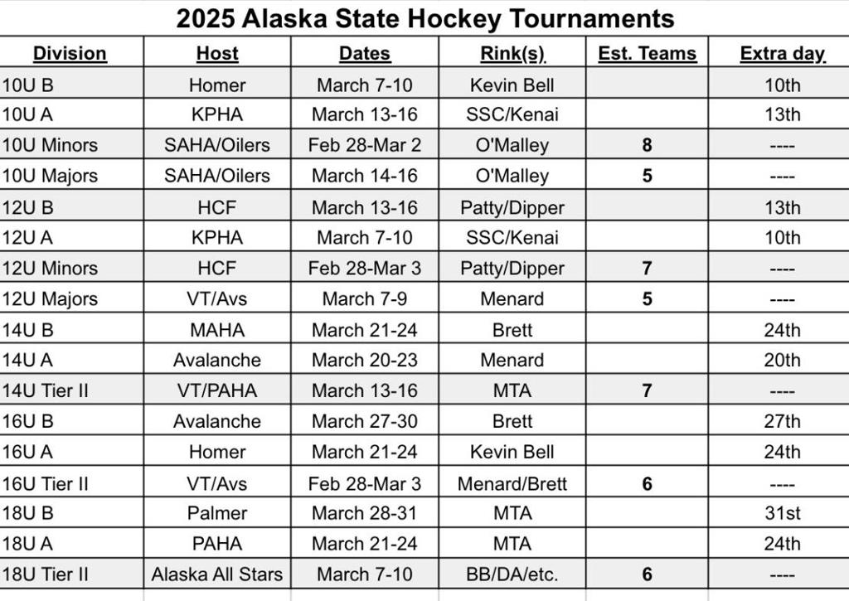

Board Members
  President - John DeCaro (JD) | Vice President – Moe Niederer (MN)
  Secretary – Richard Oelkers (RO) | Treasurer – Abby DeBonis (AD)
  House Program Director – Korey Day (KD) | Public Relations – Arlene Rinder (AR)
  Comp Program Director – Powell Gallagher (PG) | 6U/8U Coordinator – Shawn Casey (SC)
  Girls’ Coordinator – Holly White (HW) | Office Manager/Registrar – Shannon Zink (SZ)
  President - Joey Merrick (JM) | Vice President – Moe Niederer (MN)
  Secretary – Melissa Casey (MC) | Treasurer – Matt Kirby (MK)
  House Program Director – Amanda Bell (AB) | Comp Program Director – John DeCaro (JD)
  Volunteer Coordinator – Abby O’Neill (AO) | Public Relations –
  Coach Coordinator – | Girls’ Coordinator – Nic Dutton (ND)
  Player Development – | Office Manager/Registrar – Heather Calcaterra (HC)

