Board of Directors Meeting Minutes

December 18, 2024 @ 7:00 PM

In Attendance: John DeCaro Mark Passard Richard Oelkers
Korey Day Powell Gallagher Arlene Rinder Abby DeBonis Holly White Shawn Casey Shannon Zink

Meeting Call to Order: 7:05 pm
Meeting Location: Mac Community Room

Approval to excuse absent Board Members: N/A
Approval of the October 16, 2023 Agenda: Motion made to approve Agenda, (MP/KD), motion carried
Approval of the September 18, 2024 Minutes: (MP/PG) motion carried
Approval of the Treasurer’s Report: Rulien is still cleaning up registration income from the Leftover Turkey Tournament registration income and we anticipate some changes to a few categories, including Ice. Overall, loss of revenue due to fewer registrations this year and significant decrease in sponsorship funding. Increase in expenses at this time due to Payroll and upfront Goalie Coaching fees. (HW/MP)

Items for Discussion:

Guest Concerns:
None

Committee Reports
- House Update (KD) – U10 A and B have been merged to help with their competitiveness and team sizing (separate teams were too small). A few new players have signed up recently. Tournament just finished up this weekend, overall a good tournament.
- Comp Update (PG) – 10s and 12s are heading to Dallas in January for a tournament. State meeting last weekend, only major policy discussion there was on shrinking the board, both shot down, so no changes for now. Both proposals were looking to establish votes based on the size of associations. ½ ice games must be played on ½ ice, not anything greater than ½ ice. This will be enforced starting today through the end of the day. Boys selects coming up for 2010, 2009, and 2008 birthyears.
- Girls Update (HW) – Girls skate on Monday that Korey ran, everything went great. Ponytail tournament registration is set up (more info here: https://www.anchoragehockey.com/ponytail). Girls selects coming up for 2008-11 birthyears.
- Future Planning Committee (JD) – Discussed
- Tournament (MN) – LOT tournament went well, got a lot of help from parents and families. 10 major won their division. Now getting ready for the Mac Attack.
- Fundraising (JD) –
- 6U/8U Update (SC) – New 8U jamboree toys for tots and they did the Candy Cane, all attended well. Kids had fun, no complaints. 6U jamboree will be at the Mac at 1045 on Saturday. Learn to Skate starts in January, got a few kids signed up already.

Old Business
- None

New Business
- Comp Treasury Rolls (PG) – We need to have some conversations with our team treasurers on how we do things in regards to collecting payments for ice bills each month.

Next Meeting: January 15, 2025, at 7PM
Adjournment: 7:30 pm Motion to adjourn, AR/MP. Motion carried.

Executive Session
- Comp Scholarship (PG) –

Executive session adjourned at 7:46

24-25 Season Board Meeting Dates:
July 17, 2024 January 15, 2025
August 21, 2024 February 19, 2025
September 18, 22024023 March 19, 2025
October 16, 2024 April 16, 2025
November 20, 2024 May 21, 2025
December 18, 2024 June 18, 2025

State Tounament Dates/Locations:

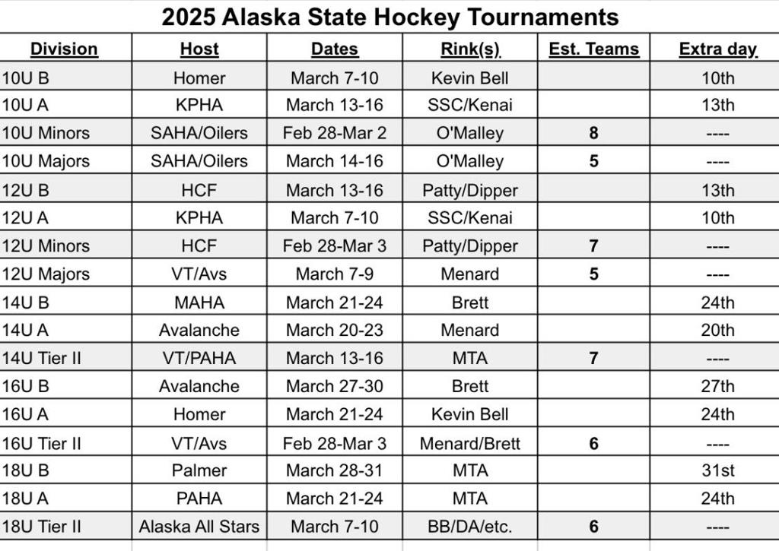

Board Members
  President - John DeCaro (JD) | Vice President – Moe Niederer (MN)
  Secretary – Richard Oelkers (RO) | Treasurer – Abby DeBonis (AD)
  House Program Director – Korey Day (KD) | Public Relations – Arlene Rinder (AR)
  Comp Program Director – Powell Gallagher (PG) | 6U/8U Coordinator – Shawn Casey (SC)
  Girls’ Coordinator – Holly White (HW) | Office Manager/Registrar – Shannon Zink (SZ)
  President - Joey Merrick (JM) | Vice President – Moe Niederer (MN)
  Secretary – Melissa Casey (MC) | Treasurer – Matt Kirby (MK)
  House Program Director – Amanda Bell (AB) | Comp Program Director – John DeCaro (JD)
  Volunteer Coordinator – Abby O’Neill (AO) | Public Relations –
  Coach Coordinator – | Girls’ Coordinator – Nic Dutton (ND)
  Player Development – | Office Manager/Registrar – Heather Calcaterra (HC)

