,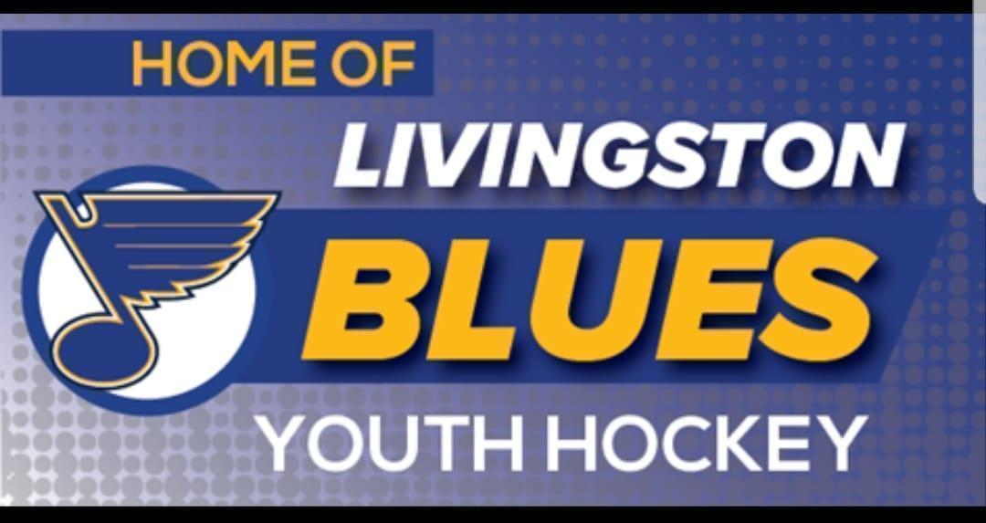
January Board Meeting Agenda
Sunday, January 11, 2025 - 7:00pm
Vitale Park
5828 Big Tree Rd, Lakeville, NY

AGENDA
- Call to Order

- Approval of October Minutes : (Motion, Second, Vote)

- New Business:

  - Team/Player photos - feedback

  - SUNY Geneseo Concession Guidelines

  - Ice time Scheduling

  - Committee Charters

  - NYSAHA updates

  - Treasurer's Report

  - Registrar’s Report
    - Coaches/Board certifications

- Next Board meeting February 8th at 7pm.

- Adjournment : Motion to Adjourn (Motion, Second, Vote)

