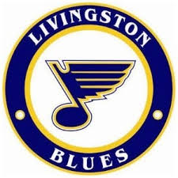
HOME OF
LIVINGSTON
BLUES
Youth Hockey
Agenda April Board Meeting
1- Call to Oder Agenda
2- Approval of Minutes Sunday, April 12, 2026
3- Open Floor for Nominations 7:00pm, Livingston Lanes
4- Old Business
- Jersey’s

- Grant
- Missed Coaching Stipend
5- Board Reports
- Up
- Register
- Ace
- Treasurer
- Empire Rep
- Western NY Rep

- Grow the Game
6- Set the Next Board Meeting

