

Stevenson High School
Hockey Association
Player Handbook 2024/2025
2021-2022

Revised August 1, 2024

Dear Parents and Players,
Welcome to the 2024-2025 Stevenson High School Hockey (SHSH) season. The new season promises to provide our student-athletes with outstanding opportunities to compete in high school hockey. Hockey is a lettered sport at Stevenson High School.
Per Stevenson’s Athletic Department guidelines, only one sport per season may be played. Ice Hockey is designated as a Winter Sport but spans over multiple seasons. Because of this, the school allows Hockey players to participate in both Fall and Spring sports and any desired Fall and Spring activities in addition to Hockey.

This handbook will help you prepare for your involvement with the Stevenson High School Hockey Program, we are excited about the future and direction of our program. Please refer to www.stevensonhockey.org regularly for any information and updates, up-to-date calendars for both JV and Varsity teams can be accessed on the website. In order to participate in the Stevenson Hockey Program, all players and parents/guardians must indicate their acceptance of the principles and rules established by Stevenson Hockey by signing this Handbook.

TEAM PHLOSOPHY
The Stevenson Hockey Program is committed to balancing excellence in hockey with promoting the development of its players as leaders both academically and within the Stevenson community. The program establishes an environment in which all our players can grow as students, athletes and teammates. We take pride in the way we play and present ourselves both internally as a team and externally to our opponents and the Stevenson community we represent both on and off the ice.

EXPECTATIONS OF PLAYERS
- Players are expected to maintain a good academic standing at Stevenson High School in order to participate in the SHS Hockey Program. Players who fail to earn a passing grade in the minimum indicated classes in the Stevenson High School Academic Eligibility Rules will be ineligible until such time as their eligibility is reestablished by the school. Please see the Stevenson High School Academic Eligibility Rules for complete details.
- Players are expected to be at practices and games at the specified time and to be ready and focused to participate at their highest ability. Players are also expected to participate in all tournaments throughout the year as scheduled by the team. Failure to participate in any tournament may result in a 3 game suspension.
- Players may be double rostered on both the Varsity and Junior Varsity Teams. At the coach’s discretion, players may be required to participate at either level up to the limits of the 7 up and down rule for official league games.
- Players must abide by the Stevenson High School Extracurricular/Co-Curricular Code of Conduct, which is available at www.d125.org/athletics. Any violation of the Code, including, but not limited to the use of illegal drugs, tobacco products (cigars, cigarettes, e-cigarettes or vaping devices), alcohol and bullying will be subject to discipline according to
the Code.
- Players must follow the rules and regulations of any rink at which they play and must treat their opponents and teammates with respect.
- Players must understand the rules of the game as set forth by USA Hockey, AHAI and the leagues in which they play.
- Players must respect the integrity and judgment of all game officials.
- Use of any electronic media device and/or any website or other similar forum to make disparaging comments towards other teams, players, parents, or members of any organization will not be tolerated. This is inclusive of, but not limited to, Facebook, X, Instagram, Snapchat, Tiktok, internet blogs, email, and texting.
- Players are expected to be truthful with the coaching staff as well as the team trainer regarding any injuries that may occur on or off the ice. The player will abide by all trainer and coach’s decisions following an injury, including following all required concussion protocol and/or staying off the ice.
- Players are expected to communicate to the coaching staff regarding any issues such as injuries, absences and other commitments that would result in any missed team activity.
- Players are put on the ice at the coach’s discretion. If the player would like to discuss issues about playing time, they should schedule a time to talk with their coach. Playing time will not be discussed during a game.
- Players must read the Stevenson High School Concussion Protocol, found at: https://www.d125.org/parents/medicalhealth-forms.
- Players must attend school on the day of a game or prior to a weekend in order to participate that day or weekend.

EXPECTATIONS OF PARENT/GUARDIANS
The Stevenson Hockey program could not exist without parent volunteers willing to serve on its boards and committees. Parents are expected to fulfill their mandatory volunteer hours during the year and work during major events such as the Thanksgiving Tournament.

Our players are building a solid foundation for character development. Stevenson Hockey Coaches and the Board expect all our parents/guardians to comply with the following expectations:

- Parents/Guardians must respect all participants, coaches and game officials.
- Parents/Guardians will not participate in name calling or other undesirable acts that detract from the game and resolve to conduct themselves as a responsible adult, even during the most trying circumstances.
- Parents/Guardians will remember that our players look to us for guidance and tend to conduct themselves according to our examples.
- Parents/Guardians will discuss the positive aspects of the game and not dwell on the negative.
- Parents/Guardians will recognize good play, no matter who makes it and strive to make each year the best hockey season possible.
- Use of any electronic media device and/or any website or other similar forum to make disparaging comments towards other teams, players, parents, or members of any organization will not be tolerated. This is inclusive of, but not limited, to Facebook, X, internet blogs, email, and texting
- Parents/Guardians are subject to the SHSHA Discipline Committee for conduct considered in violation of this Handbook and/or harmful to the image of Stevenson High School and the SHSHA, its players, coaches, officials and fans.
- Parents/Guardians will not embarrass themselves or team members by yelling at players, coaches, managers, officials, or other parents and will always show a positive attitude toward the game, players, coaches, officials and fans.
- Players are put on the ice at the coach’s discretion. If your player has concerns about their ice time, have them schedule a meeting with their coach to discuss. This is not a discussion for the parents to have with the coaches.
- Parents/Guardians must read the Stevenson High School Concussion Protocol, found at: https://www.d125.org/parents/medical-health-forms

EXPECTATIONS OF COACHES
- Coaches are expected to provide coverage at practices, games and tournaments
- Coaches will strive for their team to compete at the highest level.
- Coaches will inspire players to love the game, instill a desire to win and teach good sportsmanship with a respect for teammates, opponents and officials.
- Coaches should provide detailed continuous feedback to players throughout the season. Coaches will do their best to provide tips, drills, and best practices to improve on a player’s strengths and weaknesses. Detailed feedback is not going to happen during a game.
- Coaches have the sole discretion to determine playing time for all players.

PLAYING TIME
SHSHA believes it to be in the best interest of each player to provide a safe and fair environment for competition. SHSHA believes it is important that we see measurable growth from all players on and off the ice. Our goal is to get the best effort out of all of each of our players. With that being said, we believe playing time is earned. Coaches will play a player based on the ice time that they have earned. It is a coach’s responsibility to decide when players should be on the ice and when they should not. Coaches should make decisions based on what is best for the team. Ice time can be determined based on observations in practice, games, and off the ice. Coaches will often make decisions on who plays based on attitude, consistency, work ethic, skill level, knowledge of the game, and other factors.

CONFLICT RESOLUTION

If a player has an issue or concern, they should speak with their coach first. If they are not comfortable contacting the team coach, then please follow the chain of command below. This protocol allows the coaches and the SHSHA to address an issue in the most effective way possible.

- Talk with your Team Coach(s)
- Contact your Team Manager
- Contact the SHSHA President (President@StevensonHockey.org)
- Contact the Hockey Director – Dan Wood (dwood@d125.org)
- Contact the Athletic Director – Trish Betthauser

Please remember, the safety and well-being of all our players is our first priority. If you want to remain anonymous we have created an anonymous way to contact the program. It will go to our SHSHA President and Rules & Ethics Chair who will not know who the individual that reported the issue. We can then use the athletic department to investigate if something seriously wrong has occurred.

RULES AND ETHICS COMMITTEE
The SHSHA Hockey Rules and Ethics Committee is responsible for investigating reports of inappropriate player behavior that take place outside of game situations. Player offenses committed during games are first escalated directly to AHAI by the game referees. AHAI has the right to reassign the investigation back to the club level. The SHSHA Rules and Ethics Committee shall also conduct investigation into complaints lodged against parents, spectators and coaches.

Committee Members
  - Jim Brown- Rules & Ethics Committee Chair
  - Robert Wojdelko
  - Greg Wiener
  - Lidia Vysotskyy
  - Jon Corteen

Safe Hotline Anonymous Reporting Category
1-855-662-SAFE (1-855-662-7233)
Code: 5360406426

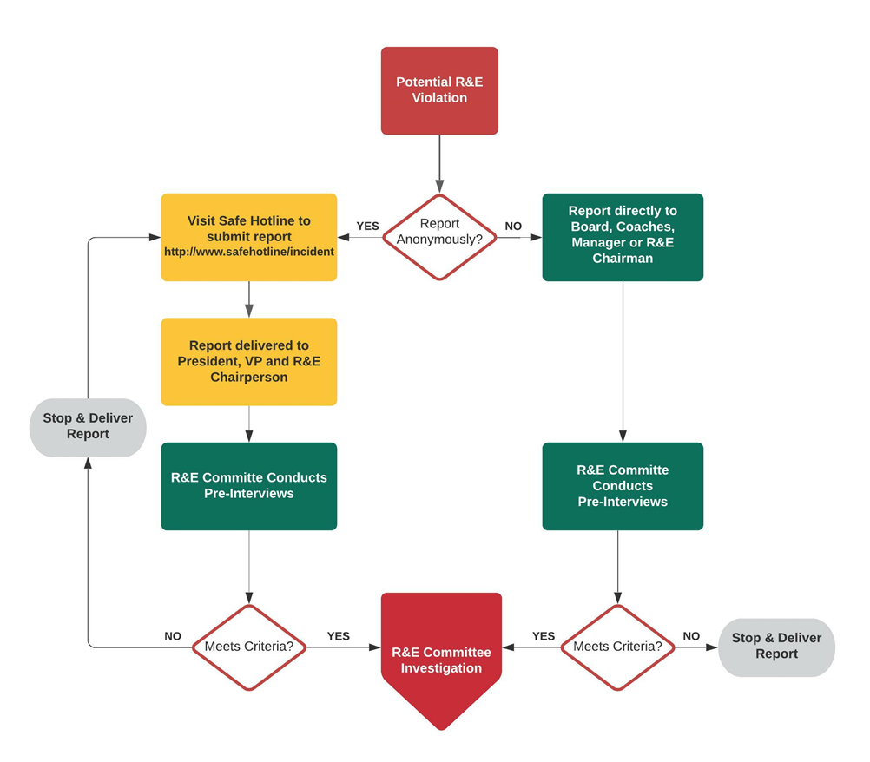

FINANCIAL POLICY

SHSHA policy requires that payment of the player dues, team fund and payment package must be made by the required due date. Failure to pay any installment by the designated deadline will result in a player's immediate suspension from team activities until payment is made or a payment plan is agreed upon. Failure to pay will also be referred to the AHAI Rules and Ethics Committee for player suspension.

If for any reason you feel your credit card or debit card will not clear, please notify the Treasurer at least 10 days prior to the transaction date to avoid a late fee. A 2-day grace period will be given on all payments and then a $100 late fee will apply.

SHSHA also recognizes that hockey is a physical sport and as such there will be absolutely no refunds due to injury. If a player is injured prior to all installments being paid, the remaining installments will still be due.

Once a player is placed on a roster, there will be no refund given for any reason.

BUSES
Before 11/15
Buses will be scheduled at the discretion of the coaches and team managers. The general rule is to schedule a bus if the game is more than 45 minutes from Stevenson and/or an early start/finish.

After 11/15
All SHS Hockey teams will be provided bus transportation to all non-home rinks.
Buses will not be provided for games at the following rinks: Twin Rinks, Glacier Ice Arena, Northbrook, Mount Prospect, West Meadows, Sports Complex, North Shore Ice Arena, and Gurnee. The association may add or remove rinks on this list as needed.

All players must ride the bus to and from the games when a bus is provided. Any exceptions must be cleared with the coach PRIOR to the game.

Volunteer Hours
Volunteer hours are mandatory for all families, without exception. 27 general volunteer hours are required and 7 Thanksgiving tournament volunteer hours are required. There is a $1,500 buyout available for the general season hours and a $525 buyout for Thanksgiving tournament hours. If families do not meet the required volunteer hours by the end of the season, a prorate hourly charge will be assessed.

The purpose of volunteer hours is to support the organization. We hope that even if the minimum required hours are met that families will still participate in game day functions in the spirit of supporting the organization, but even more importantly their player.

STEVENSON HIGH SCHOOL

HOCKEY ASSOCIATION

2024-2025 Handbook

Signature Page



I have read and understand the purpose of the Stevenson Hockey Handbook
and agree to adhere to all its rules and policies.

Player Name:___________________________________ Date:________________________

Player Signature:______________________________________________________________

Parent/Guardian Name:___________________________________ Date:_______________

Parent/Guardian Signature:_____________________________________________________

Received by:_____________________________________ Date:_______________________

