Waupun Ice Sculptures Solo Team
CORPORATE SPONSORSHIP OPPORTUNITY
A great way to support a local cause that will have a direct positive impact on the community!
The Waupun Ice Sculptures Solo Team was created by a few local visionaries who saw an opportunity to bring a competitive individual skating program to Waupun.
Support the Waupun Solo Team!
Your support will have a direct positive impact on skaters in the Waupun and surrounding communities. Our young skaters compete at a varying level with sportsmanship, work ethic and passion – honoring those we are representing.

More facts about Waupun Ice Sculptures Solo Team:
⮚ Comprised of 10+ skaters from the Waupun Figure Skating Club and surrounding clubs.
⮚ 1 team of skaters that compete individually at varying levels of competition around the state and surrounding states.
⮚ Our Board and coaching staff are dedicated volunteers with a wealth of figure skating knowledge.
⮚ This is a program that we are hoping to continue for many years to come and continue to grow
throughout the community and surrounding areas.

Corporate sponsorships allow us to keep skater fees down. Our team expenses include skate bags, clothing, travel expenses, skating music, coach lessons, and class fees specific to competitions.

Benefits of a donation:
⮚ Being part of a very positive successful community program helping shape local young skaters.
⮚ Logo on our team clothing that will be proudly worn at all competitions as well as other skating
events.
⮚ Follow upcoming competitions and results on Facebook where we will show our sponsor banner
with the skaters.

If you are interested in donating to our team, please fill out this form (see the back of this letter) and return with your donation. Please make checks out to WFSC and mail to 506 S West St, Waupun, WI 53963. Deadline to have your logo/name appear on the clothing is August 1st, 2025.

THANK YOU VERY MUCH FOR YOUR SUPPORT!
Kate Grulke, Head Coach on behalf of the coaching staff and skaters.
Kevin Smith, Team President on behalf of the entire team and Waupun Figure Skating Club Board.

*see back for donation form

Waupun Ice Sculptures Solo Team
CORPORATE SPONSORSHIP OPPORTUNITY
A great way to support a local cause that will have a direct positive impact on the community!

Levels of Support…..
Platinum Level Sponsor
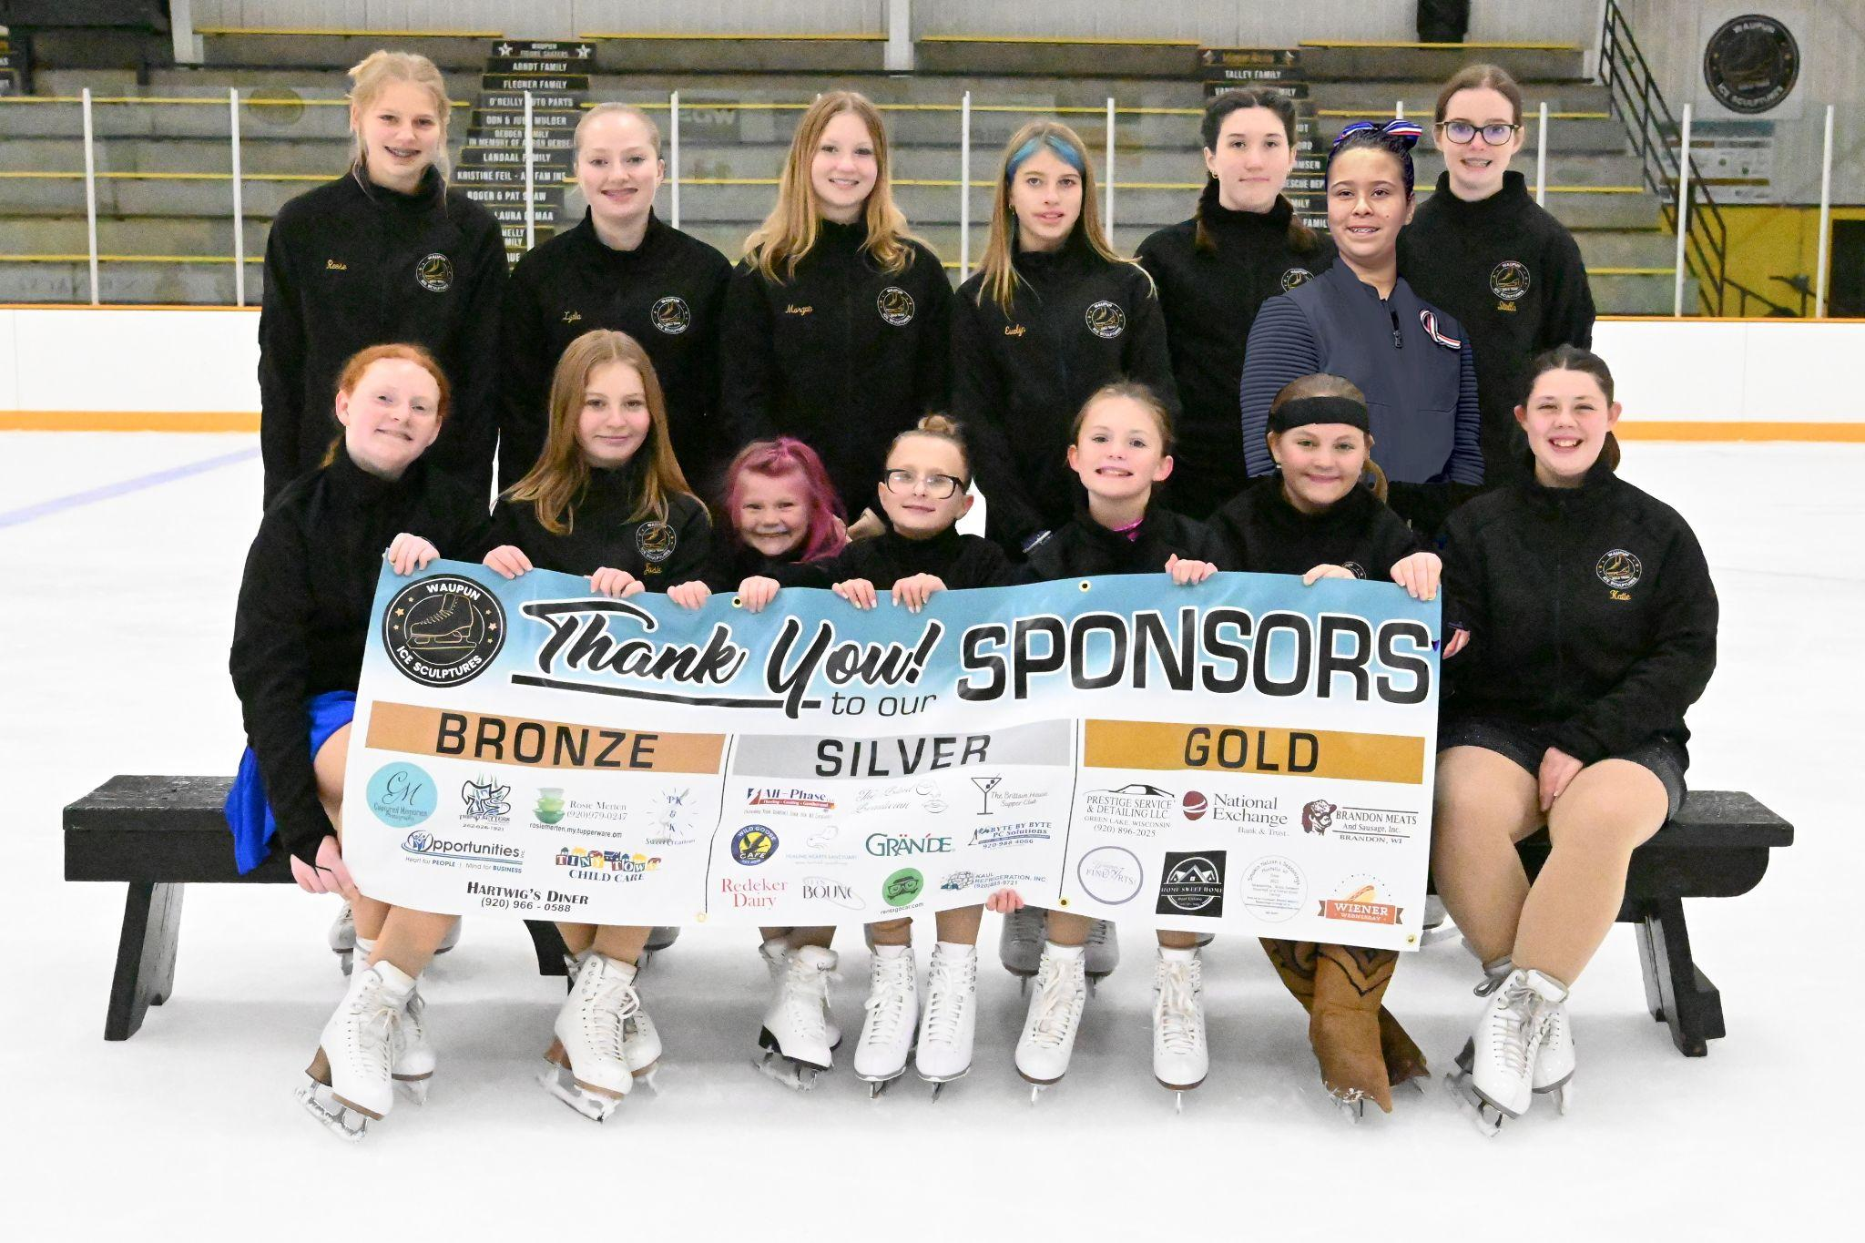
$600+
Business Logo on Clothing & Combined sponsor
Banner – also a separate banner with your logo
to be hung in the rink

Gold Level Sponsor
$400 - $599
Business Logo on Clothing & Combined
sponsor banner

Silver Level Sponsor
$200 - $399
Business Logo on Clothing & Combined sponsor banner

Bronze Level Sponsor
$50 - $199
Business Name on Clothing & Combined sponsor banner

To Thank our Sponsors, we will take a picture at each competition with the travel sponsor banner and post on our Facebook page. We will have a sponsor banner hung in the rink for the season as well as a banner that travels to competitions.
- - - - - - - - - - - - - - - - - - - - - - - - - - - - - - - - - - - - - - - - - - - - - - - - - - - - - - - - - - - - - - - - - - - - - - - - - - - - - - - -
Donation to Waupun Ice Sculptures Solo Team

Business Name: ____________________________________________
(as you would like it to appear on clothing)

Contact Name: ____________________________________________

Email Address: ____________________________________________

Phone Number: ____________________________________________

Donation Amount: $________________

Skater Name: ______________________________________________

THANK YOU!
*Please email a jpeg of your logo to waupunicesculptures@outlook.com
*Please make checks out to WFSC and mail to 506 S West St, Waupun, WI 53963.
Waupun Ice Sculptures Solo Team
CORPORATE SPONSORSHIP OPPORTUNITY
A great way to support a local cause that will have a direct positive impact on the community!
We are excited to share that as we have grown this program over the years our skaters have begun to qualify to compete at higher-level competitions. Some of our skaters from last year have also qualified to compete at the State Games of America that will be located in Pennsylvania in 2026. With these new opportunities comes additional costs for travel and many are located out of state. For this reason, we are adding an option for businesses to specifically sponsor the skaters at these events in addition to the Team sponsorship. Below are examples of competition events that you could sponsor in addition to the team sponsorship:
Badger State Games 2026: Badger State Games are a series of annual Olympic-style multi-sport events for amateur athletes from the state of Wisconsin, held twice per year in Wausau. It is at these games that skaters can qualify to compete at the State Games of America 2026.
Excel Series Competitions: The excel series competitions offer young athletes an exciting and competitive environment that motivates them to focus on strengthening their program components and advancing their technical skills each season. Skaters on the Solo Team participating in this series will register for the Excel Series where they will earn points based on their result of an excel event at a designated excel series competition. The top finishers are invited to the Excel National Final held in the summer of 2026. These competitions are typically located farther away and some out of state.
State Games of America: To qualify to compete at the State Games of America skaters must compete at the Badger State Games 2025 and/or 2026. Skaters must place either 1st, 2nd, or 3rd in their event at Badger State Games to qualify. At the 2025 Badger State Games the Solo Team had 6 of the 7 skaters that competed qualify for the State Games of America. This competition will be held in the State of Pennsylvania in 2026. There will be many extra fees associated with attending this event that would not be required for our standard competitions.
If you are interested in sponsoring a specific event, please fill out and return the bottom portion:
- - - - - - - - - - - - - - - - - - - - - - - - - - - - - - - - - - - - - - - - - - - - - - - - - - - - - - - - - - - - - - - - - - - - - - - - - - - - - - - -
Donation to Waupun Ice Sculptures Solo Team – Competition/Event Specific Sponsorship

Business Name: ____________________________________________
(as you would like it to appear on clothing/banners)

Contact Name: ____________________________________________

Email Address: ____________________________________________

Phone Number: ____________________________________________

Donation Amount: $________________

Competition/Event to Sponsor: ______________________________________________

THANK YOU!
*Please email a jpeg of your logo to waupunicesculptures@outlook.com
*Please make checks out to WFSC and mail to 506 S West St, Waupun, WI 53963.

