WE WANT TO FEED YOUR TEAM

ATTENTION COACHES AND TEAM MANAGERS: FALCONS NEST AT MARYVILLE UNIVERSITY HOCKEY CENTER HAS CREATED A TEAM MENU THAT YOU ORDER AHEAD AND IT’S READY FOR YOUR TEAM AFTER THE GAME. WE WILL RESERVE AN AREA IN OUR RESTAURANT AND SET UP THE FOOD BUFFET STYLE.
WE SUPPLY ALL SERVING AND EATING UTENSILS.
OR WE CAN PACKAGE EVERYTHING UP TO GO
To place an order contact
FALCONSNESTGRILL@MARYVILLEUHC.COM

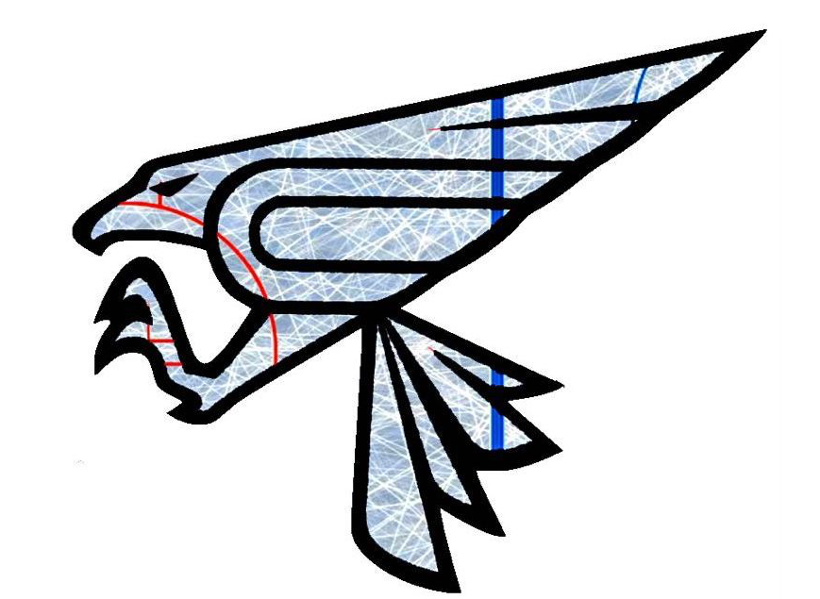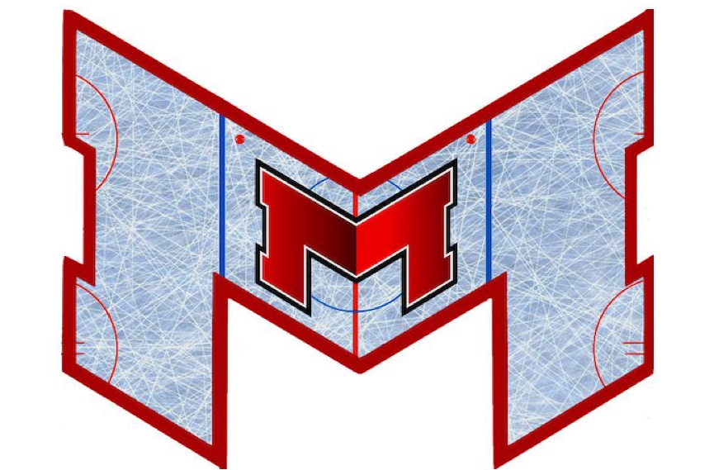

*FALCONS NEST TEAM CATERING MENU*
APPETIZERS-PER 50 PIECES (1/2 PAN)
WINGS- $58.00 TOASTED RAVIOLI- $37.00
PRETZEL BITES-$30.00 MINI TACOS- $32.00
CHEESE GARLIC BREAD- $28.00
SAUCES ON SIDE- MARINARA, RANCH, BLUE CHEESE, HONEY MUSTARD, SALSA, BBQ
CHICKEN
CHICKEN TENDERS- 1/2 PAN (30 PCS*) $52.00 - FULL PAN (60 PCS*) $104.00
GRILLED CHICKEN BREAST- 1/2 PAN (15 PCS*) $52.00- FULL PAN (30 PCS*) $104.00
BAKED CHICKEN PARMESAN- ½ PAN (15 PCS*) $61.00- FULL PAN (30 PCS*) $113.00
SAUCES ON SIDE- MARINARA, RANCH, BLUE CHEESE, HONEY MUSTARD, SALSA, BBQ
PASTA- 1/2 P FEEDS 8-10, FULL FEEDS 16-20
PENNE W/ALFREDO - 1/2 PAN $42.00 - FULL PAN $84.00
ALFREDO W/ CHICKEN- 1/2 PAN $58.00 - FULL PAN $110.00
BAKED MOSTACCIOLI W/ MEAT SAUCE- 1/2 PAN $55.00 - FULL PAN $105
SALAD- 1/2 P FEEDS 8-10, FULL FEEDS 16-20
CEASER SALAD OR GARDEN SALAD- 1/2 PAN $32.00 - FULL PAN $63.00
W/ GRILLED CHICKEN- 1/2 PAN $47.00 FULL PAN $89.00
DRESSINGS- CEASER, RANCH, ITALIAN, BLUE CHEESE, HONEY MUSTARD
PIZZA 14” THIN CRUST
1 TOPPING PIZZA-$12.00
(PEPPERONI, SAUSAGE, BACON, GREEN PEPPER,ONION)
NACHO BAR/ MEXICAN BUFFET
NACHO CHIPS, TORT ILLA, GROUND BEEF, GRILLED CHICKEN, BLACK BEANS, MEXICAN RICE, LETTUCE, TOMATOES, JALAPENOS, SOUR CREAM, SALSA $15.00/PER PERSON
DRINKS- PITCHERS OF LEMONADE, COKE, DIET COKE, SPRITE $8.00 PER

