2025 10K Puck Challenge

To Register a new player who did not participate last year start here:
- skip to page 4 for directions to set up an existing account for the 25-26 challenge
Step 1- Register/Create Account
https://www.hockeyshare.com/
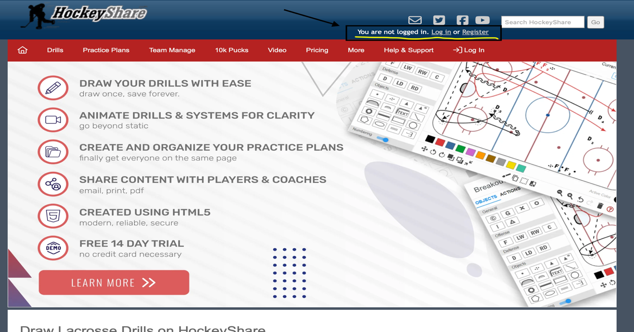

Step2- Login, Click on 10K, Create Player
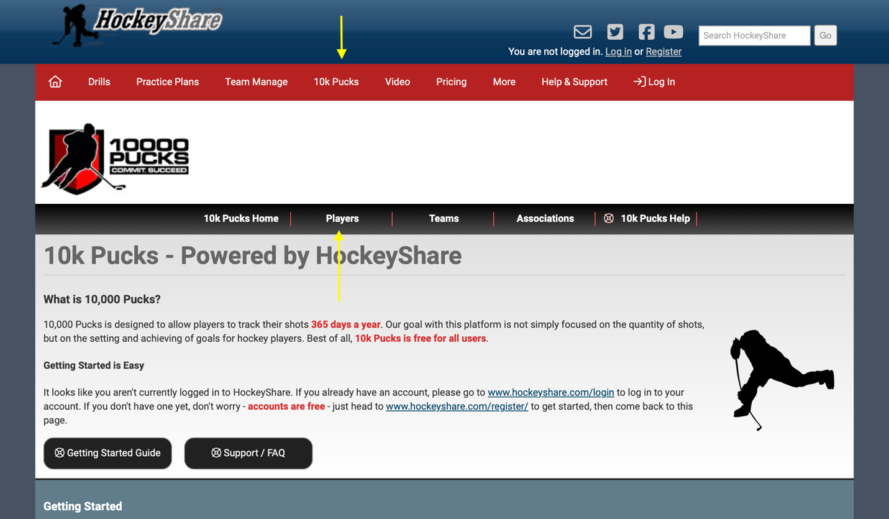
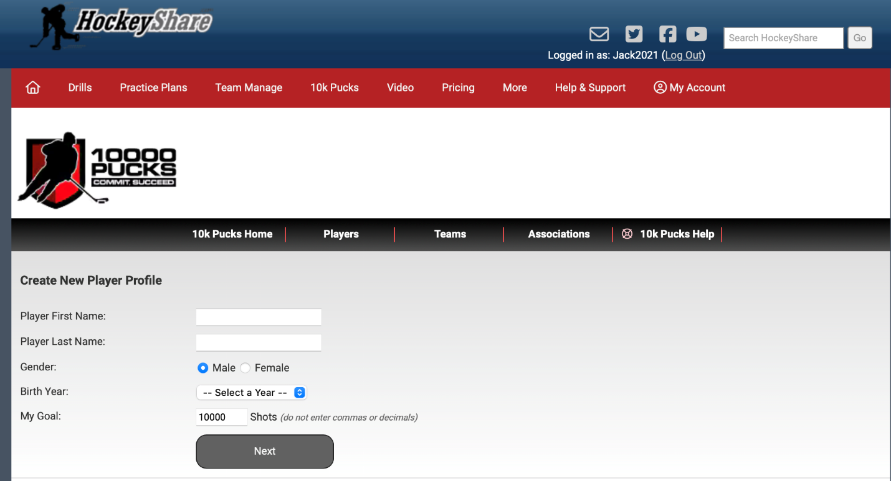

Step 3- Click on “Track Shots” and then Link Player with Team/level
Link Player to the level they will be playing for the 25-26 season. Search “BW Blades Youth Hockey”
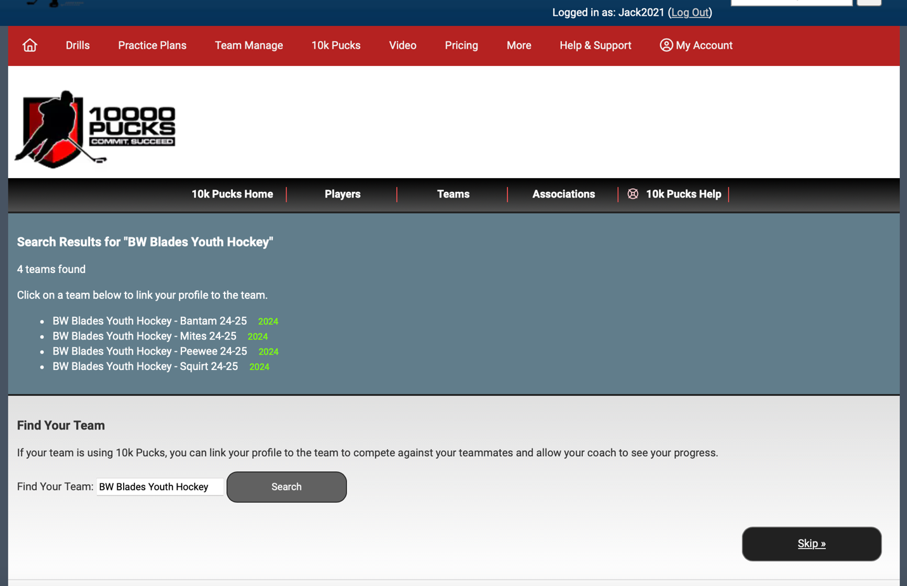

You are now ready to Record Your Shots Daily! Your profile should look like this
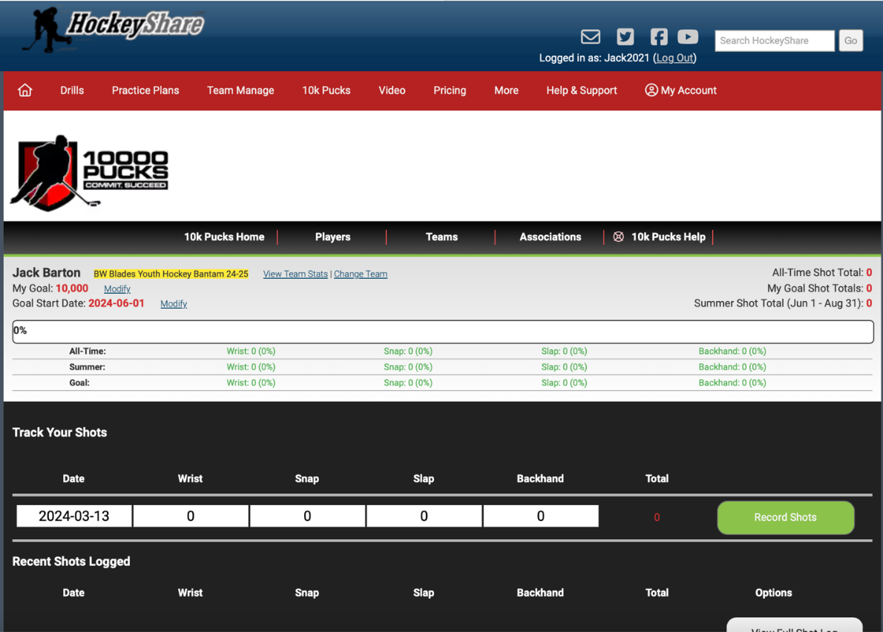
If you already have an account from last year:
Login to your account using last years credentials:
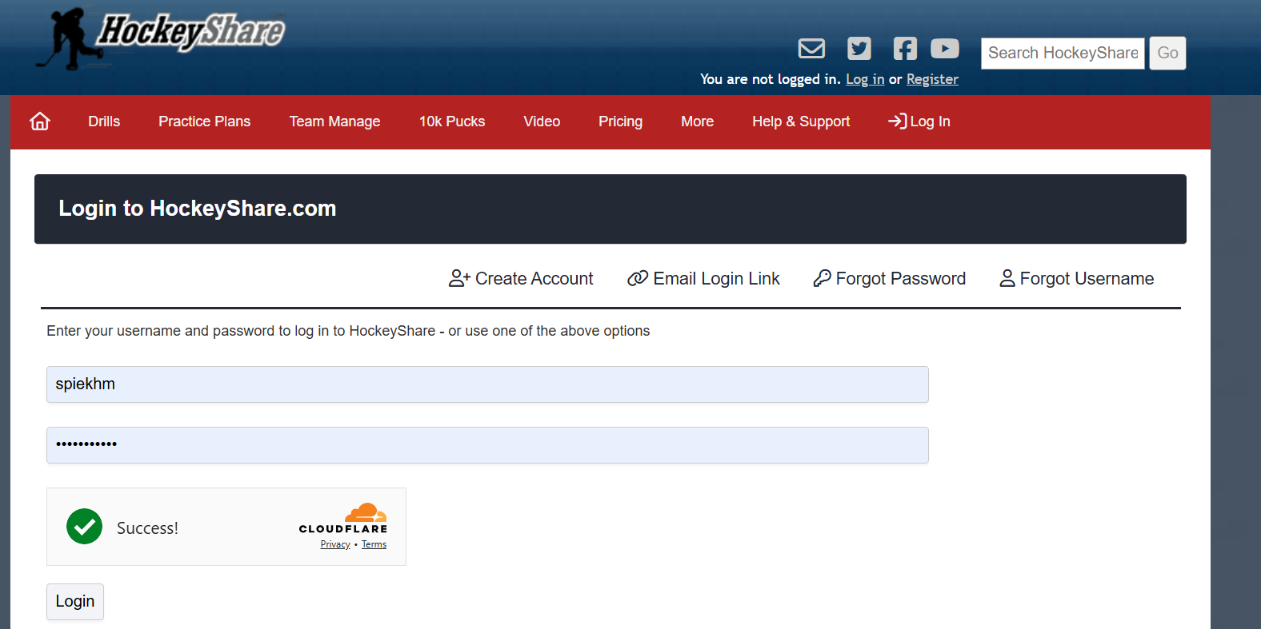

Click on 10k pucks in the middle of the screen and then click on the black track shots button
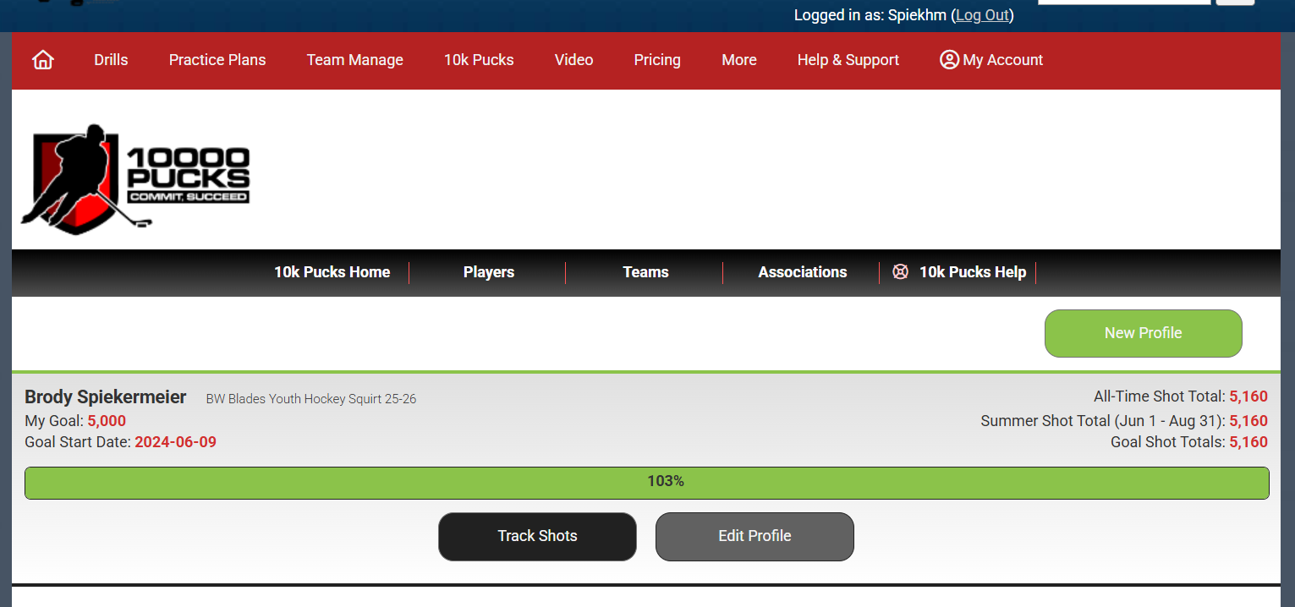

Your players name should populate with stats for 24-24 season
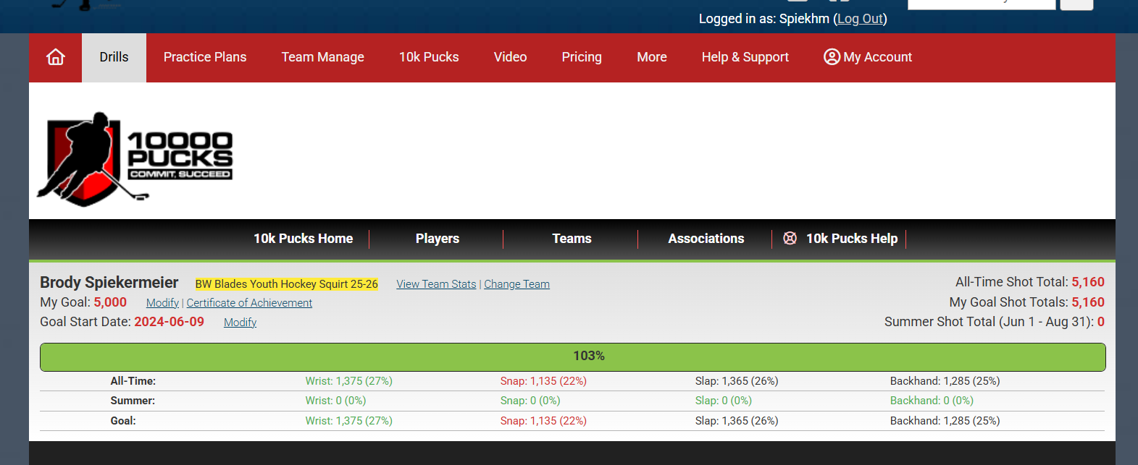

Click on Change Team next to your players name and enter “bw blades” into the search bar
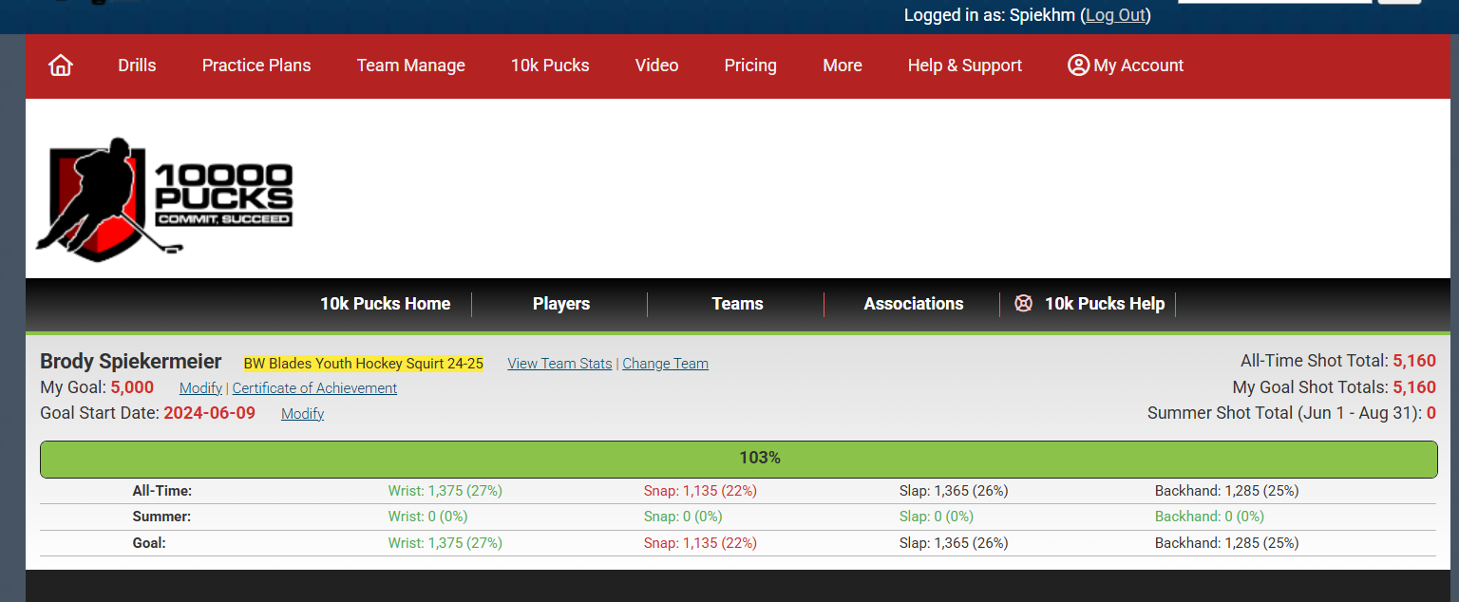

The following selections will pop up- be sure to select the level your player will be on for the 25-26 season
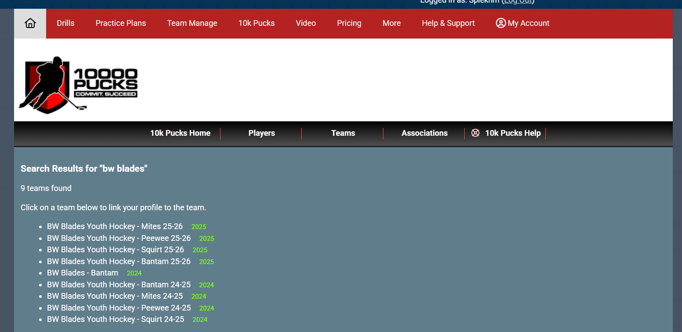

Once you have selected the team for the 25-26 season it will bring you back to the original page where you should see the new season has loaded and you will have the ability to begin tracking shots!

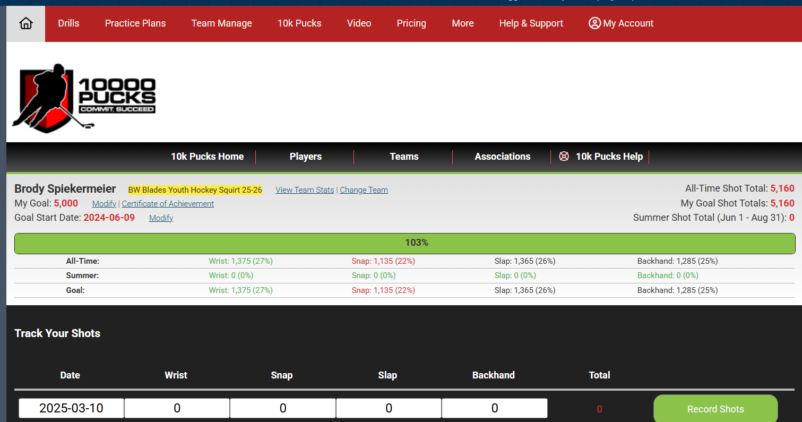

In the middle of the screen you will need to modify start date to whenever you would like to begin shooting and modify your goal as either 5k or 10k shots- awards will be given for both achievements in the fall.

The BW Blades 10K puck challenge will run from May 1st through August 31st 2025, your players goal should be to shoot 10,000 pucks or more during this time.

