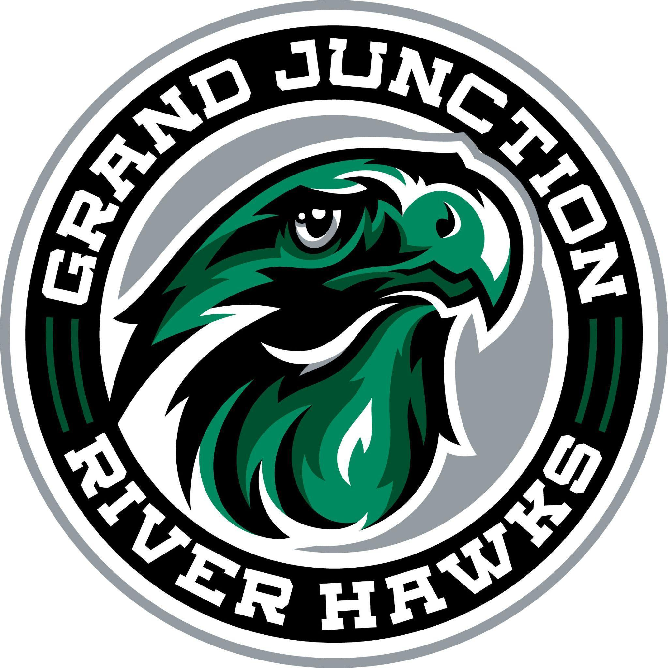
Grand Junction Hockey Club
Board of Directors Meeting Minutes
June 30, 2026
5:30 pm

Invitees:
Name | Position | Name | Position
Chris Birdsong (CB) | President | Meghann Hurt (MH) | Secretary
Jamie Neyers (JN) | Vice President | Jackson Wilson (JW) | Hockey Director
Jessica Miracle (JM) | Treasurer | Amy Szaller (AS) | Rink Representative
Luke Story | Guest | – | –
Strikethrough indicates “Not Present”

Call to Order: CB called to order, JM seconds at 5:34 pm

Old Business
CB motions to approve and JN seconds the 5/28/26 meeting minutes.

New Business
- Financial update: JM and JW will meet on July 6 to go over fiscal year end information. Financial forms for the fiscal year will be available after that date. Outstanding items include reimbursement to CB, ice time for April, May and June. CB and JM need to meet to reconcile the golf tournament.
- Vice President Election Update: Welcome Luke Story as the new Vice President. Thank you, Jamie Neyers, for your service!
- 26/27 Registration Planning: JM will present a budget to the board following her meeting with JW on July 6. JW would like to open registration around July 15th.
- Scholarship Application Preparation: CB will send out last year's version so updates can be made based on notes from last season.
- Grant writing assistance Update: CB reached out and let the volunteer know that can move forward with using volunteer hours to complete applications. The Board will review applications prior to submission.
- Room Block Coordinator Update: The coordinator is willing to assist however, the Board believes that there may not be enough participation from club members to fully utilize the preselected room blocks. Team Managers have the option to set up a room block for their team, if they would like.
- Outstanding Payments Update: Need to review Crossbar notifications to ensure the GJHC and families are aware of missed payments for registration or tournaments. CB will review Crossbar payments and missed payments to see what is still on the list of outstanding payments.
- Rink Representative Board Position: Board looking to evaluate the position of the rink representative and evaluate how that position can best assist the GJHC with gaining insight and information into the things going on at the rink. Action: JW to invite Mitch Knight (NAHL River Hawks Marketing and Sales) to the next meeting.
- Hockey Operations Coordinator Position and Start Date: JW presented the Board with a Hockey Operations Supervisor job description and suggested hours and pay for a candidate for that position. CB motion to approve Hockey Operations Coordinator position with an offer to Martina Kleinova-Timm. The Board unanimously approves. Start date pending her acceptance.
- Hockey Director Bonus Payment for 2025-2026 season: JW had target growth rate of 10% for 25/26 which he exceeded allowing payout of bonus payment. Retention metric was met and entitles him to full payout of bonus payment. The third metric is still outstanding (profit metric). CB motions for Board to pay $6000 to JW to cover growth rate and retention bonus payments. The Board unanimously approved.
- NAHL Assistant Coach youth hockey agreement: NAHL assistant coach will be available to help coach in the youth program.
- Spring programming / Summer camp updates: Girls team is going well. This is the only spring and summer skates going on right now. A number of people have signed up for upcoming summer camps.
- Discuss strategic planning for next season committees: Club level social media coordinator, fundraising coordinator, SafeSport coordinator and registrar are positions we want to ensure are functional going into the season. Will ensure that the registration portal allows for those signing up to express interest in a position or committee they want to volunteer for.

Next Meeting: 7/14/26 @ 5:30 pm
Meeting Adjourned: CB moves to adjourn, JN second, adjourned at 7:40 pm

