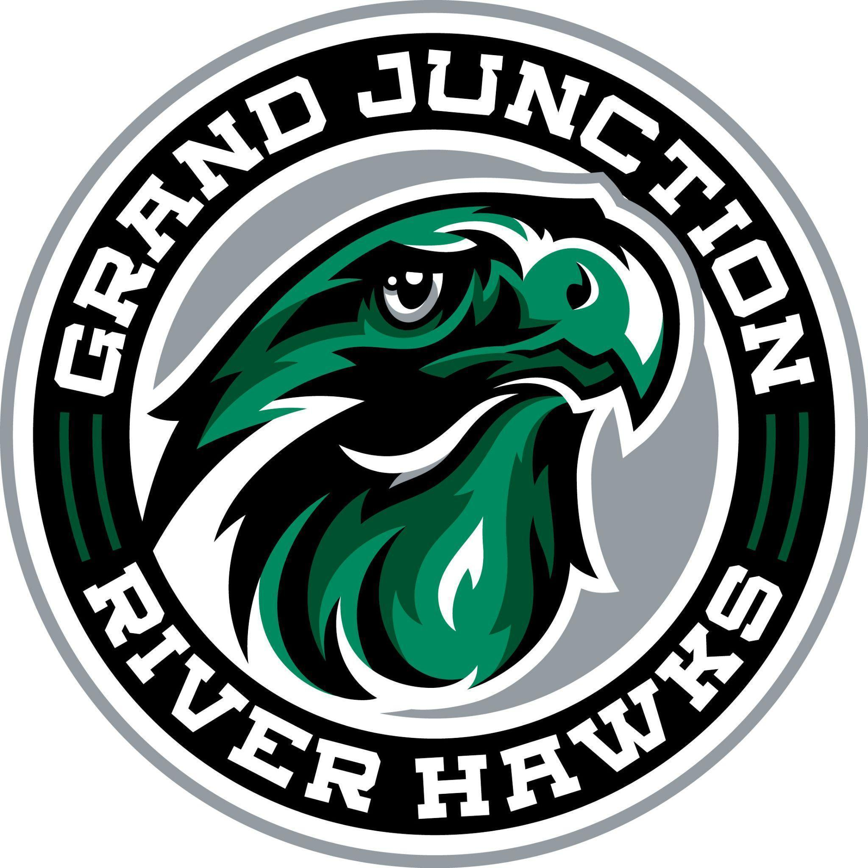
Grand Junction Hockey Club
Board of Directors Meeting Minutes
July 28, 2026
5:30 pm

Invitees:
Name | Position | Name | Position
Chris Birdsong (CB) | President | Meghann Hurt (MH) | Secretary
Luke Story (LS) | Vice President | Jackson Wilson (JW) | Hockey Director
Jessica Miracle (JM) | Treasurer | Mitch Knight (MK) | Rink Representative
Marsa Larson (ML) | Registrar (Guest) | Martina Kleinova-Timm (MKT) | Hockey Ops Coordinator (Guest)
Strikethrough indicates “Not Present”

Call to Order: CB called to order at 5:37 pm

Old Business
CB motions to approve and LS seconds the 7/14/26 meeting minutes.

New Business
- Financial Update
  - Prior Year Final: Still waiting on reconciliation of ice charge overages. Final still pending.
  - 26/27 Registration Update: A few questions prior to finalizing registration fees: Are practice socks included? They will be ordered and then purchased separately as needed by families. Pricing for 26/27 is still being finalized. For the 10U teams, there will be a 10UA, 10UB, and 10U Rec. All 10U players will be charged the rec registration cost and then as rosters are finalized, 10UA and 10UB players will be charged an additional $400 for WCHL league fees. Starting this year, breezer covers will be required and can be ordered when the portal opens. New practice jerseys will be required as well. Black warm ups will be required and available through the uniform page. CB will coordinate with Dylan Albert (Athletic Director) at Caprock about using the gym for the GJHC Annual Meeting at 6pm on August 27th.
  - Outstanding Payments Update: making progress
- Status of Jersey Sizing/Ordering Role: Portal will be open until some time in September. May need to have multiple jersey ordering options to accommodate those who may register late.
- Scholarship Application Discussion: Based on notes from last season, the scholarship application will be updated for this season.
- Hockey Operations Coordinator Position and Start Date: Board reviewed the contract for Martina Kleinova-Timm as the Hockey Operations Coordinator and approved. Contract is effective 7/28/26.
- NAHL Assistant Coach youth hockey agreement: no update.
- Summer camp programming updates: Camps are going well. Last week camps made ~$1,500 and this week made $5,600 for the Club.
- Discuss strategic planning for next season committees: JM talked to a few people about volunteer opportunities related to fundraising and social media. Still looking for SafeSport and Culture and Character committee leads.
- 26/27 CAHA Renewal Application: Due by September 10, 2026. CB will send out Member Agreement for the Board to review.

Next Meeting: Monday, 8/10/26 @ 5:30 pm
Meeting Adjourned: CB moves to adjourn, adjourned at 7:00 pm

