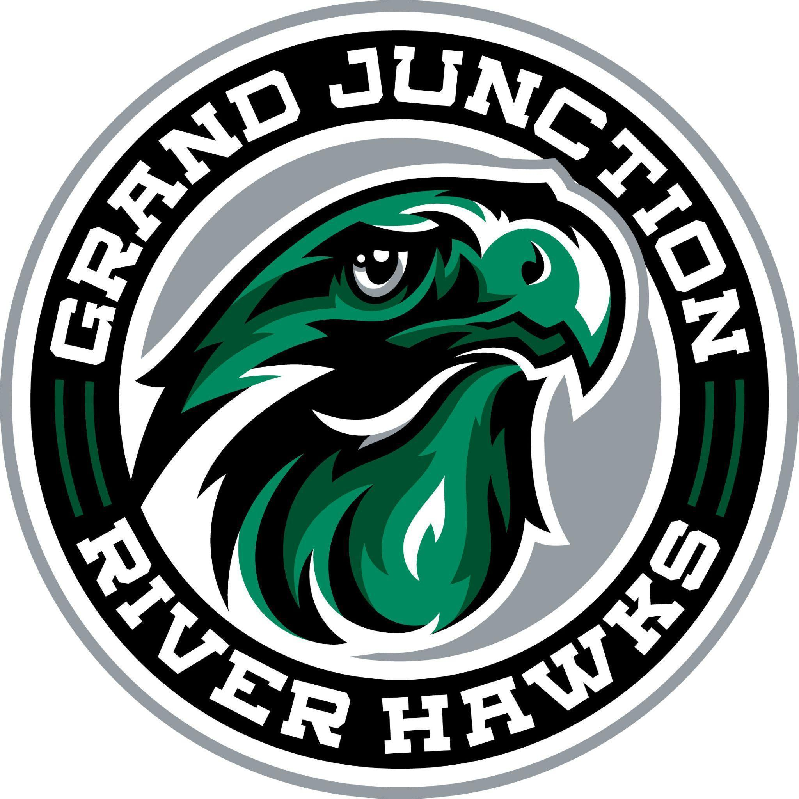
Grand Junction Hockey Club
Board of Directors Meeting Minutes
October 7, 2025
6:30 pm

Invitees:
Name | Position | Name | Position
Chris Birdsong (CB) | President | Meghann Hurt (MH) | Secretary
Jamie Neyers (JN) | Vice President | Jackson Wilson (JW) | Hockey Director
Jessica Miracle (JM) | Treasurer | Amy Szaller (AS) | Rink Representative
Strikethrough indicates “Not Present”

Call to Order: (JN) called to order at 6:42pm

Old Business
(JN) motions to approve and (JM) seconds the 8/4/25, 8/20/25 and 9/30/25 meeting minutes.

New Business
- Registration / Financial update
JM is still working on accessing financial statements. JM, JW, and Marsa Larson now have cards. Temporary cards can be requested. There is a bill pay system available.

164 registration, up from 149 at the end of 2024-2025. Marsa Larson (registrar) takes care of jersey orders. JN will reach out to Marsa Larson regarding jersey orders.

- Scholarships update
All codes went out. All but one Acknowledgement forms were returned (CB was sent the one outstanding form). MH to check Crossbar to ensure all scholarship codes were used and players registered.

- Coaching Compensation Discussion
  - Assistant director compensation package
Assistant Director is Eli Wilson. JW wants to increase contractor fee. Eli was at every tryout and was not compensated. A six month stint, beginning in September, going through February. Eli is comfortable with up to 10 hours/week for youth River Hawks.

  - Goalie Coach compensation
JW wants to see the contractor fee increased for Coach Babin for six months (September through February).

JN and JM will discuss a compensation package for both Coach Wilson and Babin including rates and hourly expectations. Action Item: review Director Compensation Form edits and provide comments.

- Hockey director bonus metrics 25/26
On hold for now so the Board can review JWs previous Hockey Director Bonus Compensation Elements.

- Apparel
GJHC will move forward with their own merch sales this year. Need to have an online store opened ASAP.

- 19u Girls Team
Players from Gunnison are concerned that the girls team is rebranding from the dual name of both areas to Lady Hawks. JW recommends that CB could talk with Gunnison Director and/or President to discuss. CB agrees to coordinate with JW on setting up a meeting.

Next Meeting: 10/21/25 @ 6:30 pm (with remote option)
Meeting Adjourned: (JN) moves to adjourn, (JM) second, unanimously adjourned at 7:54 pm

