Wayha Student Coach Requirements

- Student coaches (under 18) will need to register with USA Hockey as a skater.
- Complete Wayha Director of Hockey or President Interview & Check list.
- Complete USA Hockey form below and return to association Registrar or President.
- Register on www.wayha.com for “Student Coach”.
Age:
- 17 and/or turning 18 during the year they are coaching, they are required to complete SafeSport.
- 18: If they are 18, they are required to go through all USA Hockey Coaching Requirements: SafeSport, Background Check, Level 1 Coaching, and Age Specific Modules.

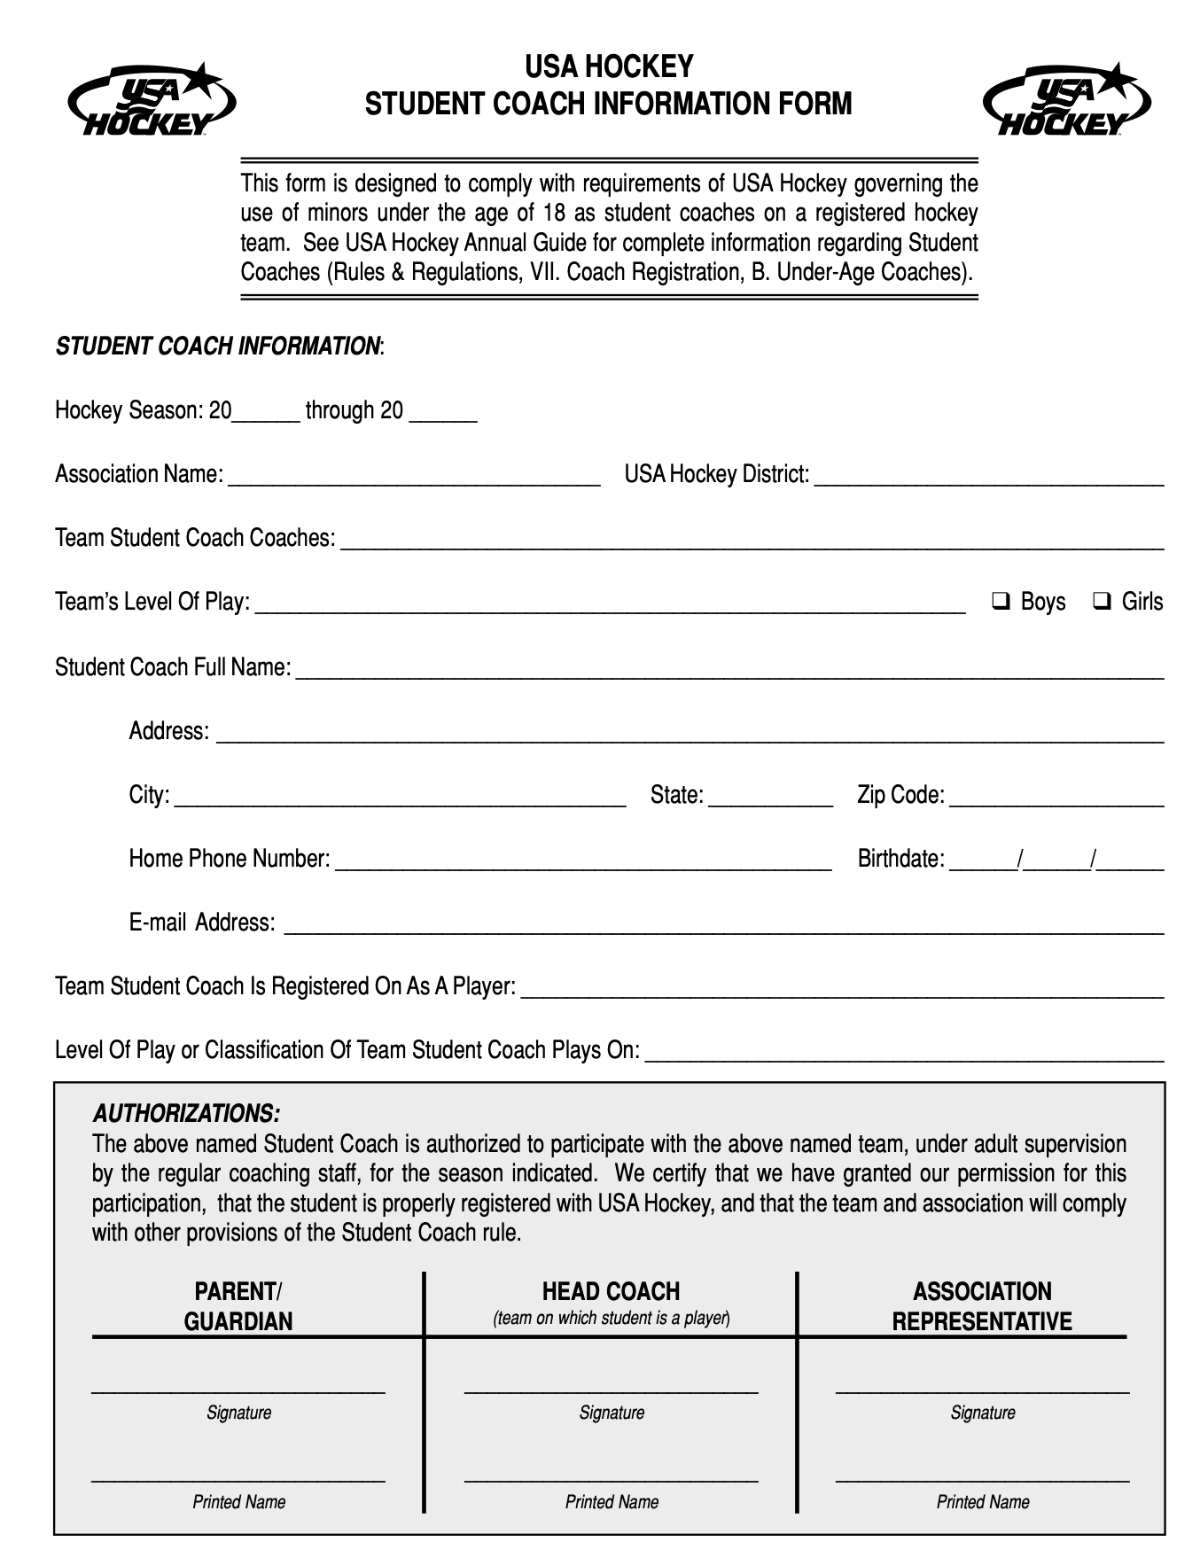
- Overview

Student coaches are important:
  - Help practices run smoothly
  - Be role models for younger players
  - Learn leadership and coaching skills
Important: Student coaches support the team — they do not replace the coach.

- Student Coach Responsibilities:

Before Practice
- Arrive 10–15 minutes early
- Ask the coach: “How can I help today?”
- Help place cones and equipment for drills

On-Ice Responsibilities
- Help set up cones, tires, nets, and dividers
- Explain and demonstrate drills when asked
- Encourage players during drills: “Nice job!”, “Keep your feet moving!”
- Be positive, respectful, enthusiastic, patient and fair
- Help keep lines moving and players focused
- Stay near your assigned station
- Help reset drills quickly or collect pucks or cones

3. Communication & Leadership Tips
- Use a positive tone
- Be constructive not destructive
- Keep instructions short and clear
- Be fair, equal and inclusive
- Lead by example: hustle, listen, work hard
- If unsure what to do, ask a coach
- Thank the Coach and players

Golden Rule: Younger players copy what you do — act how you want them to act.

What Student Coaches Should NOT Do:
- Yell at players
- Coach strategy unless asked
- Discipline players
- Do Not use this time to practice your skills

4. Safety & Awareness
- Wear Helmet with cage, gloves and skates when on the ice
- Follow all rink and club safety rules
- Always be aware of pucks and skaters
- Never stand in shooting lanes
- Notify Coach of player injury immediately

