Zach Tomlinson

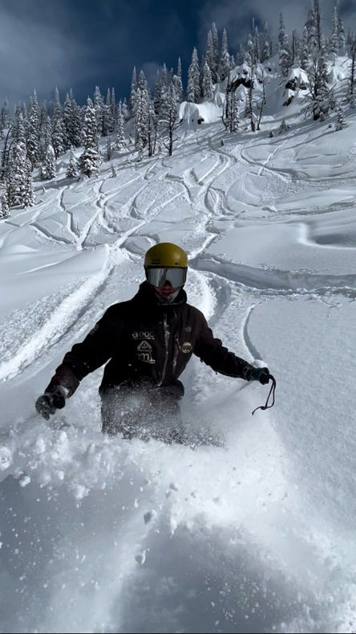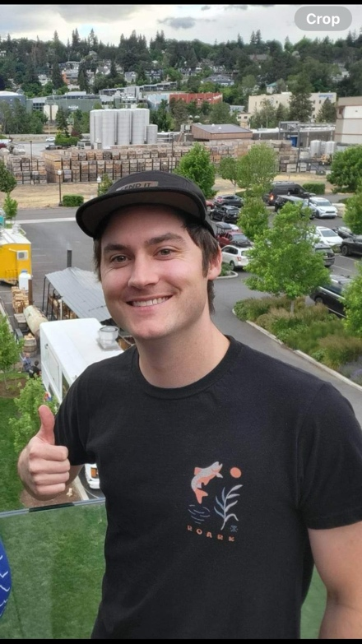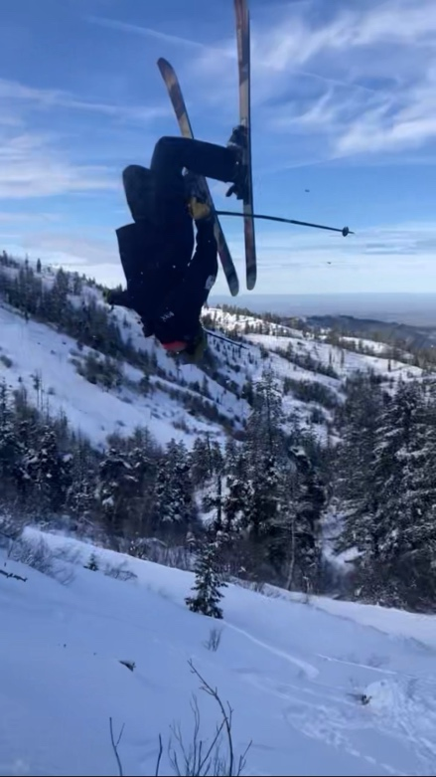

Big Mountain Head Coach
Big Mountain Head Coach Zach Tomlinson is stoked for the season ahead. “The Big Mountain team has been very successful in recent years. We’ve swept regional podiums at Bogus, Brundage and Tamarack. We’ve had some top 5 finishes at Nationals and even sent multiple athletes to the Junior Freeride Championships, and we are looking to do so again this year.”
Zach has coaching in his DNA. His grandfather was Director of the Squaw Valley Ski School, and his dad coached US Alpine Team members Julia Mancuso and Travis Ganong when they were rising stars on the Squaw Valley Ski team.
A skier by age two and a Mitey Mite by kindergarten, Zach went on to race his way around the Far West Division. At home, he and his friends took full advantage of the Squaw Valley playground. “Growing up, my skiing buddies were Bryce Bennett, Nick Daniels and Keith Moffat. Squaw always made it a point to train up and freeski a lot. So, we ripped all over the mountain,” said Zach.
Zach wanted to play baseball in college. So, he looked for a college that was near a ski hill. College of Idaho sounded like a good fit. Plans changed though when Zach ran into Coach Bonneau during his campus visit. “I was in the middle of a tour, and he came up to me in the hallway and introduced himself. We talked for a bit, and everything just clicked.” Zach dropped his baseball plans and joined the Yotes ski team.
That decision worked out in more ways than one for Zach. “Sophomore year, the race team did not qualify for Nationals, so I went across the mountain and asked the coach if I could go with them to Freestyle Nationals in Sun Valley.” The coach agreed, and Zach walked away with second place overall. “As a former racer, I had an advantage in the icy conditions that year,” he says.
Zach's great outlook shines on and off the mountain. Every year, BBSEF receives numerous compliments from freeski parents who appreciate Zach’s coaching style and how much their kids enjoy skiing with him. "His work ethic and overall positive attitude make him a great coach and role model."

Here’s to a great season ahead!

