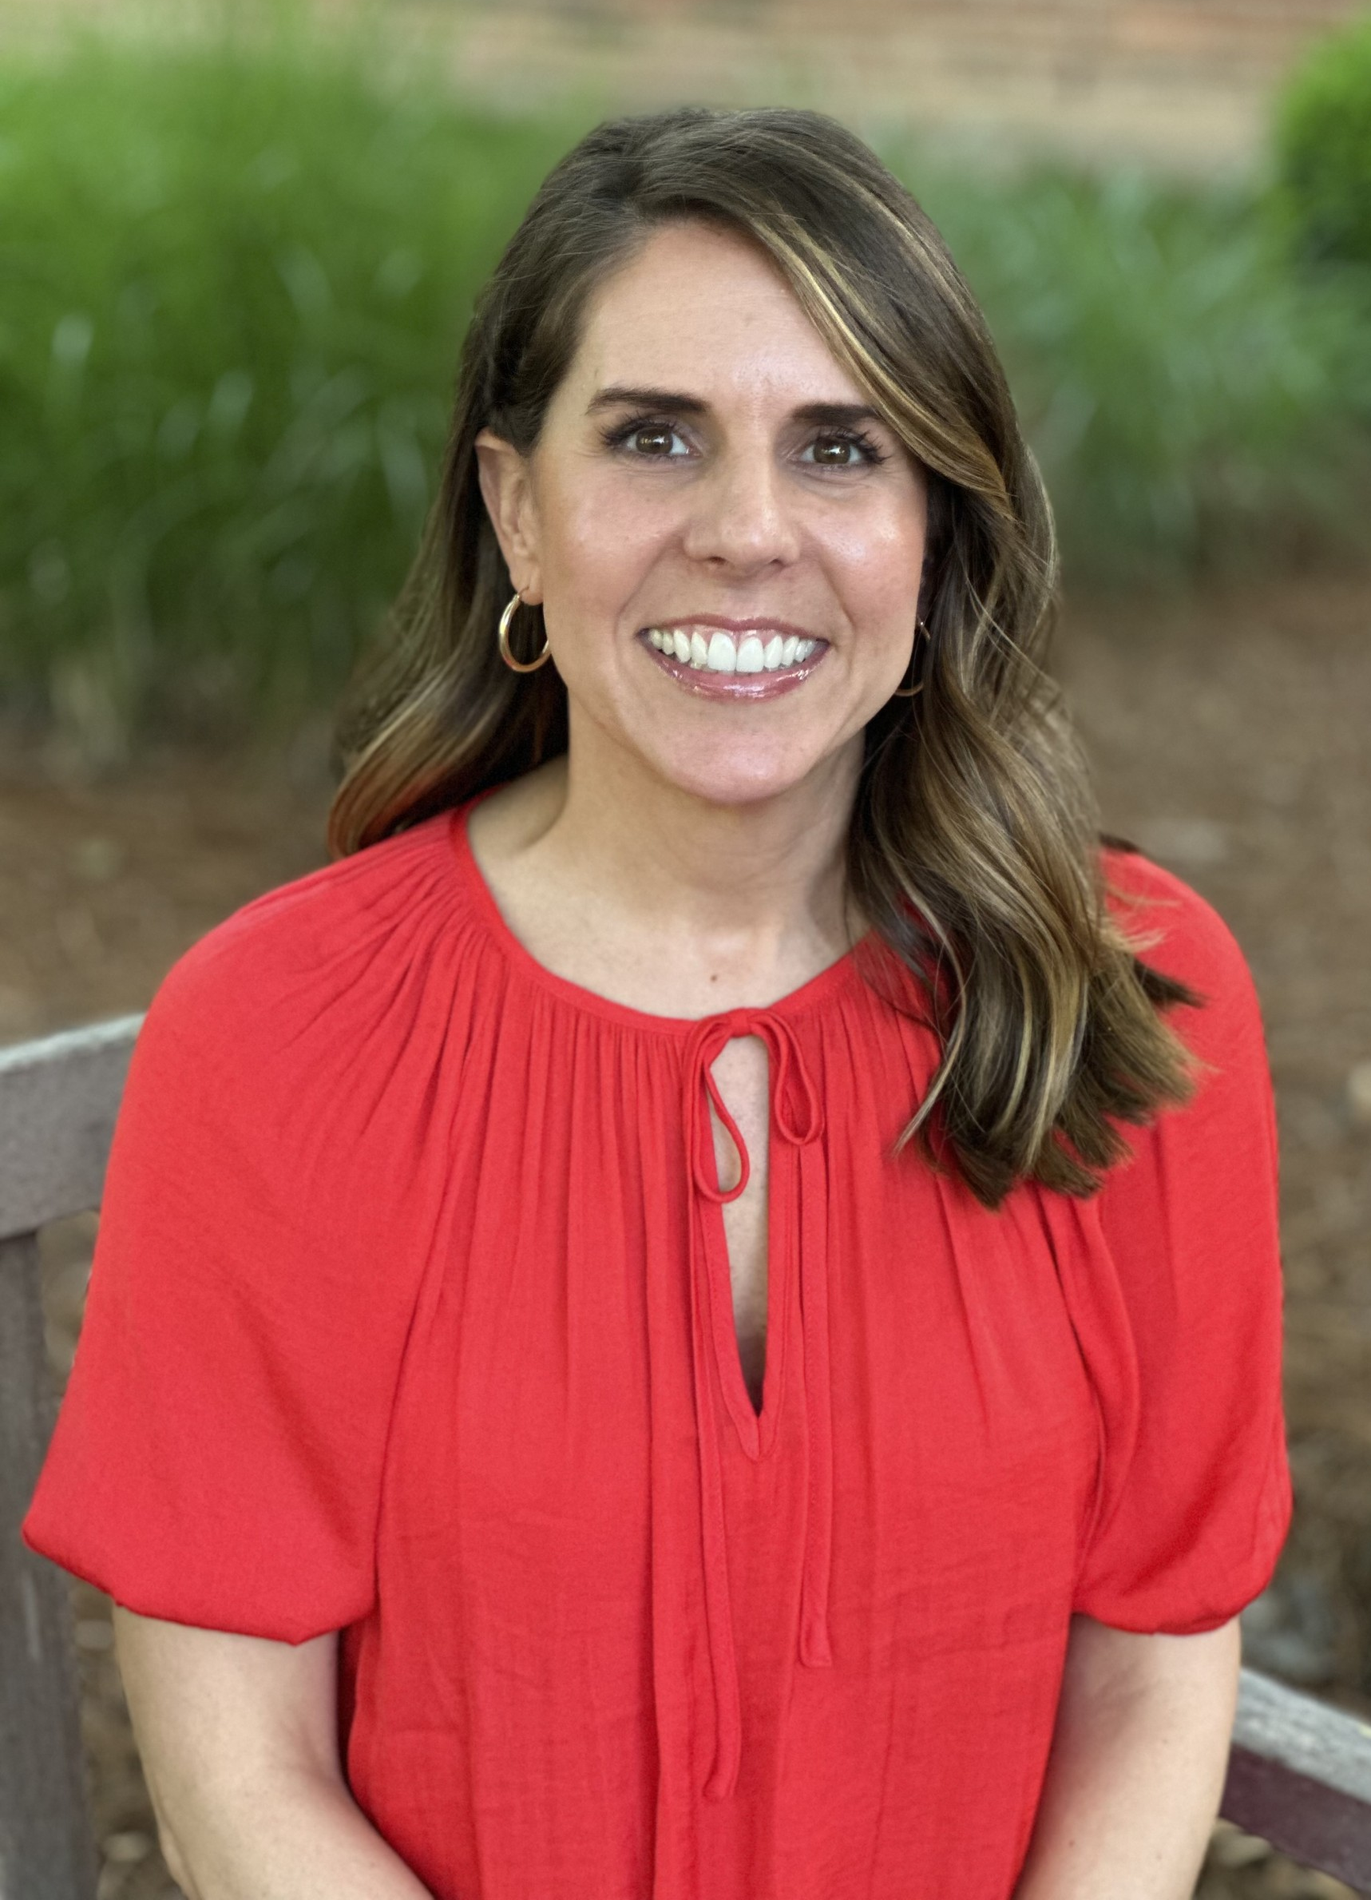


12 Years Experience
Coach
+Judge
+Event Partner
11 Years Experience
Coach
+ Former Competitor
+Volunteer
5 Years Experience
Coach
+Parent
+Volunteer
Chris Allen
Chris_Allen@brentwoodacademy.com
Director of Robotics
HS Coach
Hank Roberson
Hank_Roberson@brentwoodacademy.com
US Head Coach
Linnea Wells
Linnea_Wells@brentwoodacademy.com
HS Coach
Robotics Billing
IRHS Sponsor
Meet the High School Coaches
2025-2026
2025-2026 Iron Eagles Handbook
Contact Us:
robotics@brentwoodacademy.com

