

Beaver Dam Hockey Association
4.23.25/6:30pm/Ooga

ATTENDEES
Justin Rhodes | Present | Mike Pogorelec | Present
Jeremy Hanni | Present | Sara Wild | Present
Stacy Shaw | Present | Chris Mueller | Present
Crystal Bates | Present | Andreya Armstrong | Present
Kelly Guenther | Present | Celina Tratar | Present
Jason Drake | Present
Guests:

Agenda

Call to order
Approval of minutes | March Minutes

Last Meeting Follow-up
Updates/Discussions

President

BDFC board meetings
Youth Hockey/Girls Hockey | Discussion about quantity of teams  -Ice distribution and how a potential JV team will impact that

Safesport
Calendar Events | - Treasure to send fundraising and volunteer credit bills out to members by May 15th.  - Plan Registration for the next season.  - Review Handbook and Bylaws

Vice President

Hockey 1&2

Tournaments

Treasurer

Finances

Fundraising

Fundraising Credits

Secretary
Upcoming Meetings: | Annual Meeting date?
Elections/terms: | 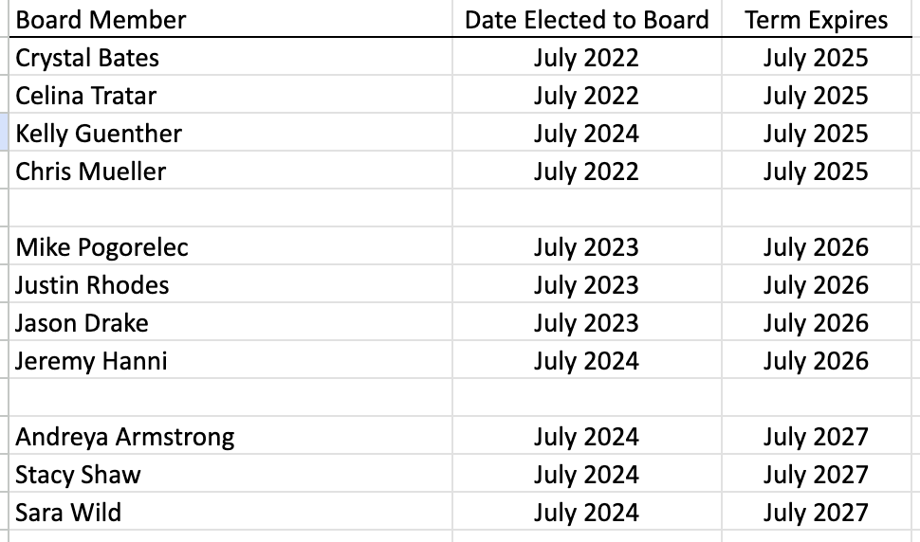

Action Items From Previous Meeting
Action Items Future Meeting

Other Topics

Facility Report?

Spirit Wear

Next Meeting:
Date/Time/Location

